

S.M.A.R.T. Alarm:

Smoke Monitoring and Reactive Tasking Alarm

Senior Design 1

Project Documentation

Spring 2017

Group A

**Carlos Castro**, Computer Engineering

**Courtnie Coleman**, Electrical Engineering

**Lucas Plager**, Computer Engineering

**Patrick Schexnayder**, Electrical Engineering

# Table of Contents

Table of Contents i

List of Figures vi

List of Tables vii

1.0 Executive Summary 1

2.0 Project Description 3

2.1 Motivation 3

2.2 Goals, Objectives, and Function 4

2.3 Engineering Requirements/Specifications 4

2.3.1 Smoke sensors 4

2.3.2 Transmitter and receiver 5

2.3.3 Software 5

2.3.4 Battery 5

2.3.5 Lights, Direction Indicator, Sound 5

2.4 House of Quality 5

2.5 Block Diagram (Hardware) 7

2.6 S.M.A.R.T. Alarm Operations Manual 9

2.6.1 S.M.A.R.T. Alarm System and Components 9

2.6.1.1 Wireless Communication Network 9

2.6.1.2 Fire Alarms 9

2.6.2.3 Central Processing Hub 10

2.6.2 Users 10

2.6.2.1 Installation User(s) 10

2.6.2.2 Maintenance User(s) 11

2.6.2.3 Evacuee(s) 11

2.6.3 Installation 11

2.6.4 Maintenance 12

2.6.5 Evacuation 12

2.6.6 In Case of Fire 13

3.0 Project Research 14

3.1 Existing Fire Detecting and Alarm Systems 14

3.1.1 Fire Alarm System Components 15

3.1.1.1 Control Panels 15

3.1.1.2 Fire Sensors and Detectors 15

3.1.1.3 Output Devices for Fire Alarm Systems 17

3.1.2 Conventional and Addressable Fire Alarm Systems 19

3.1.2.1 Conventional System Diagram 19

3.1.2.2 Addressable System Diagram 21

3.2 Smoke Detecting Sensors 23

3.2.1 Photoelectric Sensors 23

3.2.2 Ionization Sensors 24

3.2.3 Carbon Monoxide/Gas Sensors 24

3.2.4 Heat Sensors 25

3.2.5 Dual Sensor Technology 25

3.2.6 Conclusion 26

3.3 Assessing Fire Detection Options 26

3.3.1 Smoke Chamber Design 26

3.3.2 Infrared LED 27

3.3.3 Photodiode 27

3.3.4 MQ-2 Sensor 28

3.4 Fire Alarm Batteries 28

3.4.1 Shelf-life 29

3.4.2 Performance 29

3.4.3 Cost 29

3.4.4 Power and Capacity 29

3.4.5 Two sources of power vs. UPS 30

3.5 Fire Alarm Sound and Signaling 31

3.5.1 Sounders 33

3.5.1.1 PS1927P02 Piezo Sounder 33

3.5.1.2 PS1920P02 Piezo Sounder 34

3.5.1.3 PS1740P02E Piezo Sounder 35

3.5.1.4 12 VDC PUI Programmable Buzzer 36

3.6 Wireless Communications 37

3.6.1 Overview 37

3.6.1.1 Why use wireless communication? 37

3.6.2 Wireless Fidelity (Wi-Fi) 37

3.6.3 Bluetooth 39

3.6.4 Radio Frequency 39

3.6.5 ZigBee 40

3.6.6 ZigBee Protocol 42

3.6.7 ZigBee Modules 44

3.6.7.1 NXP JN5168-001-M003 44

3.6.7.2 Telegesis ETRX351 45

3.6.7.3 Digi International Legacy XBee S1 46

3.6.8 DIGI International XCTU Software 50

3.6.9 Antenna 52

3.7 Central Processing Hub 52

3.7.1 Arduino Uno 53

3.7.2 Raspberry Pi 54

3.7.3 BeagleBone Black 54

3.7.4 Hub Comparison Conclusion 55

3.8 Fire Alarm Components for Use in S.M.A.R.T. Alarm 57

3.8.1 Microprocessor for Fire Alarms 57

3.8.1.1 Bootloader 58

3.8.1.2 Bootloading Process 58

3.8.2 16 MHz Crystal Oscillator 59

3.8.3 LM3940 Voltage Regulator 60

3.8.4 Auto Transformer 61

3.9 Printed Circuit Board 62

3.9.1 PCB terminology 63

3.9.2 Silkscreen 63

3.9.3 Solder mask 64

3.9.4 Copper 65

3.9.5 Substrate 65

3.9.6 PCB software 66

3.9.7 PCB constraints 67

3.9.8 Track design guidelines 68

3.9.9 Thermal issues 69

3.9.10 PCB Layout Steps 70

4.0 Design Constraints and Standards 72

4.1 Constraints 72

4.1.1 Economic Constraints 72

4.1.2 Environmental Constraints 72

4.1.3 Social Constraints 73

4.1.4 Political Constraints 73

4.1.5 Ethical Constraints 74

4.1.6 Health and Safety Constraints 74

4.1.7 Manufacturability Constraints 75

4.1.8 Sustainability Constraints 76

4.1.9 Time Constraints 76

4.1.10 Testing/Presentation Constraints 77

4.2 Standards 77

4.2.1 Standards for Power Consumption 77

4.2.2 IEEE Wireless Standards 79

4.2.3 Security Standards 79

4.2.4 Notification Appliances and Standards 80

5.0 Project Design 84

5.1 Hardware Design 84

5.1.1 S.M.A.R.T. Alarm Fire Alarm Breadboarding 84

5.1.2 S.M.A.R.T. Alarm Fire Alarm Schematic 86

5.1.3 Battery Monitoring Circuit 87

5.1.3.4 Power supply 88

5.2 Software Design 89

5.2.1 Hub Software/Network Overview 89

5.2.2 Fire Alarm Software Overview 96

5.3 Wireless Network Design 99

5.3.1 ZigBee Network Configuration 99

5.3.2 Implementing the Network 100

5.3.3 Sending and Receiving Data over ZigBee Mesh Network 100

6.0 Testing 103

7.0 Administrative Content 104

7.1 Estimated Budget 104

7.2 Actual Expenditures: Prototype 104

7.2.1 Central Processing Hub 104

7.2.2 Fire Alarm 105

7.3 Financing Plan 105

7.4 Project Timeline 106

8.0 Conclusion 107

9.0 Appendix 108

9.1 References 108

9.2 Copyright Permissions 111

9.3 Datasheets 118

# List of Figures

Figure 1: House of Quality Diagram 6

Figure 2: S.M.A.R.T. Alarm System Block Diagram 8

Figure 3: Manual Pull Alarm 15

Figure 4: X3302 Multispectrum Infrared Hydrogen Flame Detector from Det-Tronics 17

Figure 5: Control System Diagram 20

Figure 6: Addressable System Diagram 22

Figure 7: Photoelectric Sensor - No Smoke Present (left), Smoke Present (right) 23

Figure 8: Ionization Sensors - No Smoke Present (left), Smoke Present (right) 25

Figure 9: MQ-2 Flammable Gas & Smoke Sensor (printed with permission of Polulu.com) 28

Figure 10: Offline Uninterruptable Power Supply (left), Online Uninterruptable Power Supply (right) 31

Figure 11: 12 VDC PUI Programmable Buzzer 36

Figure 12: Wi-Fi Network 38

Figure 13: Routing Network Method (left), Flooding Network Method (right) 40

Figure 14: ZigBee Star Network (left), ZigBee Mesh Network (right) 41

Figure 15: General OSI Model 43

Figure 16: Beacon Network Data Transfer Diagram 44

Figure 17: NXP JN5168-001-M003 45

Figure 18: Telegesis ETRX ZigBee Series 46

Figure 19: Digi International Legacy XBee S1 47

Figure 20: UART Data Transfer Diagram 47

Figure 21: 5 Modes of XBee Module 48

Figure 22: XCTU Software 51

Figure 23: MikroTik 2.4/5 GHz Omni Swivel Antenna 52

Figure 24: Arduino Uno 53

Figure 25: Raspberry Pi 54

Figure 26: BeagleBone Black 55

Figure 27: ATmega328P Microprocessor 57

Figure 28: Arduino Loading Bootloader to Microprocessor 58

Figure 29: LM3940 Voltage Regulator 60

Figure 30: Step-Up Auto Transformer 61

Figure 31: TPA2100P1 Audio Amplifier 62

Figure 32: S.M.A.R.T. Alarm Fire Alarm Module Breadboard 84

Figure 33: Battery Monitoring Circuit 87

Figure 34: Power Supply Circuit 88

Figure 35: Power Supply Circuit Block Diagram 89

Figure 36: Hub Communication Diagram 90

Figure 37: Central Processing Hub Software High Level Design Flowchart 92

Figure 38: Optimized Path Calculation Algorithm Design Flowchart 94

Figure 39: Optimized Path Calculation Algorithm Class Diagram. 95

Figure 40: Fire Alarm Software Design Flowchart 97

Figure 42: XBEE Router Configuration 99

Figure 41: Xbee Coordinator Configuration 99

Figure 43: (a) Broadcast, (b) Multicast, (c) Unicast 102

# List of Tables

Table 1: Average Ambient Noise Level and Minimum Required for SPL (This table is in accordance with NFPA 72) 32

Table 2: Square Wave Drive for PS1927P02 Piezo Sounder 33

Table 3: Square Wave Drive for PS1920P02 Piezo Sounder 34

Table 4: Square Wave Drive for PS1740P02E Piezo Sounder 35

Table 5: Specifications for 12 VDC PUI Programmable Buzzer 36

Table 6: ZigBee Module Comparison 49

Table 7: Comparison of Development Boards 56

Table 8: PCB Terminology 64

Table 9: PCB Design Software 67

Table 10: Width of Tracks 68

Table 11: Circuit Design Voltages 78

Table 12: Visible Signals per Room Standard 83

Table 13: Fire Alarm Breadboard Components 85

Table 14: Estimated Budget 104

# Executive Summary

Every year many lives are lost in fires in both residential and commercial across the world. With as many precautions and safety measures taken to prevent fires, and to alert people of fires many times the confusion of such an event leads to loss of life. The confusing nature of an unfamiliar building layout and the lack of information about the fire, and most importantly its location, are factors that if addressed properly can severely reduce the current amount of fire-related deaths and injuries. In the situation of a fire, time is a factor and even a few seconds can make the difference between survival and death, and the S.M.A.R.T. Alarm system aims to address the issues of the lack of knowledge regarding the location of the fire, and finding the fastest evacuation route of a building. This is done by alerting those in the building of which route to take when evacuating a building while taking into account the locations where there might be the danger of fire, using a combination of audio and visual signals that will lead to an effective, fast and smart evacuation of a building.

Smart alarms currently on the market, may track the location of the fire for the purpose of giving the information to fire departments for controlling and extinguishing the fire. However, the occupants of said building are not alerted of this and taking a wrong turn can be deadly for an evacuee. S.M.A.R.T Alarm stands for Smoke Monitoring and Reactive Tasking Alarm, and its purpose is to fulfill what its name stands for, by monitoring for smoke or fire and alerting the occupants of a building how to react.

The system consists of a Central Processing Hub, connected to AC Power, that is in constant communication with all of the Fire Alarms in the system, via wireless communication using ZigBee Radio Modules. Each individual Fire Alarm in the network is powered primarily by constant AC Power from the building’s power grid and backed up by a 9V battery in case of power going out in the building. A Fire Alarm device is constantly sampling the air using an IAFF approved fire and smoke detecting method and sensor. If any of the alarms sense a fire or smoke, a data packet will be sent to the Central Processing Hub, informing it of the potential for fire and knowing the location of the specific Fire Alarm. The Central Processing Hub can use this information to calculate the most efficient evacuation routes based around avoiding the fire and evacuating occupants as quickly as possible, using the Directional Evacuation Algorithm. The Central Processing Hub will then inform each Fire Alarm of the signals they must sound and display based on the evacuation routes. This will result in alarms playing the sound in a synchronized manner, where the sound will echo toward the nearest exit by playing alternating sound from the speakers and allowing occupants to “follow” the sound to the exit. At the same time, each alarm will display an arrow that will point in the direction they must follow for the evacuation route. In case of low power or low battery power, the Central Processing Hub will push notifications to the building manager using a connection to the building’s Wi-Fi network, so that they may address the issue and perform the necessary maintenance.

The S.M.A.R.T Alarm System is designed for easy installation, that requires the installer to access a custom program run on the Hub using the Microcontroller’s operating system. There a layout of the building may be designed and locations of the Fire Alarms may be marked, following that the system will be ready to monitor the building for fire and save lives.

This report documents the S.M.A.R.T. Alarm System design process. This report begins by relating the motivation, goals and function behind this project, followed by a more in-depth look at the engineering requirements and specifications and the operation of the system. The research chapter takes a detailed look at current systems and based on the information collected components to be implemented in the system. Some of the more important components selected as a result of the research performed in this section include the microprocessor to be used, the smoke and fire monitoring sensor, the microcontroller tasked with being the Central Processing Hub, Wireless Communication methods and various alert components. Following the Research chapter, the topics of several constraints considered in designing and implementing this system are considered such as economic and environmental constraints. This section will also include standards that are to be considered in the design process such as IEEE and NFPA. Following this, the design section will discuss the intricacies of hardware, software, and network design. This includes the schematics, block diagrams and other related documentation that are used for planning and designing the system. The hardware section will focus on PCB design for the Fire Alarms, while the software section will focus on programming the direction algorithms. The Administrative Content section goes into details regarding the budget and actual expenditures, as well as the project timeline and the such.

# Project Description

This chapter describes the S.M.A.R.T. Alarm System project more in depth than in the previous section. This begins by describing our motivation for creating this project, based on our realization that a major improvement could be made in a device and system as common place as fire alarms, and how this could save a lot of lives if implemented correctly. Following this, the goals and objectives for the system are described in detail, and from this the function of the system is derived and described for further understanding of what the systems is meant to do. To further specify what the project is meant to do, the Engineering Requirements for major system components are described in order to design the best system possible. A House of Quality chart is included to better demonstrate the tradeoffs that must be addressed when designing the system’s components and the whole system. A block diagram for the hardware is also included for better understanding on how the fire alarm and central processing hub will interact with each other and how each will perform its defined functions. Lastly, a section is designated for the operations manual for the S.M.A.R.T. Alarm System, that serves as instructions for the installation, maintenance and general use of the system.

## 2.1 Motivation

In today’s day and age, technology advancements are occurring at a rapid pace. There are new inventions being created every minute improving people’s lives and making the world a better and safer place. Our group saw that while technology is advancing and becoming a bigger part of our everyday lives, one piece of technology that has not seen a major improvement in decades is the smoke and fire alarm. This device is a standard in everyone’s homes, offices, hotels and all other major buildings that we spend time in every single day but has been neglected as far as engineering advancement and innovation is concerned. The smoke and fire alarm that you have inside your house is essentially the same one your parents had inside theirs. We think we can do better. When looking at the average use case of a smoke detector, it was discovered that while they are useful, these devices do not provide the user with an abundance of information. Frequently, someone would hear the alarm go off and just frantically run to wherever they believe to be the nearest and safest exit without much of a plan. This scenario has the potential for disaster when you consider that there could be multiple people inside the building who do not know their way around and could be endangering themselves. Individuals could be wasting valuable time or be heading in a direction that is dangerous. We believe that a smoke alarm with improved functionality can help to eliminate this scenario and make everyone’s lives easier, and most importantly, safer. This can be achieved by creating a more connected fire alarm system. When the location of a fire is a factor in directing evacuation of a building, communication between the detection system and alarm system can provide crucial, life-saving information.

## 2.2 Goals, Objectives, and Function

The goals for the smart smoke and fire alarm are to make an affordable, customizable, connected system of smoke alarms that alert employees and residents of the safest and fastest exit of the building in the case of a fire emergency. We would like this system to not be that much more expensive than existing options to convince the market to adopt our system. In the event of an emergency, these smoke alarms would sound off in an order that would lead people to the closest and safest exit. Users would just have to follow the sound that is projected from these alarms until they reach the exit to the building. These smoke alarms would be dynamic in the sense that they adapt to where the fire is located. This means that if a smoke alarm that is in the middle of a hallway goes off, people on the left of that area would be directed to the exit that is closest on their side of the fire while people on the right of that area would be directed to the exit that is closest on the other side of the fire while nobody is directed though the dangerous area. The system would also be able to handle hallway intersections and other confusing areas. This allows for residents to know where the fire is and what areas to avoid. For people that have hearing issues, these alarms will also have a visual display using light-up arrows that will point individuals in the direction they should go to exit the building. This also allows for better handling of confusing areas where sound alone could be confusing. This system should be achieved by mapping the building layout using a custom-made application during set up of these alarms, creating spatial awareness for each of the fire alarms, while using an algorithm to signal each alarm which is the best exit direction relative to its position. Our final goal is to focus on the ease of installation of our system. This system needs to be simple enough to install so that specialists are not required to configure, set up, and install these fire alarms. An effective ease of installation would ensure that almost anyone would be able to adapt our system into their building plans.

## 2.3 Engineering Requirements/Specifications

The fire alarm that will be designed will give a clearer indication as to where to go during a fire. For this system to work each alarm will be connected to each other and will be able to send and receive signals. This system will be mapped to the floor plan of the building, so that when a fire breaks out the alarm system will recognize where the fire is coming from and send out a signal to each alarm to light the LEDs in the direction people should go to get away from the fire.

### 2.3.1 Smoke sensors

Smoke sensor will be used to detect smoke within the building, there are different types of smoke sensors to detect fast flaming fires and slow smoldering fires. Upon more research we will be decided which would be best for us to use within our fire alarm. We want to make sure that we have the most cost-effective sensor that are also very efficient, to provide the costumer with the best product.

### 2.3.2 Transmitter and receiver

For this fire alarm system, we want to make sure to direct the people away from the fire and to the closest exit. For this to work we will need each alarm device to be connected to each other. So each separate alarm will have a transmitter and a receiver so that way each alarm would be able to communicate to each other, and send the correct signal.

### 2.3.3 Software

For the fire alarm system to be successful we will be using a script language to program the devices to recognize the layout of the building, and to be able to set off the sequence as to where to go when one of the smoke sensors go off. It has not yet been determined which script language will be use yet, we want to make sure you use the one that would be the most efficient and easy to implement.

### 2.3.4 Battery

For the fire alarm system, it will be using a 9v battery with 1200 mAh current, due to some research on current fire alarm systems and the profession grade batteries they use. We are also researching the different types of batteries that would provide us with the best life expectancy. We would want the battery to have a life expectancy that will last between 5 to 10 years. This way the alarm system requires minimal maintenance as possible, on top of annual inspections.

### 2.3.5 Lights, Direction Indicator, Sound

To help with the indication of a fire, and to help direct people in the right direction away from the fire there will be two LEDS in the shape of arrows on the fire alarm. Depending on the signal that is sent out, one of the arrows would illuminate in the direction to go. This will help give a clearer indication as to where the fire maybe and where to go. In addition to the lights and the direction indicators, there will also be an echoing sound that will sound when the alarm goes off. This echoing sound will follow the sequence of the signal that was sent out, and the sound will go towards the closest exit, just like the lights.

## 2.4 House of Quality

When engineers have customers that are interested in their services, and they want to make sure they can meet their clients’ needs while keeping in mind the practicality of meeting their needs; a house of quality is used. The House of Quality is a chart that helps give a better understanding as to what the customer requirements are and what the engineering requirements for that customers’ product. With this chart, you can find the correlation between the consumers’ needs and the engineering requirements. Once you find the correlation between the consumers’ requirements and the engineering requirements, you can then determine the specs of what that product would have. Also with the correlations you can determine what is most important and what is the least important.



Figure : House of Quality Diagram

When looking at the house of quality chart the top portion of the chart is where the engineering requirements are listed. Above those listed engineering requirements shows the correlation between each of those requirements. With this correlation, you can determine if one requirement will affect another one either negatively or positively. On the left side of the chart it shows the request/requirements of the consumer. Usually in some House of Quality charts there would be an extra space next to the needs the customer states, and you would rate them, on a scale of your choosing. You would then rate the request of the customer from most important to least important from the consumers point of view. The middle portion of the House of Quality chart is where the correlation between the consumer/marketing requirements and the engineering requirements happen. At this point this is where you can decide whether the engineering requirements would be able to support the marketing requirements set by the consumer. The bottom part of the house of quality chart are the set targets for the engineering requirements that have been stated. This part of the chart helps declare a range for your specs for that specific project.

With our house of quality, you can see the we have the requirements the consumers would want in an alarm system. Also, we have the engineering requirements that would be needed to take into consideration to help meet the consumer requirements that were requested. When doing the correlations, we could differentiate the requirements that were more important and the ones that weren’t as significant. With the correlation, we able to come up with a good idea of the targets we needed to satisfy the engineering requirements. So, from this house of quality chart that we have we can see that the most important thing when it comes to the consumer side is that they would want a good battery life. The costumer would want the battery life to be long. This necessity relates to a lot of the engineering requirements, because the battery is essential to the actual system work, and having a bad battery that doesn’t last long or has a bad discharge rate can affect the efficiency of the product. Also, the house of quality chart helps us target which aspects of the product to focus more on than the others. With this chart that we have we would need to focus more the battery, the smoke sensor, and the indicators. These three stipulations effect the targets we are trying to maintain when it comes to the production of this alarm system.

The House of Quality is used just to make sure that the engineers can help meet the needs of their customers while staying within a practical aspect when designing the product. There’s always going to be a give and take when it comes to trying to provide a product to a consumer, and trying to meet all the expectations that they want. Unfortunately, all the stipulations that the consumer may want within their product may not be achieved. However, it is the engineers job to make sure that they are able to produce the most efficient product even if they can’t meet all of the consumer’s needs.

## 2.5 Block Diagram (Hardware)

The layout of the S.M.A.R.T. Alarm system consists of two types of devices, a central processing hub, known as “The Hub” and each Fire Alarm. The Hub will consist of a main alert computation system that includes the CPU for this device, which will be able to process any information received from the Fire Alarms in the same system through a wireless communication network, therefore The Hub will also require a communication module component in order to receive and transmit this information. The Alert Computation System will be in charge of using the data received and making any decisions necessary for the system, and instruct each individual alarm of the appropriate response in its specific case based on location. This Alert Computation System is also in charge of creating any alarms and pushing them to any users in charge of maintenance of the system so that they may perform any maintenance required. The Hub will receive Power from an AC outlet connected to the building’s power grid.



Figure 2: S.M.A.R.T. Alarm System Block Diagram

The Fire Alarms consist of several component blocks. The Fire Alarms will rely heavily on the communication module that allows wireless communication between the alarms and The Hub. This communication component block will be in communication with the Fire Alarm System that contains the CPU of the device. This component block will make any decisions for the individual alarms, including but not limited to deciding whether the data received from the Sensors block requires alerting The Hub of a potential fire, checking the Power Status block for the status of the primary AC power and the backup 9V Battery Power. The Fire Alarm System Component block is also in charge of managing the Alert System Component block in case it receives a message from The Hub that the fire alarms should sound, this message will also tell the CPU how to direct users in case of fire through the Alert System Block. Ideally, in the actual system there will be several of the Fire Alarm Devices communicating with The Hub, and for the purposes of demonstrating the project, the final project product will contain 5 Fire Alarm devices and one Central Processing Hub to manage them.

## 2.6 S.M.A.R.T. Alarm Operations Manual

The S.M.A.R.T. Alarm System is designed with the end users in mind, of which there may be several different roles that could be played, ranging from passive to active in the use of the system. So that the S.M.A.R.T. Alarm system may accommodate the wide range of experiences for different types of users, and the different interactions that will be necessary of them, the system must be as simple to use for installation, maintenance and building evacuation purposes.

### 2.6.1 S.M.A.R.T. Alarm System and Components

The S.M.A.R.T. Alarm system is comprised of a wireless communication network that contains two types of devices: the Fire Alarm and the Central Processing Hub.

#### 2.6.1.1 Wireless Communication Network

The network is created using ZigBee radio modules, for transmitting simple data packets between the Fire Alarms and the Central Processing Hub, as well as having the ability of relaying the data packets from among Fire Alarms in order to extend the coverage area of the system. The use of ZigBee modules is due to the low power applications of these modules, as well as the simplicity in communication, which will consist of data packets that are to be parsed by either the Hub or individual Fire Alarms. Using ZigBee modules allows a certain level of security that would otherwise be harder to achieve if using Wi-Fi or Bluetooth methods, in order to avoid false alarms or the interception of alert packets by a third party.

#### 2.6.1.2 Fire Alarms

The Fire Alarms used by the S.M.A.R.T. Alarm system are fully original and designed by the S.M.A.R.T. Alarm team. These Fire Alarms are designed after extensive research taking into account several factors including maximized warning time, effectiveness of alarm, ease of installation and ease of understanding the evacuation procedure. Each alarm consists of a communication component using the ZigBee modules for communication with the Hub in case of fire as well as communication between Fire Alarms in order to relay the evacuation procedure calculated by the Hub. They also consist of a fire detection component that is constantly sampling the air in the vicinity of the individual Fire Alarm, and will send out a warning packet to the Hub in case of detection. If an alert signal is sent by the Hub to the Fire Alarms, the alarm component will warn the occupants of a building through audio and visual signals. This consists of a buzzer or speaker that will play a loud enough noise to ensure acknowledgement by occupants, this sound will echo from Fire Alarm to Fire Alarm in the direction of the nearest safe exit to a building, thus directing evacuees using audio cues. In addition to the sound emitted by the Alarms, each alarm will also include three arrows lights that consist of LEDs, one for that points right, one pointing left and one that tells evacuees to turn around. Only one of these arrows will light up when the alarm is sounding and will serve as a visual cue for evacuees to follow.

#### 2.6.2.3 Central Processing Hub

The Central Processing Hub, or the Hub, serves as the coordinator for the whole system, and is what makes the S.M.A.R.T. Alarm system smart. The Hub is tasked with coordinating communication with the Fire Alarms and between the Fire Alarms, if necessary. This would occur in the case of receiving a warning signal from one or more Fire Alarms, and in that case the Hub would calculate the best paths in case of fire from each Fire Alarm and send a signal giving each individual Fire Alarm directions. The Hub consists of a Raspberry Pi that can be connected to a monitor or be used through remote desktop, and comes pre-loaded with a custom program that can be used to configure the location of the fire alarms at installation. Following this the hub will monitor the Fire Alarms for any issues or errors including a loss of power or issues with components. In case of receiving a warning signal from a Fire Alarm, the best exit routes will be calculated and the proper signals will be sent to each individual Fire Alarm in order to properly warn the evacuees.

### 2.6.2 Users

The S.M.A.R.T. Alarm system has 3 different types of users, defined as any third party that interacts with the system for different purposes. The three types of users are the installation user, the maintenance user and evacuees. Many times the installation user and the maintenance user may be the same person, as well as an evacuee, however for the purposes of explaining these roles and how they interact with the system they will be treated separately.

#### 2.6.2.1 Installation User(s)

The installation user, or installer, will interact with the system during installation of the fire alarms. This role may vary, as there may be several installers with different roles in the overall installation of the system. However, the main objectives of the installers are to place the Fire Alarm devices in the appropriate locations according to NFPA standards, as well as setting up the Central Processing Hub in an appropriate location meeting several constraints for the location. The installer is also in charge of configuring the Hub software, according to the layout of the building and location of the Fire Alarms, using a custom program with a graphical user interface, created by the S.M.A.R.T. Alarm team.

#### 2.6.2.2 Maintenance User(s)

The maintenance user, or maintainer, will interact with the system on a daily or weekly basis depending on the needs of the system. Depending on the maintainer’s preferences, his role may be very active or rather passive. This user is tasked with ensuring that the alarms are all connected to the network and that there are no issues detected with the individual alarms or the whole system. Depending on the issue, the maintainer may choose to address it him/herself or make a service appointment with the S.M.A.R.T. Alarm system. The maintainer may choose to receive email alerts, sent by the Hub automatically, regarding any issues detected by the system’s maintenance relevant monitoring, such as power monitoring or sensor malfunction monitoring, as an alternative the maintainer may actively monitor the status of each alarm and the system using the custom program installed on the Hub.

#### 2.6.2.3 Evacuee(s)

The evacuee will interact with the system, seldom, and only in case that the alarm system is triggered by the detection of fire and the alarm signal being sent by the Hub. In this case the evacuee, is only charged with evacuating the building as quickly as possible, while following common emergency evacuation procedure, by following the arrows on each fire alarm station in the building and the echoing sound of the system that will lead to the closest exit to safety for the evacuees at their given location.

### 2.6.3 Installation

The installer(s), either S.M.A.R.T. Alarm team members or a third party, is tasked with performing the installation by following the following steps that are designed for easy, practical installation and configuration of the S.M.A.R.T. Alarm System.

1. Install each Fire Alarm device according to NFPA standards, such as number of alarms per room, placement in room and hallways, etc.
2. Install the Central Processing Hub in a well air conditioned room, in an area that will pose very little risk for the Hub, such as risk of disconnection, extreme temperatures, or physical damage. Connect the Central Processing Hub to a working power supply and connect to a monitor using the HDMI port.
3. Boot up the Central Processing Hub and open the custom S.M.A.R.T. Alarm System software. Connect each Fire Alarm device to a working power supply for the building.
4. Add each Fire Alarm in the network using the unique device IDs. Create a layout for the building using the custom software, and begin placing each Fire Alarm in the corresponding location.
5. Ensure every Fire Alarm is placed and in the correct location. Use the test feature for each individual Fire Alarm to ensure that communication works properly and the alarm component works.
6. Set preferences, as prompted, for notification settings and monitoring of the system.
7. Disconnect the Central Processing Hub from the monitor (if necessary) and leave the Hub powered on.

### 2.6.4 Maintenance

The maintainer, in most cases associated with also management and maintenance of the building in general, is charged with ensuring that the S.M.A.R.T. Alarm system is working properly and that any errors reported or issues with the system are resolved in a timely manner in order to ensure the safety of the occupants of the building.

1. Check status of each Fire Alarm on the Central Processing Hub through the custom S.M.A.R.T. Alarm software. Ensure that all Fire Alarms are powered and connected to the network, and that the system does not detect any issues with the equipment inside each alarm.
2. Depending on the preferences of the maintainer, email notifications will be sent when any issues present themselves in the S.M.A.R.T. Alarm system.
3. If any issues are present with the system or any of its devices, the maintainer may choose to perform the maintenance himself, or request a service appointment with the S.M.A.R.T. Alarm team. The maintenance on the system must be done as quickly as possible from detection, in order to ensure the safety of the building’s occupants.
4. Checking the status of the system does not have to a be performed daily, however it is important that it is performed frequently and consistently, so that any action may be taken in a swift manner, and the S.M.A.R.T. Alarm system’s integrity is maintained.

### 2.6.5 Evacuation

The evacuees in most cases will not be familiar with the S.M.A.R.T. Alarm system, however the system is designed with practicality and to be intuitive in nature for anyone who comes into contact with it in case of an emergency. Those who are in a S.M.A.R.T. Alarm building should do the following:

1. Listen for the alarm sounds: the Fire Alarms, as part of the S.M.A.R.T. Alarm system, will play their sound intermittently, causing an echo effect towards the nearest safe exit.
2. Look for the flashing arrows: each Fire Alarm, as part of the S.M.A.R.T. Alarm system, will flash one of 3 arrows. One pointing right, one pointing left and one signaling a “U-turn”, intuitively the evacuees will follow these arrows.

### 2.6.6 In Case of Fire

When one of the Fire Alarms in the S.M.A.R.T. Alarm network detect fire and send a warning signal to the Hub, the Hub will parse the packet received with the location of the fire alarm(s) in distress. Using this information, the Hub will calculate a packet to send to each individual alarm with its instructions for how to direct evacuees, in accordance with the optimized evacuation plan calculated by the S.M.A.R.T. Alarm software.

The Fire Alarms will cease any sensing/detecting activity when in alert mode, and will only serve to alert evacuees on their best exit route. These alarms will continue to sound and signal the nearest safe exit, until they receive a stop signal. The only way to send a stop signal is by accessing the Central Processing Hub and selecting the “Stop Alarm” function in the S.M.A.R.T. Alarm software. This should be done in the case of a false alarm or in case the fire is out.

Alternatively, if something happens to the Hub during the emergency, and the Hub cannot boot. Each alarm should be reset manually using the reset button on the outside of the casing of the Fire Alarm.

In the event that the Hub sends an alert signal to the individual Fire Alarms, the Hub will also alert emergency services in the area of the fire and thus providing a faster response time to the fire emergency. Notifications will also be sent according to the maintainer’s preferences, so that all parties involved may be notified of the emergency situation. When emergency services and the maintainer are notified of the fire, the location of the Fire Alarms that first detected the fire within the building will also be disclosed, so that emergency services may be able to find and exterminate any fire as quickly as possible. This is similar to a method already in place in several newer alarm systems, and even some older ones, that will notify emergency services of the location of a fire. This is a practice that is especially helpful in large buildings, where the fire may not be obvious through external observation and knowing where it is can lead to saving lives by saving precious time in an emergency situation.

# Project Research

This chapter covers any research necessary for designing and implementing the S.M.A.R.T. Alarm system. This includes researching existing fire detecting and alarm systems for further understanding contemporary methods and thus seeking improvements that can be made by the S.M.A.R.T. Alarm System, as well as common components currently found in fire alarms. This is followed by the Smoke Detecting Sensors topic, where several methods for detecting smoke and fire are analyzed and a technology is chosen for this purpose, this also results in choosing a specific part to be included in the final design of this project in the Assessing Fire Detection Options section. Another important topic that is researched is the use of batteries in fire alarms and other methods for powering the system, as well as a section on components used for alerting occupants of a building through audio and visual signals. A section on wireless communication assesses different technologies and standards that are under consideration for use by the S.M.A.R.T. Alarm System, this comparison also leads to an in-depth analysis of the Zigbee Radios used for communication in the system design. The development board for use as part of the Central Processing Hub device is also analyzed and assessed, with comparison of several options, leading to the choice of using a Raspberry Pi for use in the Hub. Following this, several key fire alarm components are assessed and picked for use in the S.M.A.R.T. Alarm System. Lastly, there is a section on the design and use of printed circuit boards, that serves as general knowledge for the team to acquire and apply in creating the final devices for this project.

## 3.1 Existing Fire Detecting and Alarm Systems

When building commercial buildings there are many different companies that provide fire safety systems. These systems come in many different configurations with different components that can be added to provide different features. The key task for all of these different systems is to identify an emergency in a timely manner and give notice to all of the buildings’ occupants of this emergency. Advanced systems also allergy the fire emergency organizations so fire fighters can address the emergency as quickly as possible. These fire alarm systems provide a way of identifying a developing fire emergency through both manual methods and automated methods. These systems then all have the task of alerting all building occupants that they need to evacuate the building and remove themselves from danger. After these two basic tasks have been completed, the stage of optional and additional processes can be added. This is where the different companies and components come in. A common function is the transmission of an emergency notification signal to the fire department and other emergency response organizations. More advances systems may even shut down electrical processes throughout the building, air conditioning equipment and other systems that may be more vulnerable to fire emergencies or deemed dangerous and may make fires worse. Automatic suppression systems such as water sprinklers can also be added. Below we will describe these different components that can be added to current fire alarm safety systems.

### 3.1.1 Fire Alarm System Components

There are several components that go into a fire alarm system that are all essential in warning occupants of a building and saving lives, these are all analyzed for potential implementation for the S.M.A.R.T. Alarm system. The main components to be analyzed are control panels, fire sensors and detectors, and signal output devices.

#### 3.1.1.1 Control Panels

Today’s systems generally have a central control panel. The control panel is responsible to keeping track of the various alarm input devices that are installed throughout the building. This includes both manual and automatic sensors. The control panel also has the task of sending signals to the various output devices installed throughout the building. These output devices can include bells, warning lights, emergency telephone calls, and horns. Control panels can range greatly in complexity. They could be as simple as panels with only one area to keep track of with inputs and outputs all from this one zone. They could also be very complicated controlling very advanced systems encompassing multiple floors of multiple buildings throughout an industrial complex. When choosing a control panel, the decision comes down to deciding between two general fire alarm systems. These are conventional systems and addressable systems. These two systems are covered in a later section of this document.

#### 3.1.1.2 Fire Sensors and Detectors

The first and most basic type of fire detectors available are manual sensors. People have the ability to sense many different aspects of a fire emergency. This includes heat and flames themselves in addition to smoke and odors. This is also obviously the cheapest way of detecting if there is a fire emergency because advanced sensors and systems do not need to be purchases. For this reason, most fire alarm systems that can be purchased today come with the installation of manual alarm devices. These devices are used by whoever detects the fire emergency.

Unfortunately, there are the obvious risks associated with only using human input for fire detection. A person needs to be present at the time of the emergency in order for this system to be of any use. The person needs to also remember to pull the alarm in the event of an emergency. A person’s ability to act in the event of an emergency in not something that would want to be relied on. Lastly, this system relies on a person’s ability to detect an emergency in a timely manner. For these reasons, a large assortment of automatic fire emergency detection devices has been developed. These devices are meant to mimic a person’s natural senses. There are devices that mimic a person’s sense of touch by measuring heat. There are also devices that mimic a person’s sense of smell by measuring chemicals, smoke and odors. Flame detectors are also made to mimic a person’s sense of sight. A current and effective installation of a fire system would use these types of devices in order to best detect emergencies and protect building inhabitants. These manual fire detection systems are generally connected directly to manual alarm stations. Pull switches are connected directly to alarm systems so that users to not have to scream throughout a large commercial building. The key issue with these systems, as discussed earlier, is that this is not an effective system if the structure is unoccupied. These systems also open the building up to false alarms by kids that are looking to have fun or criminals.

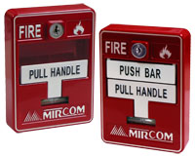The first type of automated sensor used in commercial buildings was the thermal detector. These units are usually set to go off when a room reaches a designated temperature. This temperature is commonly set between 135 and 165 degrees Fahrenheit. Temperature alarms also can go off rate of change of temperature instead of a preset temperature. These types of alarms go off when the temperature of a room heats up an abnormally fast rate. Thermal detectors can be highly reliable and resistant to false positive alarms. The temperature of a room rarely heats up to a high temperature or heats up at a abnormally fast rate if there is not an emergency present in the room. These alarms do have a major downside however. Since these alarms do not function until a certain heat condition has been reaches, this provides for the opportunity of a lot of damage to the room before the sensor goes off.

Figure : Manual Pull Alarm

The second type of automated sensor used in commercial buildings is the smoke detector. These devices are effective because they are designed to detect smoke which usually occurs in the early stages of a fire emergency. Most of these devices use a type of light sensing system that detects if there is smoke by sensing the disruption in a light beam caused by smoke. Smoke alarms are usually installed in the same manner as thermal detectors. They are usually installed either on ceilings or high on walls in hallways. Because of a smoke detectors ability to detect a fire in its early stages, they can allow enough time for fire emergency personnel and response teams to reach a fire emergency in a timely manner. This can help to prevent damage to the building as well as help to get occupants out of the building before it is too late. For this reason, they are usually preferred over thermal detectors when choosing between the two systems. There does exist downsides to smoke detectors, however. They are usually more expensive to install in high quantities throughout an entire building. When it comes to fire safety, however, cost should take a back seat to people’s lives. The other disadvantage to smoke detectors is that they are prone to false positives. They can go off because of a simple cigarette or burned food when cooking. A professional installer should be able to install these devices to limit the chance of false readings.

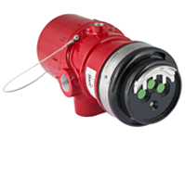The last type of automated sensor that is used in commercial installations of fire alarm systems is the flame detector. Just how the thermal sensor imitates the sense of touch and the smoke detector imitates the sense of smell, the flame detector imitates a person’s sense of sight. These devices use line of sight to detect flames and operate on either infrared or ultraviolet signals. These devices look for a high level of radiant energy and alerts a fire alarm panel of an emergency. These devices are very reliable as there are very few things that could produce the radiant energy of a fire without there actually being a fire. These devices are usually installed in high priority manufacturing environments. The major disadvantage to these systems is that they can be very expensive to install and labor intensive to keep operating at top efficiency. Another major disadvantage is that they must be looking directly at the place where a fire will occur. For these reasons, flame detectors are generally relegated strictly to manufacturing environments where corporations need the high-quality systems in areas where fires can be expected.

Figure : X3302 Multispectrum Infrared Hydrogen Flame Detector from Det-Tronics

#### 3.1.1.3 Output Devices for Fire Alarm Systems

After the actual emergency detection devices, the other devices that are connected to the control panel and fire alarm system are the output devices. These include any alarms, buzzers and alerts that are connected to the system. The primary goal for these devices are to alert the occupants of a building when an emergency takes place to exit the building.

The most common type of sounding device available for these systems are bells. These are suitable for most building types and configurations. Horns are used when a loud signal is especially important. These would be used in buildings were concealing the device or placing it in a faraway location is necessary such as those that are architecturally sensitive. Chimes are a quieter version of sound output devices. These devices are used where a soft tone is needed such as hospitals, old age homes, and theaters. The last type of sound output device are speakers. These are used in complex buildings that may be multistory. Speakers are especially important for building that have a complex evacuation procedure or may need phased stages of evacuation. Speakers output a voice signal that tell occupants exactly what they need to do. They could also be used to relay emergency PA announcements to occupants such as weather alerts or dangerous outside situations.

Another category for output devices that are part of the fire detection systems used today are visual alerting systems. These types of devices are necessary for buildings that have loud ambient sounds that could muffle or overtake the sound of audio alarms provided by the system. These would be especially useful in buildings such as factories or manufacturing plants with loud machinery. Devices that can be considered visual alerting systems would include strobe lights and flashing signals. Visual alerting systems are also especially useful in buildings that would have occupants who could be hearing impaired such as hospitals and old age homes. Many government operated buildings are also mandated to include visual devices such as these.

Emergency response notifications are another type of output device that was especially useful. The most common application for these type of devices is an telephone signal that automatically alerts emergency response centers in the area such as 911. These centers would that contact the appropriate department such as the fire department, paramedics, and police. These devices could also be used to contact private monitoring centers that are part of the company that is using the fire detecting system. Many operations such as theme parks have in house emergency management teams meant to respond to alerts like this before public authorities are able to respond.

The last type of output signal for fire detection systems that the control panel would be connected to are specifically designed systems to shut down power and electrical equipment throughout a building. These types of systems are used to mitigate further damage and danger caused by fire spreading to expensive and sometimes dangerous systems. These systems could also turn on fans used for migrating smoke throughout the building as well as keeping it in other parts. Included in the above type of output system would be fire sprinklers. Water is the obvious first response to putting out fire emergencies so it has become a logical standard for most commercial systems. These systems directly apply water to burning areas causing the cooling process to start. While these systems often do not completely put out a fire, they are extremely important in mitigating damage and preventing fires from spreading to other areas of the building. A properly installed system would detect a fire emergency and set off the sprinkler alarms within minutes of a fire emergency starting. These types of systems are most useful within the early stages of a fire when they are easy to control and contained within a small area. These types of devices are critical for keeping a fire contained until official fire response teams arrive to take care of the emergency. They are also especially important during times of low occupancy where people are not present to help put out the fire.

Another reason why these types of devices have become a staple in commercial fire alarm systems is that because a building without this type of system has a higher chance of large damage, insurance companies often offer lower premiums to companies who install this system. Most types of sprinkler systems come with the thermal detection and alarms built in to reduce the complexity of installation of the system. An effective fire detection would reduce the amount of separate electrical controlled devices as this would increase the amount of electrical wires flowing through a building that could cause increased damage in a fire emergency.

The fire detection for these types of devices usually include a type of seal that melts due to high heats. As fires heat up the room, the seals covering the sprinkler systems start to release opening up the water valves in a similar way to just turning on a hose. Most situations only require two sprinklers to contain a fire emergency but in areas that have a high change of chemical emergencies, a much higher amount of sprinklers are necessary. The major downside to a fire sprinkler system is that they can be very expensive to install within a building. They require water piping systems to go through every room where they are to be installed. This is extremely expensive to install in building that are already erected. Because of this, they are usually installed during construction of the building itself. There have been many advancements to these types of systems over the years. In addition to implementing the fire detection and alarms right into the sprinklers themselves, these systems have also been able to detect when the fire has been put out and turn themselves off. These systems use the same thermal sensors that detect the emergency in the first place to detect when the temperature has cooled to a safe temperature. [1]

### 3.1.2 Conventional and Addressable Fire Alarm Systems

Fire alarm systems can be broken into two main categories. These are the original conventional systems and the modern addressable systems. Both of these systems include heat detectors, manual pull stations, smoke detectors and output alarms. The main differences occur in how the control panels receiver data and control these systems.

Prior to the twenty first century, the conventional system was the standard fire alarm system used in commercial building designs. The way these systems are designed is that each common area and floor will be organized into a large zone. Each zone is connected to one common circuit which is connected to the control panel for that zone. Along each circuit there will be many thermal sensors, smoke detectors, pull alarms and fire sensors. These devices would be placed strategically according to a variety of factors such as the type of anticipated emergency and how fast of a response is needed.

#### 3.1.2.1 Conventional System Diagram

When an emergency occurs, one or more of the detectors and sensors will operate and essentially close the circuit. The control panel for the system will recognize that the circuit has been closed which would mean an emergency has taken place. All of the output devices for this system will be connected to their own circuit separate from the input devices. When the control panel detects that an emergency has occurred, the control panel will activate the output devices. This turns on all of the sound alarms for the building and call any emergency services.

There is a major downside to this type of system. Because each input device is connected to the same circuit, there is no way of knowing which input device actually detected an emergency. The control panel only knows that an emergency is taking place within its “zone.” This also is the case for monitoring the status of the system. In order to check that the system is functioning in top condition, the control panel would send a small current through the wires of the circuit. Should there be an issue with the system, such as a break in wiring, the current would not be able to proceed throughout the circuit. This would tell the control panel that there is an issue. The control panel would know that maintenance needs to be performed but there is no way of knowing exactly where. Because of the way the components are arranges, these systems are actually monitoring and controlling entire zones and not individual areas or devices.

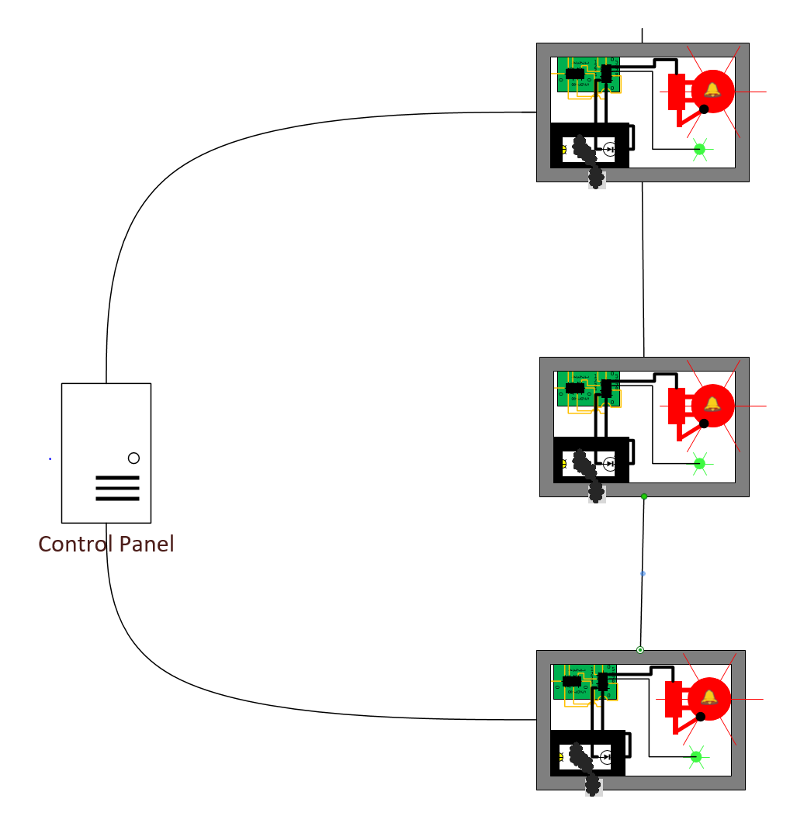

Figure : Control System Diagram

There is one major advantage to conventional fire alarm systems, however. For small or intermediate sized buildings, these systems are easy to set up, configure, and install. Because they are just simple circuits, maintenance does not require a large amount of experience. This works in the opposite way for very large areas as they require a large amount of wiring to monitor the input devices.

Conventional systems do require a large amount of personnel maintenance, however. Each input device requires its own manual test in order to verify that it is in good working condition. Smoke detectors, for example, need to be checked and cleaned every now and again. With the conventional system, there is no way of easily knowing which smoke detectors need maintenance and which don’t. Therefor maintenance working need to go through and check every smoke detector during a maintenance check.

Addressable systems are the evolution and improvement of conventional systems. They are the state-of-the-art system used in today’s commercial building designs for emergency detection. The main difference between these systems and conventional systems is that these systems have the ability to control and track each device connected to the system. This is in contrast to conventional systems where each device is connected to the same circuit with the control panel only having control and tracking of an entire zone.

#### 3.1.2.2 Addressable System Diagram

For the addressable system, each input and output device has its’ own microprocessor. This microprocessor tracks and controls the individual device that it is connected to. The microprocessors then send and receive signals from the control panel. This is the type of system that is going to be used for our design of the Smart Fire Alarm System. Each fire alarm for our project contains the ATmega 328 microprocessor.

Just like the conventional system, the addressable system also uses one circuit that goes throughout the entire building. Also just like the conventional system, one or more of these input devices may be connected to this single circuit. The big difference here is that for the addressable system, the way in which these devices are monitored is much different. In a normal addressable system, each input and output device is given its own “address” which is used to identify each device. These addresses are then programmed into the memory of the control panel along with information including the type of device that this address corresponds to, where the device is located, and details like when these devices should be checked for input or signaled for output.

For addressable systems, the control panel sends out a signal to each circuit that it is connected to. The devices also send out a signal back to the control panel. This allows for constant monitoring of each device. Every few seconds the control panel will receive an update from each device as to its status which will allow rapid response when an emergency occurs. Because of the addresses and locations, the control panel will also know which device is going off.

The control panel for this system also constantly monitors the condition of the devices connected to each circuit. This brings major improvements to maintenance for the system. Since each device has its own address and location stored in the control panel, the system can not only know when a fault occurs, but also where a fault occurs. This makes the job of the maintenance worker much easier. The maintenance worker now does not need to evaluate each and every device in order to provide maintenance to the system. The control panel can tell the maintenance worker exactly which device needs to be worked on. This allows for quicker and cheaper repairs for both the maintenance worker and the owner of the system.

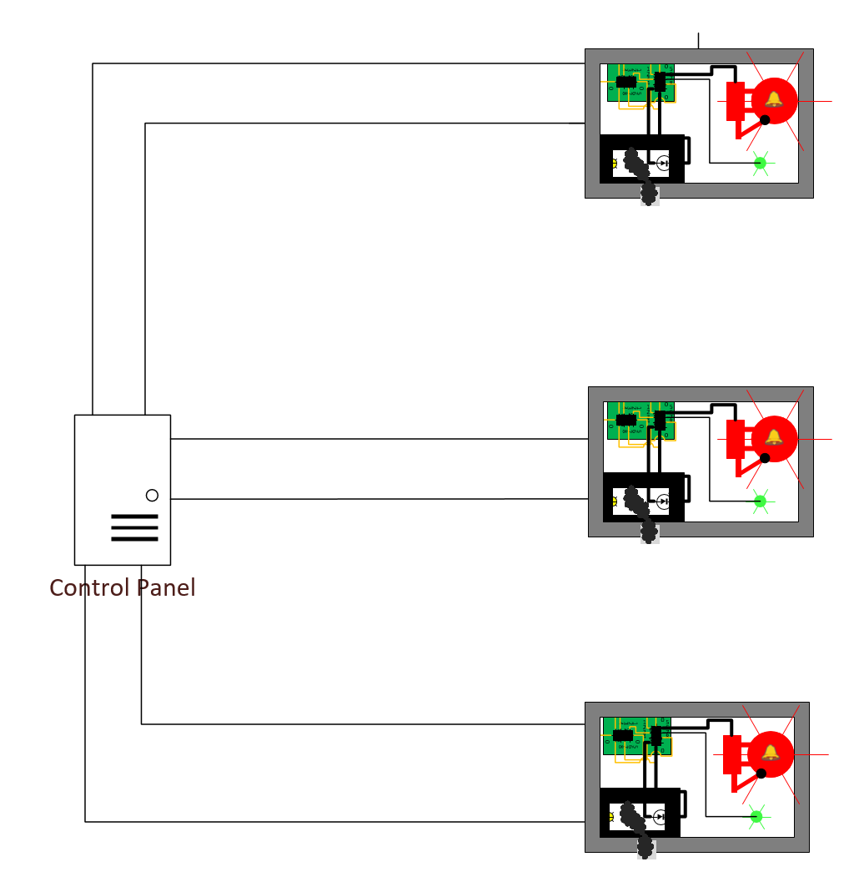

Figure : Addressable System Diagram

Addressable systems also provide a much easier process for modifying the system and adding or removing components. For addressable systems it’s as easy as setting up the individual device and then configuring the control panel’s memory. The installer only needs to go to a computer connected to the control panel and insert information such as the address, location, and type of device into the system. For a conventional system, the maintenance worker has to work with the wiring of the circuit and edit electrical configurations. This is much more work than for the addressable system.

The one major disadvantage for the addressable systems, however, is that each system is a custom design. Each system has its own unique characteristics for how the memory and control panel does calculations and stores information in memory. This requires specially trained technicians who have knowledge in the exact configuration that is being used. While this may be a major disadvantage, it is greatly outweighed by the advantages that using a addressable system provides.

## 3.2 Smoke Detecting Sensors

The two most commonly used types of sensors for used in domestic and commercial smoke detectors are Photoelectric Smoke Detection Sensors and Ionization Detection Sensors. These sensors may be used individually in commercially sold smoke detectors, used in combination with each other, and also in combination with Carbon Monoxide/Gas Sensors or Heat Sensors.

### 3.2.1 Photoelectric Sensors

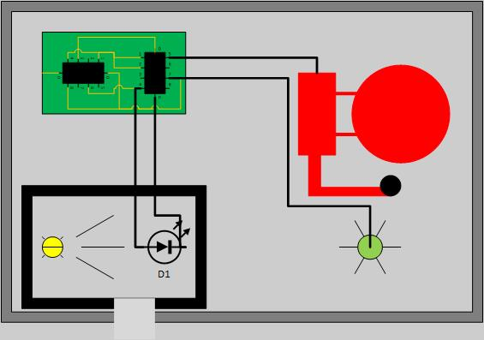 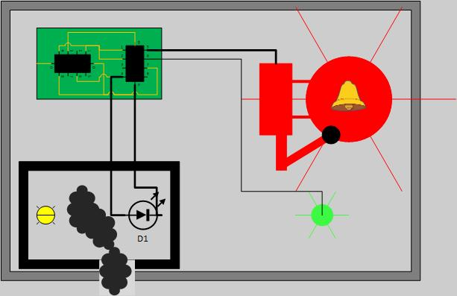

Figure : Photoelectric Sensor - No Smoke Present (left), Smoke Present (right)

The Photoelectric Sensor, is often considered to work as an “eye” due to the nature of how it detects smoke. The sensor typically consists of a using a light source that emits infra-red light, an LED is commonly used, a lens for directing the light and a photoelectric receiver, such as a photodiode, that is the target of the infra-red light. These are placed in a chamber that is open to the air, and when smoke is present, will be filled with smoke particles. Smoke particles will cause the light to scatter and affect the amount of light that comes in contact with the photoelectric receiver. This will then result in a drop in current across this sensor, which is sensed by the circuit attached and the alarm is activated accordingly. This type of sensor is typically placed on or near the ceiling of a room, as smoke tends to rise and this allows for a better reaction time in case of a fire. This alarm is also less sensitive to false alarms that result from minor smoke from candles, steam or cooking. This type of sensor is also known to react more quickly to smoldering fires, as these fires tend to produce larger combustion particles that interact well with the sensor, however it still has a good detection time for flaming fires. [2]

### 3.2.2 Ionization Sensors

The Ionization Sensor is considered a cheaper alternative to using a Photoelectric Sensor. Like a Photoelectric Sensor it can also sense smoke particles in the air that are generally not big enough to see with the naked eye. This sensor is comprised of two ionization chambers that create a current using the potential difference across two electrodes contained inside. A reference chamber has no particle entry while the other chamber is open to the air and would potentially allow for smoke particles to enter. Both chambers contain a small amount of Americium-241, a radioactive material that emits “alpha particles” which result in positively charged ions and negatively charged electrons when they collide with air particles. The electric charge of the ions creates a potential difference across the pair of electrodes and allows a current to flow across the sensor. The expected current should be the same in both chambers, as they are both facing identical conditions including air pressure, temperature and aging of the Americium. If any smoke particles enter the test chamber, ions will begin attaching to those particles and the current will not be carried across the chamber. Thus, the circuit attached will detect the current difference between the test and reference chambers and activate the alarm [3]. Once this smoke clears, the ions will begin to flow between the electrodes again and current should return to the reference level. The current draw of an Ionization Sensor is low, therefore a small battery is sufficient for powering this circuit long term. Ionization Sensors are known to quickly detect small amounts of smoke, generally produced by flaming fires fueled by paper and flammable liquids and thus is prone to false alarms. [4]

### 3.2.3 Carbon Monoxide/Gas Sensors

Carbon Monoxide Sensors are generally intended to sense deadly levels of carbon monoxide, and alert those present, usually sleeping, of the presence of the gas, so that they may escape or clear the air. These tend to respond to all scenarios of fires, and has a faster response time for flaming fires in comparison to smoldering fires, however it greatly increases response time for smoldering fires when compared to both smoke sensors. This would be ideal if used in combination with the Photoelectric or Ionization sensor, however not essential or entirely reliable as a sole sensor, due to not all fires producing large amounts of carbon monoxide [2].

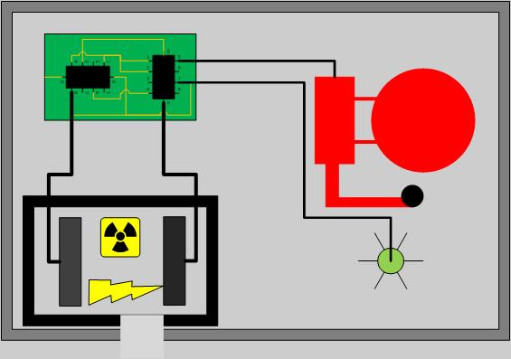 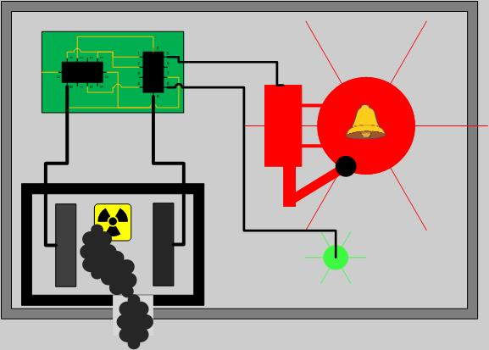

Figure : Ionization Sensors - No Smoke Present (left), Smoke Present (right)

Gas sensor modules have a steel exoskeleton for protecting the sensing element, which has current running through leads that connect, known as the heating current. Gases coming close to the sensing element are ionized and absorbed by the sensing element. This results in a change in the resistance of the sensing element and thus a different current value stemming from the sensing element. The steel mesh around the sensor is designed so that suspended particles are filtered and only gases pass into the sensor [5].

### 3.2.4 Heat Sensors

Heat sensors feature a detecting element, such as thermistors, that activate when a predetermined temperature or a previously specified temperature increase occurs in the sensor [6]. The best applications for using these sensors are “small confined spaces where rapidly burning, high heat fires are expected” [6]. These tend to have low false alarm rates, however due to the slow detection time for both smoldering and flaming fires [2] it is not very effective in residential fires.

### 3.2.5 Dual Sensor Technology

Commercially sold smoke alarms may also contain a dual sensor technology, that while it may be more expensive, the use of both photoelectric and ionization sensors allows for a functionality that quickly detects flaming and smoldering fires. However, the IAFF announced at their 2008 conference that they officially recommend photoelectric sensor alarms and stating dual sensors are no longer acceptable as the technology in ionization sensors tends to lead to a delay in sensing smoldering fires, in addition to having difficulties to high airflow environment, which would lead to an even greater delay [7]. The Ionization sensor’s susceptibility to false alarms is also problematic when creating a smoke detector and alarm system that the users can trust.

### 3.2.6 Conclusion

Due to the recommendation by the IAFF of using solely Photoelectric Sensors in a smoke alarm due to its fast response time to smoldering, over using Ionization Sensors or dual sensors, as well as the common use of Photoelectric sensors in public areas fit for large domains and the sensors simplicity, the Photoelectric Sensor will be implemented in the S.M.A.R.T Alarm system. Ionization Sensors may provide the fastest response time for more noticeable flaming fires, but the average response time of a Photoelectric Sensor is comparable according to the NIST study [2]. The use of Carbon Monoxide sensors could also be implemented, as it may increase response time for smoldering fires, the use of a Photoelectric Sensor is sufficient for targeting this type of fire, however for testing purposes it would remove the necessity of creating fires that result in smoke, which pose several risks and inconveniences during the testing phase. Heat sensors will also not be implemented in the S.M.A.R.T. Alarm due to slow detection time, it would not add much to the system while increasing cost.

## 3.3 Assessing Fire Detection Options

As far as detecting fire and smoke there are several technologies and methods discussed in the previous section, this section will focus on the design aspect of some of the better technologies so that a comparison can be made and a component may be chose for detecting fire in the S.M.A.R.T. Alarm system.

### 3.3.1 Smoke Chamber Design

The S.M.A.R.T. Alarm system employs the use of Photoelectric Sensors to detect smoke. The use of these sensors requires the design and implementation of a “Smoke Chamber” that serves as a chamber where the ambient air can enter, and thus if smoke is present it may enter as well. The most effective way to place the smoke chamber would be to have any perforation on the underside of the alarm, so that the smoke can rise into the chamber while also avoiding any light that may come from windows or the ceiling from entering the chamber. The Smoke Chamber will have two main components: an infrared or ultraviolet light emitting diode (LED) as a source and a photodiode to act as a receiver. The LED is emitting light continuously at the photodiode, and as long as the photodiode is receiving this light a current is produced, therefore if this light is interrupted then the current will stop. A lack of current stemming from the photodiode will serve as a marker for the system that smoke is present and the alarm should sound. The smoke chamber should contain as little outside light as possible, so that the outside light does not interfere with the photodiode, while allowing enough air flow for smoke to enter the chamber if present. In fact, the design of the Smoke Chamber as a Photoelectric Sensor should serve as a black box, with an input to power the LED and an output from the photodiode, so that the Alarm circuit can measure to determine the presence of smoke.

### 3.3.2 Infrared LED

Infrared radiation is a type of electromagnetic radiation that is often referred to as infrared light. Discovered in 1800 by Sir William Herschel, infrared radiation is invisible to the human eye however heat stemming from infrared can still be felt by touch, extending just past the red edge on the visible spectrum. Infrared radiation is classified as falling between the wavelengths of 0.75 um to 1mm. The IR LED used for measuring smoke presence in the Smoke Chamber serves as a low power option for transmitting the IR light meant to be received by the photodiode. This component must also provide the ability to emit the light normal to sensor, to avoid wear and tear that is associated with bending the leads of the component. The wavelength of the light transmitted should also match the wavelength of peak sensitivity for the photodiode, to ensure that the sensor will work.

### 3.3.3 Photodiode

A photodiode is a semiconductor component designed to operate in reverse bias, that generates current when light is sensed and its photons are absorbed. However, it may also produce small amounts of current while there are no photons present. Generally, the response time of a photodiode decreases as the surface area increases in size. The most common photodiode is the solar cell, which employs its properties to convert sun light into electric current for common use. Photodiodes are not much different than regular semiconductor diodes, aside from being exposed to detect light or being designed with an optical fiber so that light to reaches the sensitive part of the component [8].

The photodiode is a p-n junction, and when a photon with enough energy reaches the diode, an electron-hole pair is created, this is often referred to as the inner photoelectric effect. In case that the absorption occurs in the depletion region of the junction, the built-in electric field of the depletion region sweeps the carriers from the junction, and the electron-holes move toward the anode while the electrons move toward the cathode, creating a photocurrent. The total current of the photodiode is made up of the sum of the photocurrent and the dark current, the current that’s generated when the photodiode is not exposed to light. Therefore, to maximize the sensitivity of the device, the dark current must be minimized [9]. Photodiodes are often operated in photoconductive mode, in which the diode will be reverse biased, resulting in a reduced response time as the width of the depletion layer is increased by the additional reverse bias, thus decreasing the capacitance of the p-n junction. The reverse bias will also increase dark current while minimally affecting the change in the photocurrent [10].

However, when analyzing the viability of testing our system using a photoelectric sensor in a closed environment, we would have to create enough smoke each time we want to test the system. While this is possible, we would like to avoid the risk of creating an actual fire by burning components that would produce smoke as well as avoiding setting off the actual smoke and fire alarms in the building we are testing in. Performing tests outdoors is not very viable as there will be little control over weather and wind conditions, as well as limited access to lab materials for making any changes or fixing components of the system. Another possible roadblock is the burden of creating a working smoke detecting sensor, as this may take away from the true purpose of the project if implemented incorrectly or with error. This purpose of the project being creating a system for enhanced evacuation in the event of a fire, not creating a smoke detector. A carbon monoxide detector provides the most reliable sensor without having to create an actual fire with smoke in a lab setting.

### 3.3.4 MQ-2 Sensor

This sensor has the ability to detect several types of gases: Hydrogen, Liquified Petroleum Gas, Carbon Monoxide, Alcohol, Smoke and Propane. The type of gas detected is transmitted by the analog output of the sensor as a certain range of values for each gas, it however cannot detect more than one gas at a time. This requires the sensor to be calibrated to detect a certain gas, in the case of this project the gas would be smoke. The MQ-2 Sensor has a standard input voltage of 5.0 V +/- 0.1 V, with an adjustable load resistance. The ideal operation temperature is 20°C +/- 2°C, with an ideal “preheat time” of 48 hours. Following this combustible gas and smoke will be easily and accurately detected for 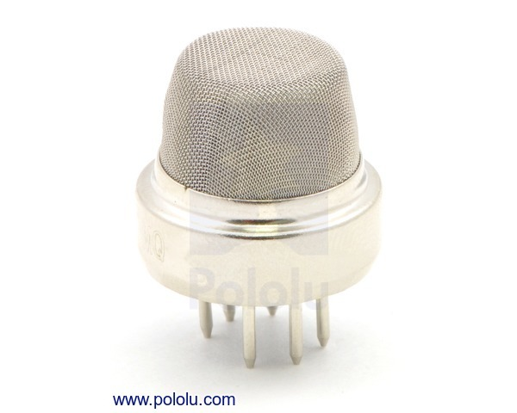concentrations in the rate 300 to 10,000 ppm. The quick detection by the sensor coupled with the simplicity of implementation and use make this sensor the best option for this project, however for future projects the implementation of a photoelectric sensor would be recommended.

Figure : MQ-2 Flammable Gas & Smoke Sensor (printed with permission of Polulu.com)

## 3.4 Fire Alarm Batteries

The battery that would be best for this SMART fire alarm system would be a 9V 1200mAh Lithium battery. The Ultra life 9V Lithium Battery is the perfect battery for low drain devices. Also, this battery has a long duration of shelf life at about 10 years, which is great for the fire alarm system. A long shelf life would help the fire alarm system be more reliable, and it will also require less maintenance. There are different types of batteries that we could use, alkaline or lithium batteries. As stated before, we chose to go with a lithium battery rather than an alkaline battery. When comparing the two different types of batteries we and see the difference between the two, and how we came to make this decision.

### 3.4.1 Shelf-life

When it comes to shelf life, we chose to go with the lithium battery because lithium batteries can last much longer than an alkaline battery can. As mentioned above a longer shelf live requires less maintenance to be done with the smoke detectors, other than routine checks to make sure that everything is up to code. Therefore, requiring less maintenance allows the customer to not have to change the battery so often.

### 3.4.2 Performance

Lithium batteries work well with devices that are low drain and high drain, whereas alkaline batteries don’t perform well with high drain devices, unless they are a special premium alkaline battery. Alkaline batteries are good batteries, just not for a smoke detector, a major problem with these types of batteries is that they are susceptible to self-discharging. This leakage could damage the device which could cause the smoke detector to malfunction and not go off which would endanger a lot of people. Lithium batteries are said to last about 7x to 8x longer than alkaline batteries. Also, it is mentioned that lithium batteries can withstand lower or higher temperatures depending on the environment that batteries are placed in. Opposed to alkaline batteries that can’t perform in those types of environments.

### 3.4.3 Cost

The upside that we found with the alkaline batteries is that they are very low cost, compared to lithium batteries, and you can get them in bundles for cheap as well. Lithium batteries are usually at least twice the amount of alkaline batteries. However, even though the lithium batteries are more expensive the quality of them are better and they outperform and outlast most other batteries. So, spending the extra money to purchase these types of batteries would be worth it so we could provide our customers with the best quality product.

### 3.4.4 Power and Capacity

Lithium batteries usually produce twice as much voltage as alkaline batteries produce, which allows them to outlast and have a longer shelf life as alkaline batteries. As mentioned above the Ultra life 9V lithium battery that we chose will have a max capacity rate of 1200mAh. Most alkaline 9V batteries don’t produce a max capacity rate of 1200mAh. Most of the alkaline batteries, besides the special premium types, produce around a max of 800mAh. With the lithium battery having a higher capacity rating than the alkaline battery this proves that the lithium battery will deliver a longer performance than the alkaline battery, which is what we want to provide a best quality product.

### 3.4.5 Two sources of power vs. UPS

Per the National Fire Alarm and Signaling Code a fire alarm system is required to have either a primary and secondary source of power or a single UPS, which is an Uninterruptable Power Supply. *“This requirement is to ensure that communications equipment will operate for the same period of time on the secondary power as the alarm control” – NFPA 72, A.26.6.3.1.12.* To be in accordance with the national code when having two sources of power the requirement is that the primary source has to be supplied by a dedicated branch circuit. However, that dedicated branch circuit doesn’t just have to be for servicing that one power supply it can also service multiple power supplies within a single control unit or multiple control units. The main purpose for this requirement is just to make sure that no other system is connected powered from that branch circuit. With a two-source power supply you can have batteries as a secondary source of power only, or you can have batteries as the primary source and have a backup generator as the secondary source of power. Although using two sources of power is still used the National Fire Protection Association (NFPA) has been pushing more to update them to an Uninterruptable Power Supply (UPS).

The purpose of a UPS system is to supply continuous power to the fire alarm system without having any interruptions when the primary power is off and the system is waiting for it to be restored, or until the backup power is online. There are two main types of UPS system, there is an offline UPS and an on-line UPS. Figures 1 and 2 below show both the block diagrams of the offline and online UPS systems.

Figure 1 shows how the offline uninterruptable power supply works. The initial path that is used to power the system is driven by an AC power source. An AC sensor is placed near the end of the path, and it is used as a function to switch between the two power sources when it senses that the primary power path has been interrupted. Once the system switches between the power sources, since the charged batteries are the secondary source of power within this system they will then be used to supply the power to the system until the primary source is back up and running.

Figure 2 shows how the online uninterruptable power supply works. With this type of UPS system, the initial path that is used to power the system is driven by a battery that is being charged as a primary power source for the system. At the end of this primary path a DC to AC inverter is implemented, and AC sensor is placed near the end of that path. As mentioned before it is used as a function to switch between the two power sources when it senses that the primary power path has been interrupted. For this type of online system since the charged batteries are the integral part of this type of UPS system and is the primary source of power within this system, the switching between the two paths is different from the switch in the offline UPS system. The ideal aspect about the online UPS system is that since it’s ran on batteries and a charger during the normal operation of the system, it can also still operate during a power outage simple because it is running off batteries and will only stop if there was failure within the pathway somehow. The only way the AC sensor will switch is if 1 out of the 3 things happen. 1.) The charger for the battery fails, 2.) The battery itself fails/dies, or 3.) The DC to AC invertor fails to work. Once one of these failures happen the sensor will switch to the secondary power source path, and it will be used to supply the power to the system until the primary source is back up and running. **C-11**

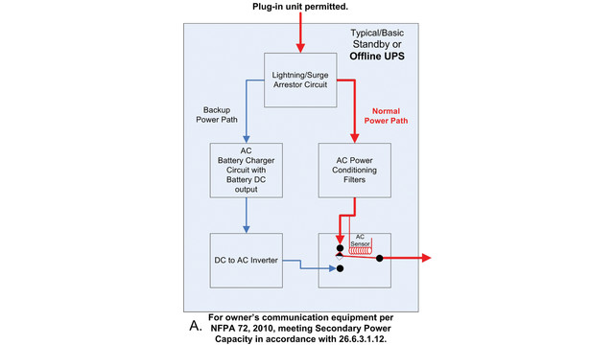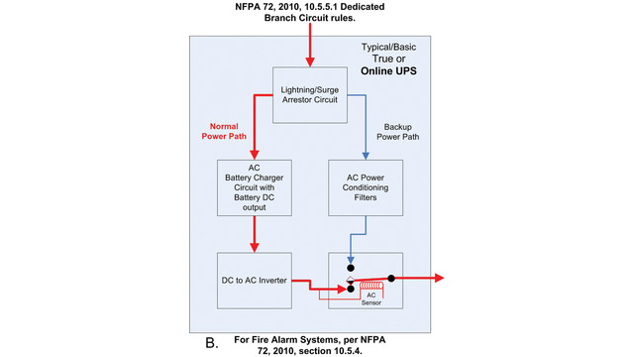

Figure : Offline Uninterruptable Power Supply (left), Online Uninterruptable Power Supply (right)

The uninterruptable power supply systems, especially the online UPS system, is very ideal for our type of alarm system we are creating. Because it would provide the security that our product will perform properly even in an incident; for example, a power outage, and still having a system still running. Considering the two different types of methods of supplying power we could us we will be using two sources of power; the primary will be an AC power supply and the 9V battery mentioned above will be the secondary source we will be using.

## 3.5 Fire Alarm Sound and Signaling

Per the National Fire Protection Association (NFPA 72) code, the audibility of the alarm varies depending on the type of environment the alarm system is in. For a public place the minimum audibility of the alarm must be 15dBA above the average ambient sound level, and for a private place the alarm cannot be less than 10dBA above the average ambient sound level. This is just one type of requirement for the audibility. Another one that pertains to both of the types of places is that the minimum requirement of sound from the alarm must be 5dBA above the max sound barrier with a duration of at least 60 seconds. Also, stated within the NFPA 72 code is that the maximum output audible sound the fire alarm system can have is 110dBA. This output is based upon the minimum hearing distance.

|  |  |  |
| --- | --- | --- |
| **Locations** | **Average Ambient Noise Level (dBA)** | **Minimum Required for SPL (dBA) per Location** |
| **Business offices** | 55 | 70 |
| **Industrial occupancies** | 80 | 95 |
| **Institutional occupancies** | 50 | 65 |
| **Mechanical rooms** | 85 | 100 |
| **Places of assembly** | 55 | 70 |
| **Residential places** | 35 | 50 |
| **Storage occupancies** | 30 | 45 |
| **Thoroughfares, high-density urban areas** | 70 | 85 |
| **Thoroughfares, moderate – density urban areas** | 55 | 70 |
| **Thoroughfares, rural and suburban areas** | 40 | 55 |
| **Underground structures and windowless buildings** | 40 | 55 |
| **Educational occupancies** | 45 | 60 |
| **Mercantile occupancies** | 40 | 55 |
| **Piers and water-surrounded structures** | 40 | 55 |
| **Tower occupancies** | 35 | 50 |
| **Vehicles and vessels** | 50 | 65 |

Table : Average Ambient Noise Level and Minimum Required for SPL (This table is in accordance with NFPA 72) **C-3**

Based on the code requirements from the Nation Fire Protection Association, we could use this as reference guide in determining the type of component we will use for the fire alarm. As mentioned above the NFPA 72 code depending on the type of environment the system is in the audible sound level should either be 10dBA or 15dBA above the ambient noise level, or 5dBA for 60 seconds above the maximum level; with the alarm system being at a distance that is 5ft above the floor level. Table 1.1 shows the different locations; the average ambient noise level the minimum corresponding dBA level for an alarm system.

### 3.5.1 Sounders

When picking the type of sounders, we want to make sure we can reach a wide range of locations based off the min amount of audible sound. Per Chapter 18 of the NFPA 72 code the implementation of low frequency of 520 HZ must be used in in sleeping areas. So, to be able to comply with this code we wanted to make sure that we chose a sounder that would be able to work between a good range of frequencies that would cover both sleeping areas and normal occupancies. From this research, we came across many different types of sounders, but we narrowed it down 4 different types. Three are Piezo sounders and one is PUI programmable buzzer.

#### 3.5.1.1 PS1927P02 Piezo Sounder C-13

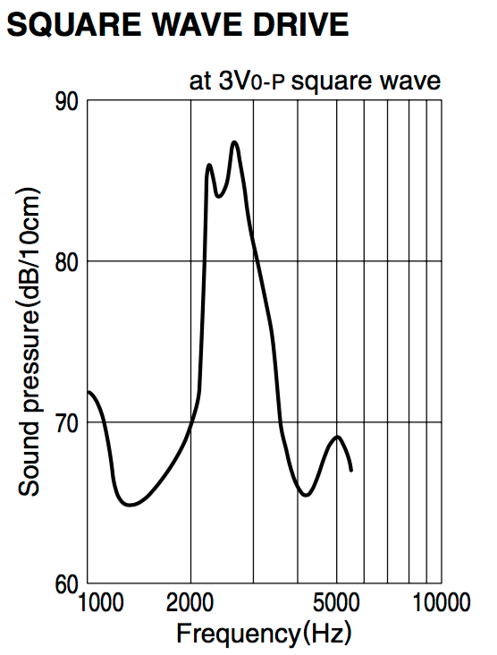

Table : Square Wave Drive for PS1927P02 Piezo Sounder.

This sounder is a high sound pressure buzzer with a maximum SPL at 90dBA/10cm min at 2.7 kHz, at 10Vp rectangular wave. This sounder has a maximum input voltage at 20Vp (without a DC bias). Table 2.1 shows a graph of the sound pressure corresponding to frequency.

We considered this Piezo buzzer because the sound pressure level was high enough to where it would work in different types location specified in table 1.1. Also, the cost of this buzzer was cheap and would work with the budget. However, the SPL was only high between 2kHz and 3.5kHz, where at lower and higher frequencies the SPL was lower. So, this type of sounder didn’t give us a wider range frequencies to work with than the other buzzer types.

#### 3.5.1.2 PS1920P02 Piezo Sounder C-13

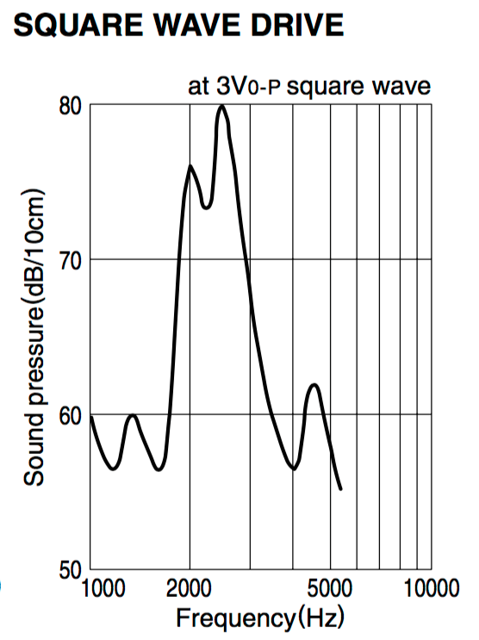

Table : Square Wave Drive for PS1920P02 Piezo Sounder

This sounder is a low frequency tone buzzer with a maximum SPL at 80dBA/10cm min at 2 kHz, at 10Vp rectangular wave. This sounder has a maximum input voltage at 20Vp (without a DC bias). Table 2.2 shows a graph of the sound pressure corresponding to frequency.

We considered this Piezo buzzer because the sound pressure level was high enough to where it would work in different types location specified in table 1.1. Also, the cost of this buzzer was cheap and would work with the budget. However, the SPL was only high between 2kHz and 3kHz. Also, this sounder had one of the lowest sound pressure level at the lower frequency than the other four sounders. As well as a low SPL at high frequencies. So, this type of buzzer didn’t give us a good range of frequency we could reach and still have a decent SPL that would work for different environments.

#### 3.5.1.3 PS1740P02E Piezo Sounder C-13

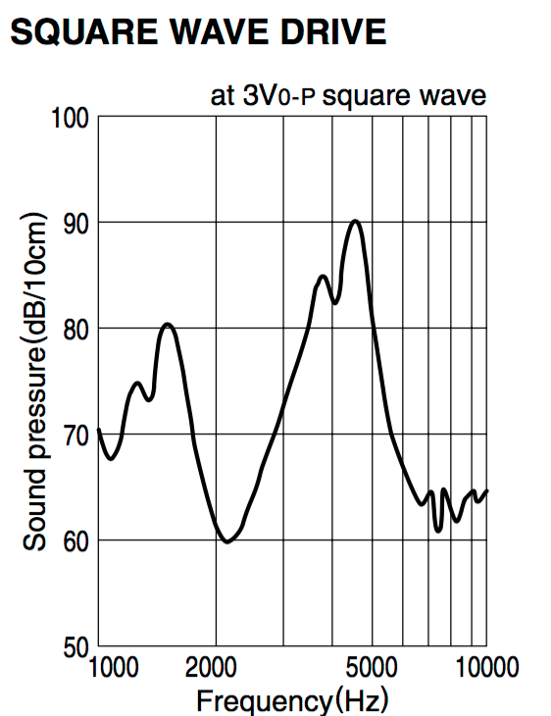

Table : Square Wave Drive for PS1740P02E Piezo Sounder

This sounder is a high sound pressure buzzer with a maximum SPL at 75dBA/10cm min at 4 kHz, at 3Vp rectangular wave. This sounder has a maximum input voltage at 30Vp (without a DC bias). Table 2.3 shows a graph of the sound pressure corresponding to frequency.

We chose this Piezo buzzer because the sound pressure level was high enough to where it would work in different types location specified in table 1.1. Also, the cost of this buzzer was cheap and would work with the budget. The frequency range that comes with this sounder is very broad which works well for this system. This sounder has a good sound pressure level with lower frequencies, which is good for private occupancies. As well as, a good sound pressure level with the higher frequency range that is good for public occupancies. Another reason as to why we chose this sounder is that the frequency gap where the SPL was really low was smaller between the other buzzers. So this sounder met a lot of specifications we needed so that is why we chose this one.

#### 3.5.1.4 12 VDC PUI Programmable Buzzer C-6

This sounder is a high sound pressure buzzer with a minimum SPL at 100 dBA/10cm min at 1 kHz. This sounder has an operating voltage ranging from 7 – 24 Vdc, as shown as in the table below. Table 2.4 shows a specification table of the programmable sounder.

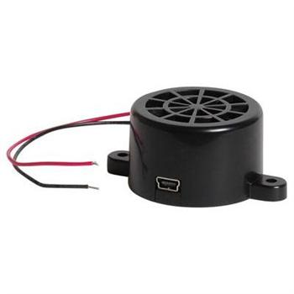We consider this 12Vdc PUI programmable buzzer because the sound pressure level was high enough to where it would work in different types location specified in table 1.1. However, the cost of this buzzer was a lot more expensive than the other buzzer that we were considering, so due to the cost it would increase our budget more than we wanted it to, because we would need to buy several of them for the fire alarm system. The great thing about this buzzer is that it’s adjustable so we would be able to change the different types of sounds that it makes, and we would be able to adjust the sound pressure level

Figure : 12 VDC PUI Programmable Buzzer

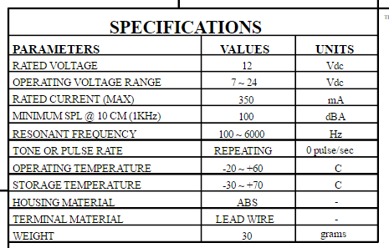

Table : Specifications for 12 VDC PUI Programmable Buzzer **C-2**

Even though the cost was high, the frequency range that comes with this sounder is very broad, as shown in the table above the resonant frequency range is from 100 Hz to 6 kHz; which works very well for this system. This sounder has a good sound pressure level with lower frequencies, and since it is adjustable it would work for private occupancies. As well as, a good sound pressure level with the higher frequency range that is good for public occupancies. So even though this sounder met a lot of specifications we needed, the cost and the SPL was a little bit too high for the use.

## 3.6 Wireless Communications

### 3.6.1 Overview

When it comes to wireless communication, there are many developments that have been made to the field in the past 20 years. Some of these developments include Wi-Fi (developed by the Wi-Fi Alliance, introduced in 1998), Bluetooth (introduced by Ericsson in 1994, developed by the Bluetooth Special Interest Group), and ZigBee (developed by ZigBee Alliance, introduced in 1998).

#### 3.6.1.1 Why use wireless communication?

Wireless communication allows multiple different devises to be connected over a wireless network. This allows devises to be self-contained without the inconvenience of communication wires. Moreover, if wires are required for communication, the system is very static. Wireless communication allows for a dynamic system that can grow and change as system requirements change.

The S.M.A.R.T Alarm system will rely heavily on wireless communication, transmitting sensor data to the central processing and direction data back to the alarms. S.M.A.R.T. Alarm is a dynamic system, have different configurations and alarm needs deepening on the building. Wireless communication is a core component of the S.M.A.R.T. Alarm system. The following section will provide information on the aforementioned wireless communication options and will discuss the feasibility of their inclusion in the S.M.A.R.T Alarm system.

### 3.6.2 Wireless Fidelity (Wi-Fi)

As the most commonly used form of wireless communication, Wi-Fi is used in nearly every household in the world. A Wi-Fi router covers an area, such as a household or business, with a blanket of Wi-Fi signal which allows any smart device to connect to the internet.

Introduced for commercial use in 1998, Wi-Fi is a Wireless Local Area Network (WLAN) that is based on the IEEE 802.11 standards. IEEE 802.11 is the radio frequency needed to transmit packets over radio links. These data packets are known as Ethernet frames, which have built-in error checking. This means that if a data packet is altered or destroyed before it reaches its destination, the packet will be resent until it is confirmed that it was received by its target. IEEE 802.11b and 802.11g use the 2.4 GHz industrial, scientific and medical (ISM) radio bands. Due to the choice of this frequency band, Wi-Fi devices occasionally experience interference by other RF devices and devices such as microwave ovens, cell phones, Bluetooth and ZigBee devices.

Spectrum assignments for the 2.4GHz band are not the same worldwide. For example, the U.S. only permits 11 channels for the 2.4GHz band to be operated without a license, whereas Australia and Europe allow two additional channels (12 and 13).  A Wi-Fi signal occupies five channels in the 2.4 GHz band, therefore it is only possible to have a group of three non-overlapping channels (Channels 1, 6 and 11) in the U.S.

All Wi-Fi certified devices will work with any Wi-Fi access point anywhere in the world, proved they can make it through the security checkpoints such as Wired Equivalent Privacy or WEP (which has been phased out due to weakness of security) or the more popular Wi-Fi Protected Access (WPA and WPA2) which requires a passcode for access to the network.

Wi-Fi range is dependent on the frequency band, radio power output, antenna type and gain as well as the technique used in modulation. A Wi-Fi access point that complies with either the 802.11b or 802.11g protocols, using a stock antenna, can get a range of about 100 meters (330ft). However, using multiple access points such as multiple routers, allow for network redundancy and higher ranges.

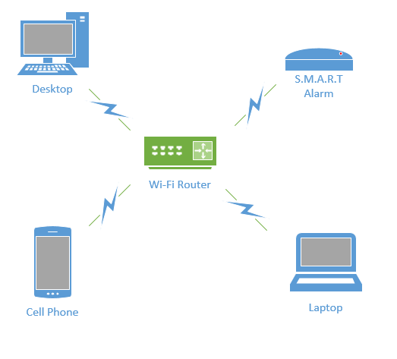

Figure : Wi-Fi Network

Overall, Wi-Fi would be an excellent form of wireless communication for the S.M.A.R.T Alarms, if not for the power consumption of transmitting and receiving Wi-Fi signals. Because the S.M.A.R.T Alarms will be powered by batteries as a backup power source, a more power efficient communication system may be desired.

### 3.6.3 Bluetooth

Bluetooth is a wireless communication technology used to transmit and receive data over short distances using short-wavelength UHF radio waves in the industrial, scientific and medical (ISM) bands (2.4 - 2.485 GHz). Most Bluetooth networks have a range of only about 10 meters (30 ft.) depending on signal strength and obstructions, classifying their networks as Personal Area Networks (PANs). The IEEE standardized Bluetooth as IEEE 802.15.1, but no longer maintains the standard.

Bluetooth has a master-slave structure and is a packet based protocol. One master may communicate with up to 7 slaves, all the slaves sharing the master's clock. Bluetooth uses a frequency-hopping spread spectrum radio technology to transmit the data packets over one of 79 designated Bluetooth channels. Each one of these channels have a bandwidth of 1 MHz, and it usually transmits at 800 hops per second. Security in a Bluetooth system is very weak compared to other wireless communication systems, only relying on a four-digit encryption, compared to the twelve-digit encryption you get from Wi-Fi securities. Due to the limited range (about 30 ft.) and lack of proper encryption, associated with Bluetooth transmission, it is not feasible to use Bluetooth in the S.M.A.R.T. Alarm systems.

### 3.6.4 Radio Frequency

Radio Frequency or RF is a very common form of wireless communication around the world. RF can be integrated into a system with relative ease due to the versatility of RF systems. RF signals can travel very long distances (at low frequencies) and can travel through many different mediums with relative ease (i.e. Water, Air, Solids, Space). Radio Frequency communication is widely use throughout the United States as well as the rest of the world and since RF can be transmitted at such a wide variety of frequencies, it is very strongly regulated. There is only a small range of frequencies that can be transmitted without needing a license or permission from the federal government.

Communication protocols like WIFI, Bluetooth and ZigBee all operate in the 2.4 GHz frequency range, an approved (unlicensed) ranged for transmission signals. If the S.M.A.R.T. Alarm were to use RF communications to transfer data packets, it would require the design of a proprietary protocol to modulate and demodulate the signal to work. Communication systems like WIFI and ZigBee already have these established protocols, making using them a for feasible form of wireless communication than RF.

### 3.6.5 ZigBee

ZigBee is an IEEE 802.15.4 based high level wireless communication system. ZigBee creates Personal Area Networks (PANs) with relatively small low power radios. Used mostly in home automation and other low-power low-bandwidth application, ZigBee communication is great for small scale projects that need wireless communication. ZigBee was designed to be simpler and less expensive than other wireless PANs, like Wi-Fi or Bluetooth. ZigBee is described as “a low power, inexpensive, wireless mesh network standard that is employed throughout many applications that utilize wireless sensor networking and control” [11].

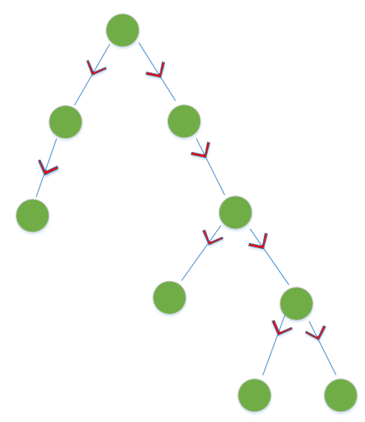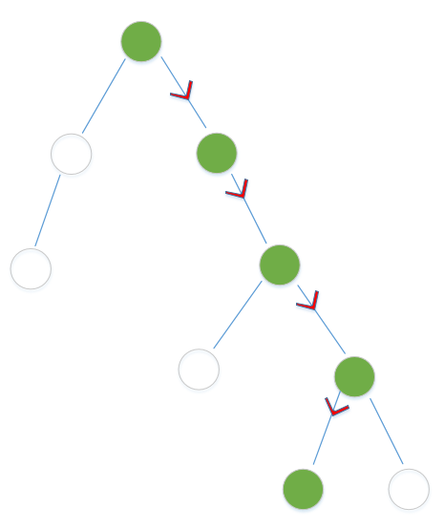Due to ZigBee’s low power consumption, it limits transmission ranges to about 10-100 meters line-of-sight depending on power output and environment. However, using a mesh network, data can be transferred from one device to another, allowing for an expansive range. A mesh network is a type of network that relies on relaying data from node to node. A mesh network can transfer this data by using either a flooding method or a routing method. The routing method propagates a message from one router node to the next, until it reaches its destination. Algorithms are used to ensure that the shortest transmission paths are used, continuously checking for path availability. If a node is damaged or unusable, the system will “self-heal” and adjust its data path to reach its end goal. Due to this dynamic routing, these types of systems are very reliable, prone to very few errors.

Figure : Routing Network Method (left), Flooding Network Method (right)

The flooding method is a process in which a data packet is sent out from a coordinator and sent through every outgoing node in the network. There are two types of flooding, uncontrolled and controlled flooding. Uncontrolled flooding is not a preferred method of networking because the neighboring nodes will send packets indefinitely, causing a broadcast storm. A broadcast storm consumes up a great deal of network resources, which can cause a system to be unable to further transfer data. However, controlled flooding utilizes two algorithms to make it a reliable networking solution. Each data packet in a controlled flood is labeled with an address and sequence number. Router nodes in the network keep track of the senders and sequence numbers it has received and only forwards packets that they have never seen before. Therefore, each of these router nodes may receive a packet more than once, but will only forward the packet one time. The network then utilizes Reverse Path Forwarding to notify the coordinator that the packet has been successfully sent to all routers in the network so it can stop transmission of that data packet [12].

The S.M.A.R.T. Alarm will utilize both routing and flooding transmission methods. It will use a routing method to send Smoke Alarm sensor data to the coordinator, using the fastest transmission path possible. Once the coordinator receives this data, it will do the necessary calculations and exit route mapping and send the alarm and direction packets out to all the alarms in the system using the controlled flooding technique. The combination of these two routing methods will ensure the S.M.A.R.T. Alarm works properly and efficiently in alerting the inhabitance of a building of a potential fire.

ZigBee operates in the ISM radio bands (2.4 GHz) with data transmission rates varying from 20 kbit/s for the 868 MHz band to 200 kbits/s at the 2.4 GHz band. ZigBee can support both star and tree networks, as well as generic mesh networking. Every ZigBee network must have one coordinating device which essentially creates the network environment, control over the network parameters and basic maintenance of the system. In a star network, the coordinating device must be the central node, in contact with all other devices. However, tree and mesh networks both allow use of ZigBee routers to extend communication at a network level.

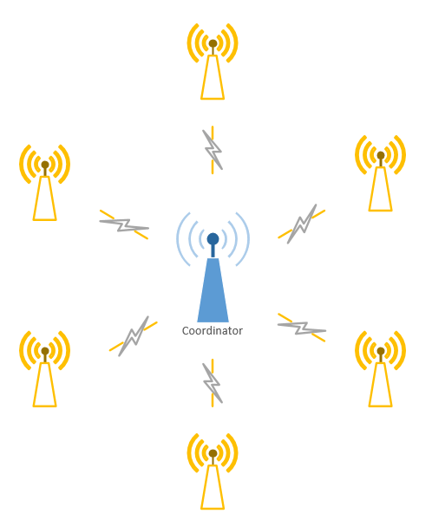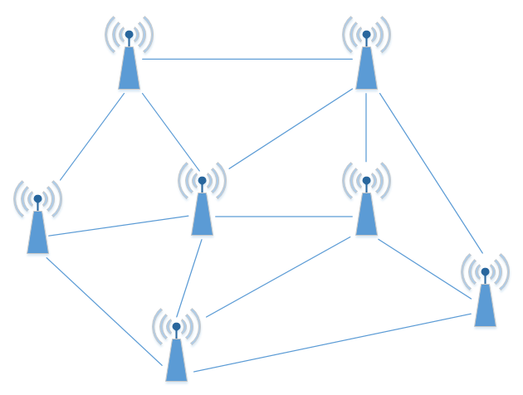

Figure : ZigBee Star Network (left), ZigBee Mesh Network (right)

ZigBee builds on IEEE 802.15.4 standards of physical layer and media access control for low rate PANs. There are four key components in addition to the set standards. Those additions are a network layer, application layer, manufacturer defined applications, and ZigBee device objects. These additions allow for customization and total integration of a system. ZigBee device objects or ZDOs are responsible for keeping track of device roles, managing network join requests as well as device discovery and security.

There are three kinds of ZigBee devices:

* ZigBee Coordinator - Described Above
* ZigBee Router - Runs applications as well as acting as intermediate router in a mesh or tree network. Requires less memory than Coordinator but more than End Device. Power consumption higher than that of End Device.
* ZigBee End Device - Has just enough functionality to communicate with parent node (Coordinator or Router). Cannot relay data from other devices. Gives the best battery life due to lack of need for communication and ability to enter sleep mode.

Software for ZigBee is designed to be easy to develop on small, inexpensive microprocessors, which will cut down on costs as well as time needed to set up the network. This is important when it comes to budgeting, as well as creating a product that is cost efficient and reasonably priced for a consumer.  Since ZigBee has very low power usage and low data rate (250 kbit/s), it is a great communication tool for battery powered devices. ZigBee also has a great security system (128-bit symmetric encryption keys). These factors make it best suited for occasional data transfers from sensors or input devices [13].

### 3.6.6 ZigBee Protocol

As previously mentioned, ZigBee communication uses the IEEE 802.15.4 protocol. IEEE 802.15.4 is one of the largest standards for low power, low data rate WPANs. IEEE 802.15.4 defines the Physical Layer (frequency, modulation, power and other wireless conditions) and Media Access Control Layer (format of data handling and data linking) of the Open System Interconnection (OSI). The 802.15.4 also uses two additional sublayers, Logical Link Control and Service Specific Convergence Sub-Layer, to allow communication with all upper OSI layers. These upper layers come from the ZigBee enhancement to the IEEE 802.15.4. ZigBee uses layers 3 and above to define additional communication features, such as encryption, data routing, authentication with valid nodes and forwarding capabilities (which allows for mesh networking). Due to this, ZigBee is the most popular wireless sensor for mesh networks [14]. These processes are done in either the Network, Transport, Session, Presentation or Application level of the ZigBee system.

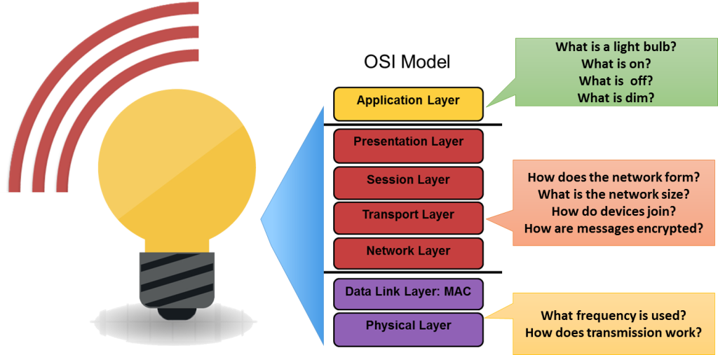

Figure : General OSI Model

Data is transferred in either a beacon or non-beacon network. In a beacon network, if the coordinator needs to transmit data to a device or group of devices, it first sends out a beacon signal that tells the devices that there is data ready to be transferred. The coordinator then waits for the device or devices to send a data request message meaning that it is ready to receive data. The coordinator acknowledges this message and begins to send the data to the device, the device can then send an optional acknowledgement message back to the coordinator to confirm the data was received. In a non-beacon network, the coordinator must wait for the reception of a data request from a device to send data. Once the data request is received by the coordinator, the process is the same as the beacon network. [15]

Error detection is a very important part of the ZigBee protocol. An error can occur in a ZigBee system when one or are received differently from the way they were sent [12]. There are two types of errors, bit and burst errors. A bit error occurs when the probability of error is the same for each bit, and a burst error occurs when the error probability is greater for bits near another error. In either case, and error is when for whatever reason, and bit or bits in a data packet are corrupt and flipping from 0 to 1 or 1 to 0. To detect and fix these types of errors, the ZigBee system makes use of three different techniques; Parity, Check-sums, and Cyclic Redundancy Checks (CRCs).

Parity is used to find a single bit error. A bit is added at the end of each frame such that the total number of bits an even parity or odd parity. These parities are checked again when data transfer is completed to see if a bit has been corrupted. This technique works in multiple detentions and is very useful for detecting single bit error as a simple form of Forward Error Correction (FEC).

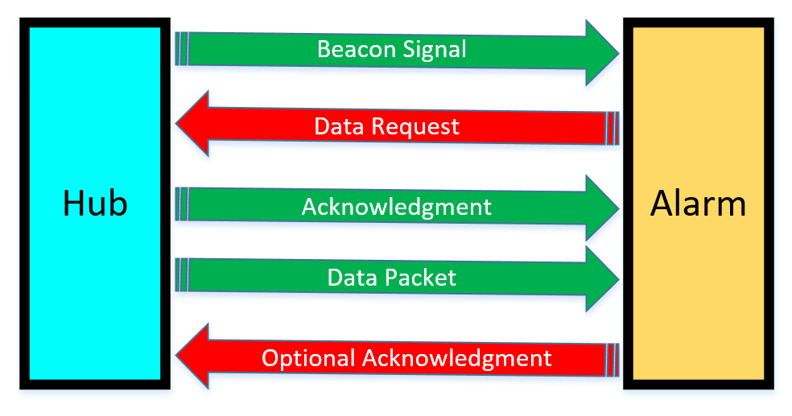

Figure : Beacon Network Data Transfer Diagram

Check-sums make use of 1’s complement sums of 16-bit words in a message (padded with a 0 byte if odd it has an odd length) [12]. This detection method can detect up to 16 bit errors, however it is not a guarantee that it will detect more than 1 error. In the event of a two-bit error, there is a 1/16th chance that the error will not be detected.

Cyclic Redundancy Checks utilized both shift registers and XOR gates to check if an error has occurred in data transmission. A CRC calculates a short binary sequence (check value) for each data packet being sent and adds it to the end of the sequence known as a “code word”. When the code word is read by the receiving device, the device compares the check value to a newly calculated one at the device. If the new check value does not match that of the one sent, the data packet contains an error. The device will then take corrective measures, like rereading the data packet or requesting the data to be resent. If the check values do match, the data is assumed to contain no errors.

### 3.6.7 ZigBee Modules

We looked at three different ZigBee modules, the Digi International’s Legacy XBee S1, Telegesis ETRX351, and NXP JN5168-001-M003 modules. The following section will dive into the specifications of these three modules.

#### 3.6.7.1 NXP JN5168-001-M003

The NXP JN5168-001-M003 is in the family of NXP’s ultra-low power, high performance surface mount ZigBee modules [16]. The modules use NXP’s JN5168 wireless microcontroller to provide large memory, as well as high CPU and radio performance with all RF components included. The module operated at 2.4 GHz with either PCB or external antenna options. Transmission power for the JN5168-001-M003 is +2.5 dBm with receiver sensitivity up to -95 dBm. The module operates at a voltage range of 2.0 – 3.6V, transmission current of 14.3 mA and receiving current of 17 mA.

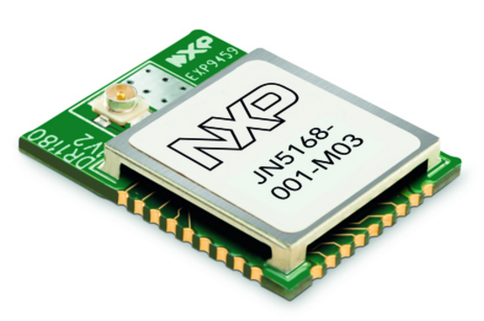The JN5168 microcontroller is a 32-bit RISC CPU, with up to 32 MIPs with low power. It supports RF4CE, JenNet-IP and ZigBee stacks with a JTAG debug interface. The microcontroller has a 4-input, 10-bit ADC with one comparator, as well as 2 UART ports, one SPI Master-Slave port with three selects, a 2-wire serial interface, battery and temperature sensor and up to 20 Digital I/Os. The modules itself is 30mm x 16mm for the PCB antenna module and 16mm x 21mm for the external antenna mount module. The JN5168-001-M003 has an operating temperature of between -40o – 85o C.

Figure : NXP JN5168-001-M003

If we were to use the JN5168-001-M002 in the S.M.A.R.T. Alarm system, we would be limited to using only the JN5168 of microcontroller. Moreover, the programmer is required to code only on the embedded microcontroller as well, making this device not a good choice for the application since it would limit the team to one architecture and implementation.

#### 3.6.7.2 Telegesis ETRX351

The Telegesis ETRX351 is a low power, 2.4 GHz ZigBee module based on the latest Ember EM351 single chip ZigBee solutions [17]. This is a 3rd generation ZigBee module developed by Telegesis, who have been recently acquired by Silicon Labs. These modules have been designed to be easily integrated into any device with minimal RF knowledge required. The module uses the EmberZNet ZigBee stack (a proprietary stack), enabling the ETRX351 to add powerful wireless networking capabilities to existing products in a timely manner. The module makes use of an AT-style command line interface which allows users to integrate ZigBee networking quickly into systems without the need for complex software.

The ETRX351 is a relatively small surface mount module (25mm x 19mm). There are two antenna option, either a PCB or U. FL coaxial connector antenna can be used with this device. This module uses JTAG programming for debugging via the Ember InSight port. The chip has 128kB of flash memory and 12kB of RAM and has the option to add a 32.768 kHz watch crystal externally. The ETRX351 can be used as either a coordinator, router or end device. This module offers up to 24 general-purpose I/O lines including analogue inputs. Hardware supported encryption is available and the ETRX351 is CE, FCC and IC compliant as well as FCC modular approved.

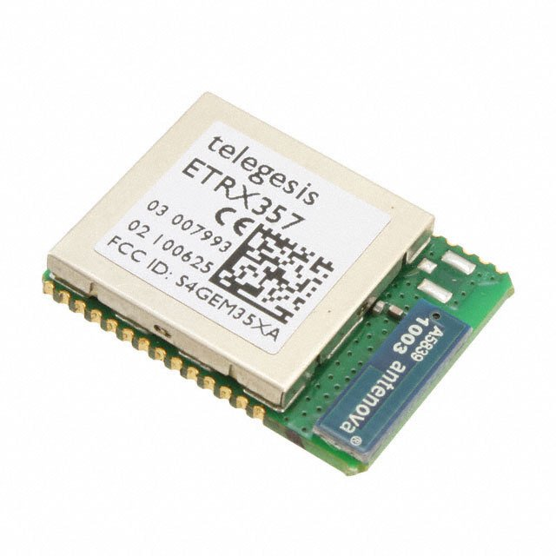The ETRX351 has a supply voltage range between 2.1 – 3.6V with an operating temperate range between -40o – 85o C. The transmission current for the ETRX351 is about 31 mA and a receiving current of about 26.5 mA. This module also has the option to go into a “Boost Mode” which boost the output power, extending the transmission range of the module. While in boost mode, the receiving current is about 27 mA but the transmission current jumps up to 42 mA, which is about a 35% increase in current consumption. The ETRX351 operates in the 2.4 GHz ISM band with an over air data transfer rate of 250 kbit/s.

Figure : Telegesis ETRX ZigBee Series

Although the ETRX351 could be a great a solid choice for the S.M.A.R.T. Alarm system, it falls under the same category as the NXP JN5168-001-M003 when it comes to integrated microcontroller. Moreover, like the JN5168-001-M003, the ETRX351 is a surface mount module, which makes it much harder to prototype/breadboard with, making it a less viable option than the Digi International Xbee module.

#### 3.6.7.3 Digi International Legacy XBee S1

The XBee RF Modules are engineered to meet IEEE 802.15.4 standards and support the need of a low-cost, low-power wireless sensor network. The modules require minimal power and provide reliable data delivery between XBee devices. The XBee modules operate within the 2.4 GHz ISM frequency band and are pin-for-pin compatible with each other [18]. XBee modules are ideal for applications that require predictable and low latency communication timing that provide quick, strong, communication in point-to-point, peer-to-peer, multipoint, star, or mesh network configurations [19]. The modules come with a free X-CTU Software for testing and configuration as well as AT and API command modes for configuring module parameters. These modules also offer analog-to-digital conversion, digital input/output and I/O line passing.

The Legacy XBee S1 has a 250 kbit/s data rate with a range of approximately 30 m (range can be extended with external antenna). The module has an transmit power of 1 mW (+0 dBm) and a receiver sensitivity of -92 dBm. The transceiver chipset used in the Xbee module is the Freescale MC13212. This XBee module has a 3.3V CMOS UART serial data interface and a DSSS (Direct Sequence Spread Spectrum) interface immunity. The module has eight digital I/O ports and antenna option that include, PCB, Wire, Whip, U.FL and RPSMA. Encryption for the XBee is a 128-bit AES (Advanced Encryption Standard).

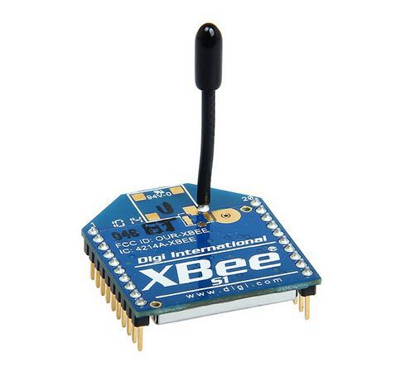The Legacy XBee S1 is 24.38 mm x 27.62 mm, has a supply voltage range of 2.8 – 3.4 VDC and an operation temperature range of -40o – 80o C. The module has a transmission current of about 45 mA at 3.3 VDC and a receive current of about 50 mA at 3.3 VDC. The XBee’s power down current is less than 10 µA at 25o C, which is great for a low power consumption system.

The XBee RF module interfaces to a host device through a logic-level asynchronous serial port. With this serial port, the module can communicate with any logic and voltage compatible UART, or through a level translator to any serial device [18]. Any device that has a UART interface can connect to the pins of the XBee RF module as follows:

Figure : Digi International Legacy XBee S1

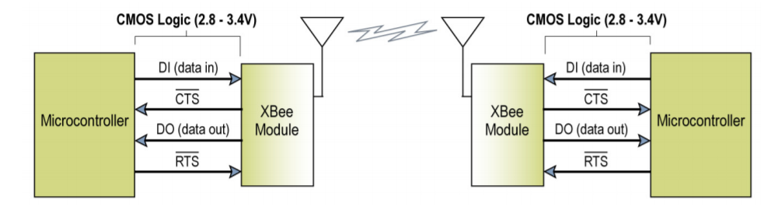

Figure : UART Data Transfer Diagram

Data enters the modules UART through the DI pin as an asynchronous signal (signal idles high when no data is being transmitted). Each data byte contains a start bit (logic low), 8 data bits with the least significant bit first and a stop bit (logic high). For the RF module and the microcontroller’s UARTs to communicate correctly, the setting for each module must be set to be compatible, such as baud rate, parity, start bits and data bits. In order to configure the baud rate and parity settings on the XBee module, the BD and SB commands must be used.

Data is buffered in the DI buffer until one of three cases occurs in the system, causing the data to be made into a packet and transmitted. One case is if no serial characters are received for the amount of time determined by the RO parameter. If RO is made equal to zero, the packetization of the data begins when a character is received. Another case is when the maximum number of characters that will fir in a data packet is reached, which is 100 characters. The final case is when the Command Mode Sequence (CMS) is received, causing any character buffering in the DI buffer to be put into a packet and transmitted. The CMS for the XBee module is “GT + CC + GT”. Since a module cannot transmit can receive at the same time, storing data in the DI buffer allows for transmission of data possible once the module is done receiving data. In the case that the DI buffer becomes full, hardware or software flow control must be used to ensure that data will not be lost and to prevent data overflow.

The XBee modules have the ability to use Application Programming Interface (API) operations to extend the level of which a host application can interact with the networking capabilities of the module. The API allows alternative means of configuring the module as well as routing data at the application level. Using the API has many advantages including transmitting data to multiple destinations without entering command mode, receiving success/failure status of each transmitted packet and identifying the source address of each received packet. These features are very useful to the S.M.A.R.T. Alarm system, especially the latter, due to the need to know which Alarm module has detected the fire so the main hub plan an appropriate route to exit a building and broadcast that data to the alarms. All I/O data is sent out the UART using an API frame in the XBee module.

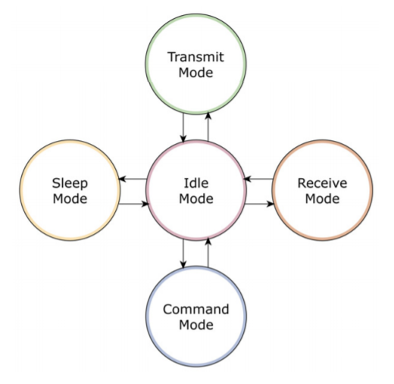The user can select a sampling rate for the XBee modules. This means instead of constantly checking ADC and DIO data, the module will check periodically these periodically on modules that are not configured to operate in sleep mode (TX) . If a module is configured in sleep mode and the sampling rate (IR) is set, the module will stay awake until the IT (Samples before TX) has been reached. Once a certain pin is enabled for IR, the sample rate must be chosen for that pin. The maximum sampling rate is one sample per millisecond or 1 KHz.

Figure : 5 Modes of XBee Module

I/O line passing in the XBee modules allows for received RF data packets that contain I/O data to update any enabled outputs (PWN and DIO) based on the data it receives. I/O lines are mapped in pair, therefore, AD1 can only update PWM1 or DI3 can only update DO3. The XBee’s default setup is that no outputs are to be updated, which mean I/O data is forced to be sent out through the UART. To allow updating outputs, the I/O Input Address (IA) must be setup with the address of the module that has the appropriate updates enabled, which basically shields the outputs of a module from the input. The IA can also be setup to accept I/O data for output changes from any module by setting the IA parameter to 0xFFFF. This feature may be used in the S.M.A.R.T. Alarm system as way to have a manual alarm trigger such as a pull lever in common alarm systems. Data will bypass the hub and the whole alarm system will begin to sound. This will be a temporary alert until a S.M.A.R.T. Alarm unit detects smoke, in which case path planning and broadcasting will commence.

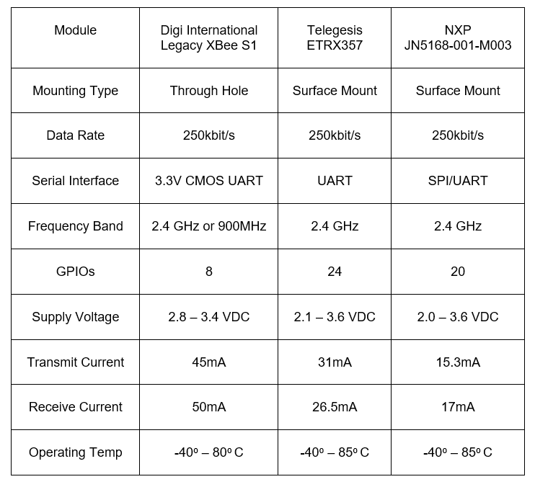

Table : ZigBee Module Comparison

The XBee RF modules operate in five different modes; Idle, Sleep, Command, Transmit and Receive Mode. Idle mode occurs when the module is not receiving or transmitting data, and will only shift out of idle if ont of the following conditions are met; Serial data is received in the DI buffer (Transmit Mode), RF data is received through the antenna (Receive Mode), Sleep condition is met (Sleep Mode) or a CMS is issued (Command Mode).

Ease of use is a very important factor when it comes to choosing the correct ZigBee module for the S.M.A.R.T Alarm system. The module needs to be able to programmed easily and have the ability to work seamlessly when integrated into a mesh network. We found that Digi International’s Legacy XBee S1 modules have all the networking capabilities necessary for the S.M.A.R.T. Alarm system to communicate seamlessly in a ZigBee network. Moreover, these modules are very highly recommended over any other ZigBee module, a fact that we did not take lightly when deciding our device. We will be powering our system off facility power, so the higher power consumption of the XBee modules compared to the competition did not come up as an issue when making our decision. That being said, if the Alarm needs to rely on its battery backup, the power consumption of the XBee’s are very small, allowing it to run on battery for quite some time, more than enough time to restore power to the facility. Moreover, The XBee modules are through hole, a plus when it comes to bread boarding our system, making the process much easier and less time consuming.

### 3.6.8 DIGI International XCTU Software

The S.M.A.R.T. Alarm system uses two main software applications to configure and implement the ZigBee wireless mesh network, the Arduino IDE and the DIGI International’s proprietary software XBee Configuration and Test Utility, or XCTU. XCTU is a software designed to enable developers to interact with all of DIGI International’s RF modules through a user friendly graphical user interface (GUI). XCTU has tools that allow the user to add as well as search for XBee® modules through a computers COMM ports. This tool makes it simple to configure and test all XBee RF modules, making it indispensable for developers trying to utilize DIGI’s XBee® modules to configure and implement a wireless ZigBee network. Configuring ZigBee devices is a very simple using the XCTU software, enabling the user to configure devices to connect to each other over a single PAN, as well as allowing the setup of Coordinators, Routers and End Devices, the three components of a ZigBee network. Using this software, one can assign network IDs, enable/disable channel verification, assign wireless channels, update module firmware and even give each node in a wireless network a unique node name for easy referencing. The S.M.A.R.T. Alarm team will be using the 6.3.5 version of the XCTU software.

The 6.3.5 version of the XCTU software has additional features that gives additional user support and functionality, making configuring XBee® devices extremely simple. There are three main working modes in the XCTU software; Configuration, Consoles and Network. The Configuration working mode is used to configure a radio module from the device list. To add a device to the device list you can either use the Add Devices to manually add a device or the Discover Devices tab to scan the computers COMM ports for XBee® RF devices [Figure 7]. Once a device is connected and discovered, you can begin configuring said device in the Configure working mode. Here you can adjust the PAN ID, Network settings, Node Identifier. Etc. as well as setting the module to be either a Coordinator, Router or End Device. The software gives the feature to read the firmware settings currently on the module, write new firmware settings to the module, load default firmware setting on to the module, update existing firmware and the option to create and load a firmware configuration (enabling the same firmware to be easy installed on multiple modules).

The next tab (Figure 7 to the right) is the Console working mode. The Console working mode allows users to interact or communicate with selected radio modules. Upon clicking this mode, XCTU will display a list of consoles with one entry for each module connected on the devices list. Each tab on the list displays the name of the device and its MAC address. One a module is selected from the device list, the console associated with that module moves to the front of the display. The console is either an API console or an AT console, depending on the module selected. Here you can send and receive frames as well as view the sent and received frames of the module. You can also construct data packets, which is useful for the S.M.A.R.T. Alarm system, allowing the hub and alarms to have predefined packets to send depending on the situation.

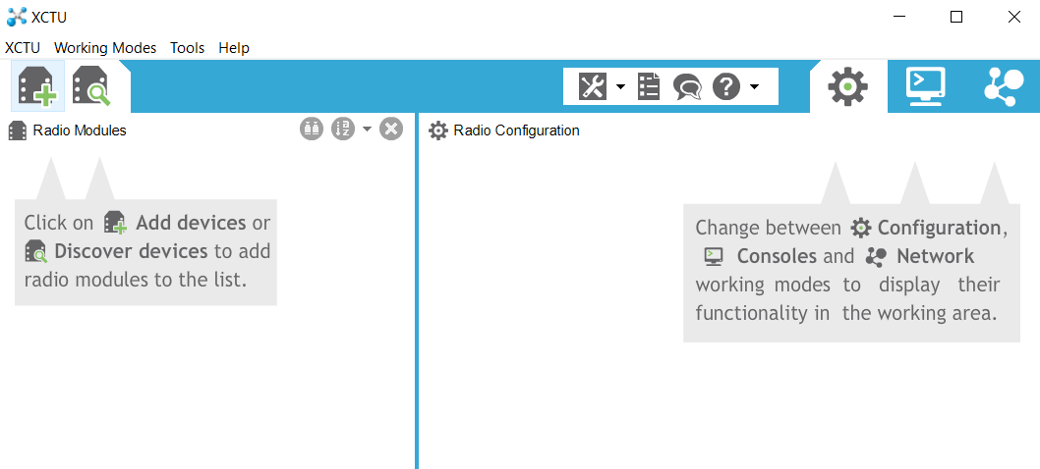

Figure : XCTU Software

The final tab (Figure 7 far right) is the Network working mode tab, the most important feature of XCTU when it comes to setting up your wireless network, The Networking working mode allows the user to discover and view the topology of a network. This feature will only work for modules operating in the API mode. Modules operating in AT mode are not supported in the network discovery process. Once you commence a network scan, XCTU will display the status of the network. This included the number of nodes connected to the network, PAN ID, Channel, current scan number, and time of scan. After a scan is complete, you can look at the current network configuration in either a graphical or table representation of the collected data. Both representations enable the user to see which nodes in the network are connected to which and how all the data is being sent (data paths). The data also shows the signal strength of each node, on a scale from 0 to 255, 255 being the strongest possible connection. Along with checking network status you can change the network configuration of the ZigBee network using the “Layout” tab. Here you can select many different network options, including composite, spring, tree, grid or radial. The S.M.A.R.T. Alarm system will utilize the composite or mesh network configuration.

### 3.6.9 Antenna

All S.M.A.R.T. Alarm modules will use the provided antenna that come standard on the XBee XB24-API-001. However, since the main hub will not be mounted on a wall once the system is set up, but most likely set up in a server room or something similar, there may be a need for an external antenna to help extend and strengthen the main hub transmission range. Therefore, this module (XBee XB24-AUI-001) will be connect to an external antenna via a U. FL coaxial connector.

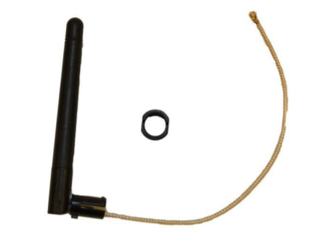The antenna chosen to pair with the XB24-AUI-001 is the MikroTik 2.4/5 GHz Omni Swivel Antenna. This antenna offers a gain of 2dBi in the 2.4 GHz frequency range. This antenna has a small nominal impedance of 50 ohms and has a length of 86mm. The operation temperature of this antenna is -20 – 60oC. The antenna can rotate and mount in a through hole manner. The S.M.A.R.T. Alarm team believe this antenna will give the necessary range extension and transmission signal boost to be able to operate properly.

Figure : MikroTik 2.4/5 GHz Omni Swivel Antenna

## 3.7 Central Processing Hub

For our project, we would like to choose a development board that could be used as a hub for our smart fire alarm system. This hub would need to wirelessly send signals to the other fire alarm systems telling each alarm what direction to send users and when to go off. We decided on creating a hub for this system because without a hub, each fire alarm would need to be programed separately with its own location relative to the other alarms. Each alarm would also need to know it’s location relative to the suitable exits. With the use of the hub, we can choose one central system to program and do computation and that system would send the signals to the other alarms. A central hub would allow set up to go smoothly as a user would just have to set up the alarms and then program the hub with the locations of the alarms and exits. This greatly increases the ease of use for our system. A hub would also allow us to easily change the locations of our alarms after set up and also send software updates to the entire system easily. As ease of use and installation was an important factor for the design of our system, the choice for this unit is something that requires much research. When choosing a development board for projects, three units generally come to mind. These are the Arduino Uno, the Raspberry Pi, and the Beaglebone. We will evaluate each board, provide technical specifications for each, and weigh our options in the following text.

### 3.7.1 Arduino Uno

The Arduino is a development board that has become extremely popular among the maker community to design small projects and perform prototyping on potential system ideas. The Arduino is a microcontroller that specializes in executing simple code directly with no operating system performing operations in the back ground. It specializes is connecting to sensors though it’s GPIO pins and sending simple signals through those pins to read data signals. The microcontroller that is included on the Arduino Uno development board is the ATmega328P which is designed by Atmel. It is a low-power CMOS 8 bit microcontroller that uses the RISC instruction set.

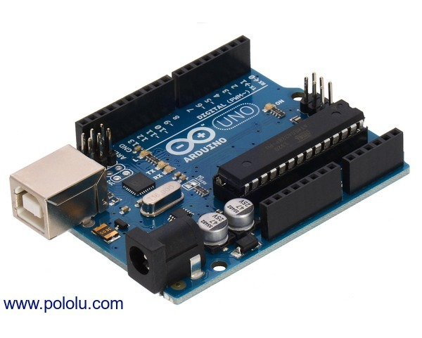The Arduino board has an operating voltage of 5 volts with a recommending input voltage of between 7 and 12 volts. The board contains 14 digital input output pins of which 6 of those provide output for pulse width modulation (PWM) [20]. It also includes 6 pins for analog input. The ATmega328P Atmel chip includes only 32 KB of flash memory of which 0.5 KB are used by the bootloader. This microcontroller ship has a clock speed of 16 MHz [21]. The power input specifications for this board allow it to be extremely low power and can be powered via a simple USB connection or with an external power supply. The reason this development board has become so popular among the maker community is that it is cheap and low powered while providing enough ease of use and input output pins to control external sensors. The board retails for $24.95 but can be very easily replicated using similar parts for much cheaper. The Arduino Uno does not come with build in wireless connections such as Bluetooth or Wi-Fi but comes with UART serial interface connections. The Arduino can communicate with a PC using original STK500 protocol. It features the Atmega16U2 programmed as a USB-to-serial converter and generally uses the Arduino IDE to be programmed.

Figure : Arduino Uno

### 3.7.2 Raspberry Pi

While the Arduino board is a small affordable micro-controller, the Raspberry Pi can be considered the most popular micro-processor among community designers. Instead of just being able to do simple calculations the Raspberry Pi can be considered a full blown personal computer. This development board is powered by the Broadcom BCM2837 quad core Cortex A53 processor. This processor runs at a relatively speedy 1.2 GHz frequency. The Cortex A53 is capable of running both 32-bit and 64-bit instruction sets. It is based on the ARM architecture that has become very popular among smartphones and other small computing devices. The Raspberry Pi also comes with a VideoCore IV graphics processing unit that runs at 400 MHz. While this is not as powerful as most modern day PCs, this is more than enough processing power to run simple graphics processes and display them over the included HDMI connection. The board also comes with 1GB of build in LPDDR2 RAM for running multiple processes. The Raspberry Pi also comes with a microSD card slot and USB port for storing external memory. The newest Raspberry Pi 3 model also comes with a much-desired addition of wireless connectivity. Included on the board are a WiFi 802.11 b/g/n adapter running at 2.4GHz as well as a Bluetooth 4.1 LE transceiver and receiver. In terms of input/output capabilities, the Raspberry Pi comes with a 40-pin header of which 26 are general purpose IO pins. It also includes 1 UART pin for debugging and 2 pins that can be used for pulse width modulation. Two pins are also dedicated so a camera serial interface as well as a display serial interface.

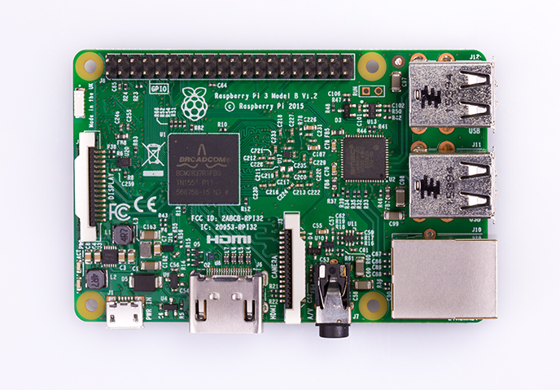The device can be powered by 5 volts via a micro USB cable. The Raspberry Pi will take up 0.31 amps at 5V during idle mode with a Raspbian UI or 0.22 amps at 5.19 volts while using the terminal only in idle mode [22]. One advantage that a board this powerful gives is its’ ability to run full 32 bit Linux distributions such as Ubuntu or Raspbian. This allows the programmer to design full applications that can be accessed via this device and a keyboard, mouse and monitor. Lastly, the Raspberry Pi retails for $35.

Figure : Raspberry Pi

### 3.7.3 BeagleBone Black

The last development of the development boards up for consideration for use as the controller for our hub is the BeagleBone black. The BeaglebBone is a microprocessor development board similar to the Raspberry Pi. This board is powered by a AM3358 Sitara processor developed by Texas Instruments. This processor is based on the ARM Cortex A8 processor but is enhanced with image, graphics processing and other peripherals [23]. This processor runs at a 1GHz frequency and is capable of 2000 MIPS. The Beaglebone is also powered by a SGX530 3D graphics engine specifically designed for 3D rendering. This is more than enough processing power to be able to run a full functioning Linux distribution and in fact comes pre-loaded with Debian Linux with a 3.8.13-bone kernel. In terms of memory, this board comes with 512 MB of DDR3L RAM running at 606 MHZ and 4GB of onboard flash memory to hold code data and any other resources you might need.

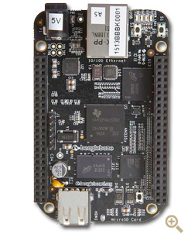Interestingly, this board also comes with a TPS65217C dedicated power management module and optional 20 pin options JTAG serial header for debug support. It can be powered by miniUSB or a DC jack and uses 5V of DC power consumption. This board also comes with large amount of input/output access as it has two separate 46-pin headers of which 65 are GPIO and two are for pulse width modulation, a micro HDMI for audio and video output, and two USB ports. One thing that is of special note to this board, however, is that it contains a 10/100 Ethernet port but does not include built in Wi-Fi or Bluetooth capability. The last article of note is that this board retails for at least $55 from many different distributors [24].

Figure : BeagleBone Black

### 3.7.4 Hub Comparison Conclusion

The development board we choose as our hub for the smart fire alarm system could very well be the most important piece of technology we choose for this project. This development board would be handling all of the computation for our system. This device would also be the central location from where all installation would be configured. An initial vision for our project is that customers would use the hub to configure and tell the system where the location of the smoke and fire alarm sensors are relative to each other as well as relative to the exits to the building. With this in mind, we have decided that this would make the Arduino Uno not the best choice to control the hub. Since the Arduino Uno does not have the processor speed or the capability to run an operating system, the Arduino would have to be connected to a computer in order for new updates or initial configuration to be handled. It also would have to be expanded with more flash memory and wireless peripherals in order for it to function as the hub. This would bring the price up to at least that of the Raspberry Pi while the Pi offers much more at this price point. Because the Raspberry Pi and Beaglebone Black have high amounts of processing power and graphics capabilities, these devices would have the ability to run full operating systems and function as a stand-alone service. This would eliminate the need for an installer or user to have a computer connected for set up and additional functionality. The installer would just have to connect a keyboard and screen to these devices for installation. This allows for the potential of developing an easy to use graphics program for set up in future development.

|  |  |  |  |
| --- | --- | --- | --- |
|  | Arduino Uno | Raspberry Pi 3 Model B | Beaglebone Black |
| Processor Speed | 16 MHz | 1.2 GHz | 1 GHz |
| Dedicated GPU | No | Yes | Yes |
| GPU Speed | N/A | 400 MHz | 200 MHz |
| Memory | 2 KB | 1GB | 512 MB of DDR3L |
| Input Voltage | 7-12 V | 5 V | 5V |
| Flash | 32 KB | SD Card | 4GB |
| Operating System | None | Linux Distributions | Linux Distributions |
| Multitasking | None | Yes | Yes |
| On board Wi-Fi | None | Yes | No, but Ethernet port |
| On board Bluetooth | None | Yes | No |
| GPIO Pins | 14 | 26 of 40 pin header | 65 of 92 pins |
| PWM Pins | 6 | 2 | 2 |
| USB | One, input only | Two ports | Two Ports |
| UART | Yes | 1 pin | 1 pin |
| On board HDMI | No | Yes | Yes |
| Price | $24.95 | $35 | $55 |

Table : Comparison of Development Boards

When just comparing the Raspberry Pi 3 and Beaglebone black, analysis shows that these two devices are very comparable. These devices have similar processor speeds, both contain a dedicated graphics processing unit, and both come with a substantial amount of on board memory. The Beaglebone does have 4GB of on board flash memory but that will be more than enough for our project while a Raspberry Pi can easily be expanded through the use of an SD card. The Raspberry Pi 3 comes with plenty of GPIO pins as 26 of the pins on the 40 pin header can be used as general purpose. The Beaglebone Black manages to more than double this amount with 65 pins which would be more than overkill for use as a wireless hub for our smart fire alarm system. The two places where a major difference between the Raspberry Pi 3 and Beaglebone Black finally start to show are the on board wireless connectivity and price points for each device. While the Raspberry Pi 3 comes with on board Wi-Fi and Bluetooth functionality, the Beaglebone bone falls short in this category. The Beaglebone only gives access to wired internet access through an Ethernet port. The Raspberry Pi would be able to provide wireless control over the sensors as well as download any updates or alerts over WiFi while the Beaglebone would need to be expanded to provide this. Lastly, while the Beaglebone may provide a large amount of GPIO pins and 4GB of RAM, we believe that these gains are not worth the $20 different in price that would be required versus the Raspberry Pi 3. The Raspberry Pi 3 provides everything our Hub would need while also having on board wireless connectivity for a price $35 while the Beaglebone Black retails for $55 or higher. For these reasons, we have chosen to use the Raspberry Pi 3 model B as the micro processing unit to control our hub.

## 3.8 Fire Alarm Components for Use in S.M.A.R.T. Alarm

This section goes over the main components chosen for use in the S.M.A.R.T. Alarm system including the microprocessor, bootloader, crystal oscillator, voltage regulator and auto transformer.

### 3.8.1 Microprocessor for Fire Alarms

Each fire alarm needs its own microprocessor to handle computing for the wireless signals and sensors that will be part of our smoke sensor design. The microprocessor will need to be low power and will not need a very high amount of processing power. For this reason, we have decided to use the ATmega328 microcontroller developed by Atmel. This chip is a low-power CMOS transistor microcontroller. The ATmega328 uses a simple 8-bit RISC architecture for executing simple instructions. This architecture is perfect for reading inputs from simple sensors and proving output signals to components such as LEDs. The RISC architecture that is used by the ATmega328 contains 131 instructions that operate in a single clock cycle. This microprocessor is capable of 20 million instructions per second when running at 20 MHz.

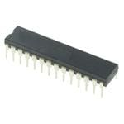Another important component of this chip is that is contains 23Kbytes of programmable flash memory. This memory is where the bootloader and functional code for our program will be stored. This flash memory is re-programmable allowing us to update and change the code as many times as needed during testing. The ATmega328 also comes with six sleep modes which may come in handy for us if we need to save battery life and power consumption on our system. This chip runs at an operating voltage of between 1.8 and 5.5V according to the data sheet provided by Atmel. The last of the important characteristics on this chip for our fire alarm system is that it contains 23 programmable I/O lines. These lines will be used to connect to the various peripherals of our alarm such as the buzzer, smoke sensors, LEDs, batteries, and wireless peripherals. One final reason that we chose this microprocessor is that it is the same one used in the Arduino Uno. This means that we can use a lot of the same resources that are provided with the Arduino Uno without having to worry about compatibility issues. Lastly, we can use an Arduino Uno to load a bootloader onto our chip alleviating the issues of choosing and writing our own bootloader. [21]

Figure : ATmega328P Microprocessor

#### 3.8.1.1 Bootloader

Because we needed to purchase multiple microprocessors for use with many custom fire alarms we are going to build it was not feasible to purchase multiple Arduino Uno boards. This lead us to purchase ATmega328 processors that did not have a bootloader installed so we will need to install one ourselves. The purpose of a bootloader is to be a small program that runs when the system is powered on before the main program is run. This bootloader software will tell our fire alarm system to wait for the software on our programming computer to sent a new program to our fire alarm to be loaded. Our custom program would then be loaded into the flash memory on out ATmege328 processor. This bootloader is what will enable us to load programs onto out fire alarms using just a USB cable without the fire alarm going straight to running whatever program is installed on the system. Because we chose to use an ATmega328 microprocessor, we can use the same bootloader that is installed on Arduino Uno boards saving us a great amount of time in writing our own bootloaders [25]. This also allows us to use the Arduino integrated development environment to program our fire alarms. Our team will only need to borrow an Arduino Uno for a short amount of time in order to create an unlimited amount of Arduino processors of our own.

#### 3.8.1.2 Bootloading Process

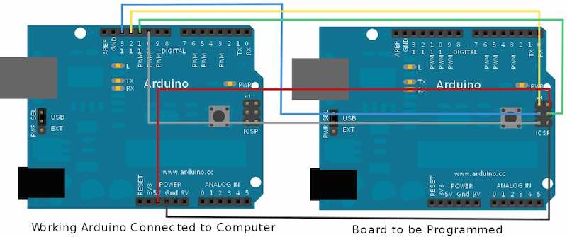

Figure : Arduino Loading Bootloader to Microprocessor

Because our ATmega328 chips do not come with a bootloader preinstalled, we will need to install our own. Other than the obvious ATmega328, we will also need a few more components to install the bootloader onto the chip. We will need a breadboard for mounting the chip onto as well as a 16MHz crystal. This crystal in conjunction with two capacitors of about 22pF will act as a clock for our processor. Lastly, we will also temporarily need a working Arduino Uno in order to copy the bootloader over to our blank ATmega328 chip. Figure 27 is an example of how an Arduino can be used to load the bootloader onto the chip.

The first step for loading the bootloader is to place the ATmega328 chip into the middle of the breadboard allowing the pins on the left and right side of the chip to connect the two separated segments of the breadboard. The ATmega328 has a small indentation indicating which is the top of the chip, or rather which side pin one is on. This side should be oriented so that it is facing the top of the breadboard. VCC then needs to be connected to pin 7 and pin 20 which should be set to the input voltage of our ATmega328, 5 volts. Pins 8 and 22 on our chip need to be connected to ground. For designing our clock, we need to connect our 16MHz crystal to pins 9 and 10 on our board. Our capacitors that we have chosen need to be connected from each pin on the crystal to ground. Therefore, one capacitor needs to be connected to pin 9 and ground while another needs to be connected to pin 10 and ground. Our Arduino Uno board now needs to be connected to our computer using the USB connection on the board. The Arduino IDE comes with example sketches that can be loaded onto Arduino boards for testing purposes. One of these is called Arduino ISP and loads software onto the Arduino which will allow it to function as a bootloader for our ATMega328. This sketch needs to be uploading to our Arduino without any connections other than to the computer. Once this is complete the Arduino needs to be wired to our blank ATMega328 chip. The first connection is Pin 10 on the Arduino board which needs to be connected to the reset pin on our blank chip. The reset pin in Pin 1. Next, Pin 11 on the Arduino needs to be connected to pin 17 on our blank chip and Pin 12 on the Arduino needs to be connected to pin 18 on our blank chip. The last wire than needs to be connected is pin 13 on the Arduino which needs to be connected pin 19 on the blank chip and breadboard. Now we can connect our 5 volt VCC and ground and plug the Arduino back in to the computer. The last step is to go onto the Arduino IDE, confirm that the correct Arduino board is selected, which is the Arduino Uno, and select Burn Bootloader. This process should take a few minutes to complete. As long as no errors are shown on the Arduino IDE, an Arduino bootloader has now been loaded onto our chip and can be used by itself to program our project. [26].

### 3.8.2 16 MHz Crystal Oscillator

The ATmega328 microprocessor that we are using to control our fire and smoke alarms will need a clock signal to control the processing speed of the circuit. The ATmega328 chip we are using does include an internal oscillator that can reach a maximum speed of 8MHz. Characteristics of the chip, however, describe that it can operate at a speed of up to 16MHz. An external oscillator would have to be used to reach this speed as the internal oscillator on the ATmega328 is only half as fast as the full capabilities of the chip. According to the AVR053: Internal RC Oscillator Calibration for tinyAVR and megaAVR Devicesdocument from Atme [27], the internal RC clock can be calibrated to an accuracy of +/- 1% using software tricks. While this seems accurate, over the course of a year the timing of the clock could be off by as much as a day. This could create issues for a fire alarm system that needs to be online every minute of every day so ensure safety for those inside the building that it is installed in. This issue drives the need for an external crystal to be used. A cheap 16MHz crystal can be accurate to 0.005% on average right out of the box. This eliminates the issue with timing over the course of long periods of time allowing our signals and alarms to always be in sink. This is very important as one of the features of our system is the use of timed buzzer alarms signifying the correct direction to exit a building. It is also important to have a very accurate clock signal because we are using multiple microprocessors all connected to each other that will all be having their own clock signals with accuracy ratings. When multiple clocks are considered, the important of accuracy increases greatly. Another important reason to choose an external crystal over the included internal RC oscillator is that this internal oscillator is also more sensitive to temperature changes in the environment. As our system will inherently deal with temperature changes caused by a fire, we would want to choose the system that is most stable. This choice is the external crystal. There exist two pins on the ATMega328 dedicated to external crystal use. These are pins 9 and 10 on the left side of the chip. One drawback of the use of crystals, however, is that many times load capacitors must be included. These load capacitors ensure that the crystal begins to oscillate. Because of this, we will be using two 22pF capacitors each connected from each pin on the crystal to ground. A crystal is a device that by itself does not have any active capabilities. Because of this, external drivers will be needed to convert the crystal into an oscillator [28]. Thankfully, the ATMega328 includes this capability built right into the chip. This is the reason why there are dedicated crystal pins located on the chip.

### 3.8.3 LM3940 Voltage Regulator

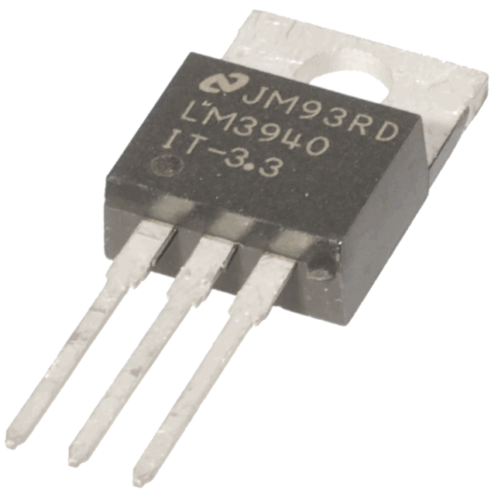The Texas Instruments LM3940 is a 1A Low-Dropout Voltage Regulator for 5V to 3.3V Conversion. The S.M.A.R.T. Alarm system requires these voltage regulators because the XBee S1 radio modules require a 3.3V operation voltage as well as 3.3V as digital input voltages. However, we are using a 5V power source, therefore causing a need for a voltage regulator. The LM3940 takes an input voltage range from 4.5V – 5.5V with a 1A output current. This regulator requires a single output capacitor to insure proper voltage regulation. The LM3940 is short-circuit protected and has an operation temperature range from -40oC to 125oC.

Figure : LM3940 Voltage Regulator

The output capacitor (minimum 33 µF) is required to maintain stability and allow for proper voltage regulation. The capacitance can be increased without limit; therefore, we chose to use a 100 µF capacitor to achieve an improved transient response. The 5V power supply must be well regulated, meaning it cannot be very noisy. If the input is in fact noisy, an additional capacitor (low ESR) can be added to the input to help improve the output noise performance.

The short-circuit protection is used to protect the low-dropout voltage regulator against high current faults or short circuits. During a current fault, the regulator sources constant current, causing the output voltage to fall when the load impedance decreases. Moreover, if a current limit occurs and the output is low, excess power may be dissipated across the regulator, triggering a thermal shutdown of the voltage regulator output. This thermal shutdown is enforced when too much heat is dissipated over the regulator. The on board semi-conductor has a thermal time-constant which is short, causing the output voltage to cycle on and off at a high rate until the power dissipation is reduced.

### 3.8.4 Auto Transformer

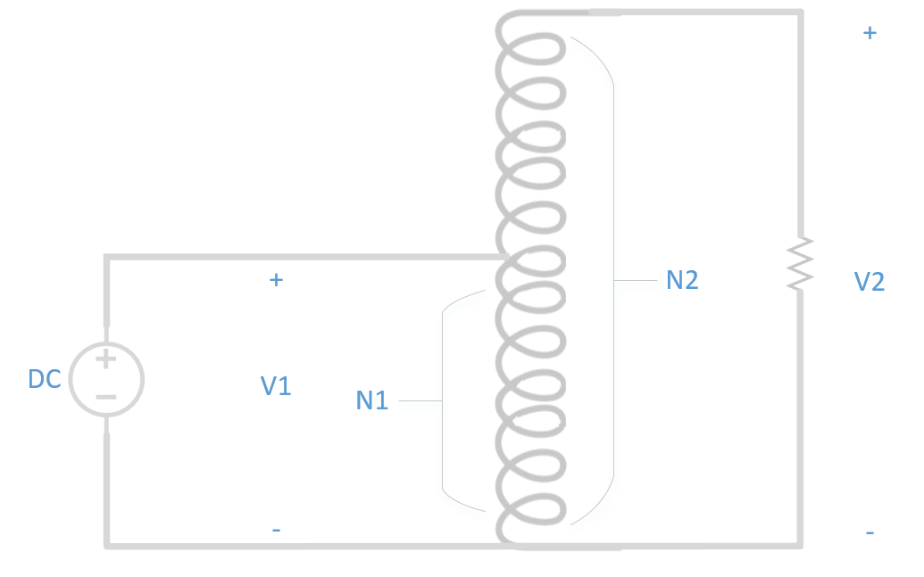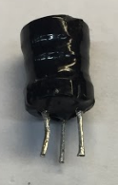

Figure 30: Step-Up Auto Transformer

An auto transformer is a transformer with only a single winding wrapped around a core. An auto transformer is similar to a two-winding transformer; however, the primary and secondary windings are interrelated [29]. The S.M.A.R.T. Alarm fire alarm modules make use of an auto transformer to step up the voltage going into the piezo sounder, allowing the alarm to be much louder. This auto transformer steps up the voltage according to the ratio of turns inside the transformer. The particular auto transformer the S.M.A.R.T. Alarms are using is one with the smaller coil (8-ohms of windings) connected to a larger coil (154-ohms of winding). The 8-ohm coil is connected to the ATMEGA328 output while the 154-ohms coil is connected to the piezo sounder. This connection allows for a step up in voltage being supplied to the piezo, without the need for a higher supply voltage.

The S.M.A.R.T. Alarm fire alarm modules will be utilizing these small auto transformers to boost the strength of the alarm sound. They are a cheap and easy way to step up the voltage going into the piezo sounder and can be implemented very easily. However, if the S.M.A.R.T. Alarm team decided that we want to make the sounder even louder, there are other options we can explore. A good alternat6ive to the auto transformer is the Texas Instruments TPA2100P1 19-Vpp Mono Class-D Audio Amplifier for Piezo/Ceramic Speakers. This amplifier can output a load voltage of 19-Vpp from a 2.5 V input supply. It has an integrated DC to DC converter that can generate a 10V supply with no external Schottky diode required.

This amplifier comes with an integrated audio input low-pass filter as well as a small boost converter inductor to get the most out the piezo sounder. The TPA2100P1 can operate with a supply voltage range between 2.5V to 5.5V, which is perfect for use in the S.M.A.R.T. Alarm fire alarm modules. At this time, we do not believe we will require these amplifiers for our alarm modules, but they will be considered to be used if deemed necessary.

Figure : TPA2100P1 Audio Amplifier

## 3.9 Printed Circuit Board

A printed circuit board (PCB) is a board made of 4 different types of materials; a silkscreen, soldermask, copper, and substrate. This board is mechanically used to support and electrically connect electrical components. For example, transistors, capacitors, resistors or any other active devices. These components are connected using conductive tracks, pads, and other features that are etched from copper sheets laminated onto a non-conductive substrate. The components that are connected on this board are usually soldered onto the board. Printed circuit boards are the backbones of all electronics devices. PCBs can be created any way you need it to be for a particular project or device. There is no specific design that must be followed when creating it. There are different types of software’s that you can use to create your own PCB board, or there are different companies that you can go through that make them, and they can create the design for you. PCBs can be either single layer, double layer, or multiple layers. Figure 4.1 shows the layout of the PDB board of a single layer and a double layer. This figure shows the composition of the PCB board; this figure does not show the silkscreen, but the silkscreen is just on top of the solder mask.

### 3.9.1 PCB terminology

Table x contains the most common terminology used in PCB design along with its definition or description. Knowledge of the terminology is useful when creating your printed circuit board and using the Electronic Design Automation software that is used when creating the PCB. **C-7**

|  |  |
| --- | --- |
| **Terminology** | **Definition/Description** |
| Annular ring | The ring of copper around a plated through hole in a PCB |
| DRC | Design Rule Check. A software check of your design to make sure the design does not contain errors such as traces that incorrectly touch, traces too skinny, or drill holes that are too small. |
| Drill hit | Places on a design where a hole should be drilled, or where they actually were drilled on the board. |
| Finger | Exposed metal pads along the edge of a board, used to create a connection between two circuit boards. |
| Pad | A portion of exposed metal on the surface of a board to which a component is soldered. |
| Panel | A larger circuit board composed of many smaller boards which will be broken apart before use. |
| Plane (“pour”) | A continuous block of copper on a circuit board, define by borders rather than by a path. |
| Plated through hole | A hole on a board which has a annular ring and which is plated all the way through the board. May be a connection point for a through hole component, a via to pass a signal through, or a mounting hole. |
| Slot | Any hole in a board which is not round. Slots could be plated or might not be depending on the cost. |
| Surface mount | Construction method which allows components to be simply set on a board, not requiring that leads pass through holes in the board. |
| Thermal | A small trace used to connect a pad to a plan. If a pad is not thermally relieved it can create difficulty when trying to create a good solder joint, due to the pad not being able to get a high enough temperature. |
| Thieving | Hatching, gridlines, or dots of copper left in areas of a board where no plan nor traces exist. This reduced the difficulty of etching. |
| Trace | A continuous oath of copper on a circuit board. |
| V-score | A partial cut through a board, allowing the board to be easily snapped along a line. |
| Mouse bites | An alternative to V-score for separating boards from panels. Many of drill hits are clustered close together, creating a weak spot where the board can be broken easily after the fact. |
| Via | A hole in a board used to pass a signal from one layer to another. Vias where connectors and components are to be attached are often uncovered so that they can be easily soldered. |

Table : PCB Terminology

### 3.9.2 Silkscreen

The silkscreen is usually used on the component side of the board to help identify different components, part numbers on the board, the test points, and other markings that are on the PCB board. When applying the silkscreen to the PCB you must consider the cost, because it can get expensive. For example, adding a second layer of silkscreen is double the original price, also added another color that isn’t one of the standard colors will cost extra. So, as you can see things can start to get more expensive the more you add. The conventional silk-screening of the PCB board requires polyester screens that are going to be stretched across and aluminum frame. When doing this silk-screening, certain equipment needs to be used for it. The type of equipment that is used is: laser photo plotter, which is used to produce the initial film that the silkscreen is on, UV printer, spray developer, and curing ovens. When also doing the silkscreen you also need to identify the type of “Ident” you want on the board. There are three different types of methods that are available to apply the Ident to the PCB.

* Manual screen-printing
  + This method is the most basic method that is used when printing the Ident.
* LPI (Liquid Photo Imaging)
  + This method provides more accurate and more legible letters than the manual screen.
* DLP (Direct Legend Printing)
  + This method id the most accurate and most legible printing of the letters than the two previous methods.

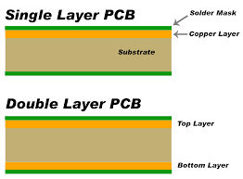

Figure 27: Composition of PCB **C-19**

### 3.9.3 Solder mask

Solder pads are pads on the PCB board that have solder joint on them from being dipped in a solder pot. Solder bridges are electrical connections between two conductors that were unintended by a small piece of solder. To prevent solder bridges from happening on the PCB board solder masked are used. The solder mask is a thin lacquer-like layer of polymer that is usually applied to the copper traces of the PCB, which is for protection against oxidation and the help prevent solder bridges from forming between closely spaced solder pads. The solder mask layer is right under the silkscreen and right on top of the copper layer. The coating of the solder mask can also help prevent corrosion and electrical shorts from happening. In addition, the mask protecting from corrosion and shorts, it also works as an electrical insulation which will allow higher voltage traces to be placed closer to each other. Solder mask are very essential when it comes to mass production. However, it does make it easier and more efficient if you decide to solder by hand. The most common solder mask used is LPI (Liquid Photo Imaging), it is said that LPI mask are more reliable, accurate, and can make a better connection with the surface of the board and with the copper. Which this allows for better connection when soldering components.

### 3.9.4 Copper

This layer is the next layer after the solder mask. This layer is a thin piece of copper foil which is laminated to the board with heat and adhesive. The thickness of this copper slate is about 1oz, which is the standard internal layer copper thickness. The thickness and width of this copper slate on the printed circuit board is very important. The copper makes up the trace that is imprinted on the PCB, but these two factors determine the amount of current the circuit can carry. These two factors are also used in impedance calculations of high speed and RF circuitry. The base of the copper is usually measured by weight over one square foot Even though a lot of PCBs us 1 oz of copper per square foot, if the design is supposed to handle high power, then some designs will use between 2 oz to 3 oz. When added more weight to the base weight that is already attached to the PCB will cost more, because it will take more time for the manufacturer to produce it.

### 3.9.5 Substrate

The substrate which is the middle piece physically holds the circuit components and the traces, and provides and insulation between the conductive parts. The most common type of substrate used is a flame-resistant material FR-4. FR-4 is a fiberglass-epoxy laminate material. The FR-4 isn’t the only type of material used for a substrate; they can be made from Teflon, ceramics, and special polymers. There are five different types of substrate that each are unique and have their our set of characteristics:

* FR-2
  + This type is the lowest type of substrate to use. It is a paper material with phenolic binder.
  + This type of material is very inexpensive to use and is found in inexpensive consumer devices.
  + This material is also easy to machine over a fiberglass substrate.
* FR-4
  + This material is the most commonly used for a substrate, it is composed of glass fiber epoxy laminate.
  + Since fiberglass is very rigid this material can be cut, drilled, or machine
  + This material is of better and stronger quality than FR-2, and is more resistant to breaking or cracking.
  + Can be found in higher end electronics.
* RF
  + Used and can be found PCBs for high power radio frequencies.
  + Comprised of low dielectric plastics.
  + Works great with electrical performance properties, but lacks with mechanical properties.
* FLEX
  + This is a thin and flexible plastic, and this type of material is used as a substrate since it is flexible the circuit board can help save space within particular devices.
* Ceramic
  + This type of substrate is used for power electronics since they demand low- thermal resistivity.

Since the substrate is in between two conductive parts the PCB substrates does not conduct electrical current. Therefore, the substrates act as a laminated electrical insulator. The insulators internal electric charge does not flow freely, which is a good thing conduct under any influences. These different attributes add to this grade of a wide variety of electrical and mechanical appliances.

### 3.9.6 PCB software

Electronic Design Automation (EDA) software is what is needed to design your PCB. Electronic Design Automation is a diverse category of software tools, including algorithms and applications. EDA is required for the design of Printed circuit boards, integrated circuits, semiconductors, and electronic products. There are a numerous amount of software packages that are able to help design your own printed circuit board. However, there are a few different types of software packages that are known and can be used to develop the design that you created and prototyped. To name some of the popular EDAs; Altium, Eagle, OrCad, DipTrace. This EDA software contains a schematic editor for the designing of your circuit diagram, so make sure to have the schematics already done before you start. This software allows back annotation of the schematic, and auto-routing to automatically connect traces due to the connection that you have based off of your schematic you have already completed. When deciding in which EDA software you want to use, you want to make sure that you consider 5 things. Functionality, usability, reliability, performance, and supportability. Most software is can be expensive however, Altium, Egale, OrCad, and Dip Trace all offer a free version of their software for non-commercial use. Yet with the free versions they do come with limitations like the amount of layers you are allowed to have with you printed circuit board. Table x displays of the different design software their prices and their limitations.

The functionality and the ease of use of most of these EDA software’s is very difficult, however there are a lot of different outlets to help. Eagle is very difficult use, nonetheless, it is a very popular software that is used. Therefore, there are a lot of tutorials online that you can. A lot of people have posted videos on how to use it as well. Also, there are many articles that give you a guideline as to how to use it as well. **C-18**

|  |  |  |
| --- | --- | --- |
| **Software Package** | **Limitations/Specs** | **Price** |
| DipTrace Free Version | 2 layers, 500 pins | $0.00 |
| DipTrace Starter | 2 layers, 300 pins | $75 |
| DipTrace Standard | 4 layers, 1,000 pins | $345 |
| DipTrace Extended | 6 layers, 2,000 pins | $595 |
| DipTrace Full | None | $875 |
| Eagle Free Version | 16 layers, 4.0”X6.0” board | $0.00 |
| Eagle Standard | 6 single layers, 99 sheets | $820 |
| Eagle Professional | None | $1640 |
| OrCad Free Version | 2 layers, 100 pins | $0.00 |
| OrCad PCB Designer | None | $2,580 |
| Altium Designer | None | $7,245 |

Table : PCB Design Software

### 3.9.7 PCB constraints

When it comes to designing a PCB there are some constraints that come into account and need to be considered. For example; size, shape, thermal issues, track design, and some other factors that may affect the overall design of your PCB. The PCB is a very crucial component when it comes to an electronic system. Since ever PCB design is different and each may have a different layout than the next, this section list some of the constraints when designing, and some guidelines and what precautions to take when in the process of designing the PCB.

* Make sure that when choosing the reference points on your PCB that you do it so that it’s suitable for the manufacturer that you are using. Since each manufacturer is different they each may have a similar but slightly different process as to how they do things. You want to have reference holes or points on you circuit board, you just want to make sure that it is clear and not obscured for the text fixtures or the pick and place machines.
* Make sure that you have sufficient enough space on the board for the circuit. Make sure that you estimate the size of the board that you are going to need for your electrical system. You want to make sure that you have enough space to accommodate all the components that you are going to have on the board, also the tracks. Having the correct size is crucial, because you need to take into account the cost that the board will be when finished.
* When creating the printed circuit board you want know the amount of layers that you board is going to require. Again cost is a factor because depending on the software that you will be using the amount of layers you have the more the board will cost. Depending on the complexity of you design, the amount of layers you may need may be essential to because you may need to route them because of the amount of tracks your design has.
* Another thing to consider is the method of how you are going to mount you printed circuit board. Because depending on the way you may need to mount your board, you may need certain areas on your board to be free so you are able to mount it the way you need to. Again you want to determine this method before you start designing your board on the software, because you must take into account the cost if you mess up.

### 3.9.8 Track design guidelines

This section will give you a brief overview of some guidelines to take when it comes to the tracks and traces on the printed circuit board. When considering this part of the printed circuit board you want to know the specs early on before starting the designing process, so you have an idea of what you want. Table x shows the width of tracks and the different thicknesses of copper boards, with the corresponding current for that track width.

**C-17**

|  |  |  |
| --- | --- | --- |
| Width of track for 1oz board (thousands) | Width of track for 2oz board (thousands) | Current (Amps) |
| 10 | 5 | 1 |
| 20 | 15 | 2 |
| 50 | 25 | 3 |

Table : Width of Tracks

The tracks that are currently used in the boards can only carry a limited amount of current through the track. Depending on the amount of current that needs to be carried through a trace; for example, a track that is connected to a power rail. Those types of traces and their widths need to be taken into considerations, since they would need to carry more current then a low level signal would need to carry.

* Establishing the standard track width you want to use in your printed circuit board design vital. Because the size of the traces does matter. If the tracks are too narrow, small and close together, then you have higher risk of having a short within your circuit. Alternatively, you also want to make sure that your traces aren’t too wide and far apart. Because this can take of space on the board, and if you don’t have enough space on the board for all your tracks then you would have to add more layers and that would cost extra.
* When first starting you design you want to know the ratio between the pad and the hole, but also the size as well. You want to make sure that the pad to hole ratio is sufficient enough so that way you have a good hole drilling tolerance. Depending on the manufacture you use for your printed circuit board, that manufacturer should provide the standards that are required for your pad and hole ratio. Since different manufacturers have a different process of how they may handle it. This ratio becomes particularly important when the size of the hole and the pad become smaller and smaller, because the accuracy needs to be exact otherwise you could risk messing up the board, and that will cost money. Via holes are important as well when the size of the hole and pad reduce.
* Another important aspect that needs to consider are the shape of the pads. All of the EDA software systems will have component libraries that will consist of schematics and PCB footprints for different components. Again depending on the manufacturer that you are using for your printed circuit design, these libraries can vary with the amount of component schematics or footprints that they have. The size of the pads are essential because they need to be large enough so that you are able to do wave and reflow soldering. Be contingent on who your manufacturer is so that way you have the correct size pads.

### 3.9.9 Thermal issues

Another aspect that may need to be consider is the thermal issue the circuit may have. Depending on the size of your circuit board you may or may not have to deal with this issue. For small printed circuit boards the thermal issue doesn’t really present a problem, so if you design is small that’s a constraint that you don’t have to worry about. However, if the design that you have is larger and preforms high component densities and processing speeds, then thermal issues would be a constraint that would need to be taken into consideration. When dealing with thermal issue you want to make sure that you have enough cooling going on for all of the components that you have. Components that dissipate great amounts of heat need to be cooled down accordingly. Also make sure to give those components that give off that large amount of heat more space on the board. If heat sinks are needed, make sure to provide enough space for that as well.

### 3.9.10 PCB Layout Steps

This section will give you guidelines and steps to help you when making you printed circuit board. Since the PCB is a critical part of any electronic system you want to make sure that you do it correctly, and make it reliable and long lasting for whatever electronic system you need it for.

**Step #1: set up initial settings**

This step is setting up the snap and visible grid, and you should be establishing the size of the traces and also the size of the pads, and set them as well. You also want to import the outline and details of your printed circuit board design that you have. You also want to establish the reference point and holes for the pick and place machines and text fixtures. So the manufacturer know for the production process of your printed circuit board.

**Step #2: put all components onto the board**

At this part of the process of creating the layout of your printed circuit board you want to place the components that are going to be used onto the printed circuit board. This is so that they will be available to use and place when you are configuring your design. Once you have the components on the layout, you then want to place them in their functional blocks. This helps to route the circuit easier and neighboring components are already close to each other.

**Step #3 identify and route layout critical tracks**

 Identify and traces that are critical and the route them as they are required. This is a good method to use because routing these first allows you to work around. This will avoid any problems you would have encountered on the PCB layout.

**Step #4 route power and earth rails**

Depending on the software, earth rails and power rails, may or may not be included as planes that could be occupying a complete layer on the printed circuit board. If you do find the earth rails and power rails occupying a complete layer it adds as an advantage, because it allows you to route the higher levels of current easily. Additionally it would also decrease any issues you may have faced with the interface on the printed circuit boards.

**Step #5 route remaining lines**

For this step you could use the auto route function that is provided in the software. This will say you trouble and a lot of time from doing the routing manually. However if you want to do the routing manually you can. When using the auto-route it is possible to set up parameters so that the software route it accordingly.

**Step #6 manually route any final lines on the PCB layout**

Once the auto-routing is complete, anything that has be done due to some trouble the system may have had with it, can be routed manually. However, if the design may be too complex for the space and also the amount of layers provided, you may want to consider some changes to the printed circuit board design.

**Step #7 undertake and complete a design rule check**

While all the design rules may have been followed it is good to do a final check so you can catch any problems or mistakes made. Because once prototype has begun it would be too late, and you would have to spend more money than what was actually needed.

**Step #8 have the work checked by and independent party**

It is also good to get a second look at your work by someone else, because they may catch an error that you may have missed. Having someone else check your work is also good practice as well.

**Step #9 release the design for prototype PCB manufacture**

Now that the PCB layout is complete and has been checked, you can now send it to the manufacturer so they can send it to get prototyped. You want to make sure that all the correct files that you have are sent. The files that you have should be released to the manufacturer to avoid any confusion. To avoid any unforeseen problems having a manufacturer of a prototype is a good thing to do. To the avoid the risk of extra cost to fixing problems.

# 4.0 Design Constraints and Standards

There are many different hardware and software design constraints as well as safety and design standards that must be addressed when designing the S.M.A.R.T. Alarm System, this chapter will go into detail various possible constraints to consider for this project. This will include the various economic, environmental, social, political, ethical, health and safety, manufacturability, sustainability, time and testing/presentation constraints. Standards discuss also include the NFPA fire alarm specification and placement requirements for residential and commercial buildings.

## 4.1 Constraints

### 4.1.1 Economic Constraints

The cost of designing and implementing the S.M.A.R.T. Alarm system is a major constraint to keep in mind for several reasons. A major reason is that this project must be self-funded by the group members, as currently there is no general funding provided by the University or partner companies for Senior Design projects. This inhibits the ability of our group in the capacity of how much regular trial and error can be used to test out different components and select the ones to be used for the prototype and the project going forward. Much of this can be taken care of by performing extensive research in all aspects of the project and selecting the adequate components for the system based on the research performed and the requirements outlined by this document. This careful selection prior to purchasing any potential parts will maintain costs low for designing a prototype and avoid any unnecessary financial burden for the project’s group members.

Further economic constraints to consider are the potential manufacturing cost of the finished product. For this system to work, several S.M.A.R.T. Alarm System Fire Alarms must be bought and used by any potential client, and having low manufacturing costs is advantageous for marketing purposes, as affordability will be an important selling point. A high manufacturing cost, will result in a high cost for the client and will negatively affect this aspect of marketing. Ideally, using the highest quality possible, while maintaining low cost will be made possible by intelligent and careful design, and will result in the balance that will provide the best possible product.

### 4.1.2 Environmental Constraints

“Going Green” is a bit movement toward renewable energy and technology that is considered environmentally friendly. This movement is mindful of the harm that has come to the environment due to various methods for creating energy using non-renewable resources, and the many harmful gases that are released as the result of using these methods. The S.M.A.R.T. Alarm team is very mindful of the issues caused by not taking care of the planet by employing harmful methods. Unfortunately, many times creating a simple and practical product requires a compromise between being responsible with the environment and what is most practical for the application. This system requires the use of electricity to work, pulled from the building’s power grid and that is most likely produced using harmful methods. In addition, to the inability for our product to use solar or wind power, as the system is meant to be used inside buildings. One particular effort that can be made to making our product more environmentally friendly, aside from designing our devices to use as little power as possible, is to offer potential clients the opportunity to invest in an alternative method for powering the system, using methods such as solar energy, that the S.M.A.R.T. Alarm team would gladly design and implement. If a client were to request this use, it would be implemented after extensive research, however at the moment the system is being designed with using traditional powering methods for the purpose of practicality, while using the least power possible.

### 4.1.3 Social Constraints

The primary goal of the S.M.A.R.T. Alarm System and its team members is to save lives by employing a system that will evacuate buildings in case of fire as quickly and efficiently as possible. One major social constraint that is encountered when approaching this goal is educating users who will come in contact with the system. While the ultimate objective is to implement this system for widespread and common use, there will be a learning curve for those unfamiliar with the system, as they will not immediately understand how the system uses audio and visual signals to guide those evacuating buildings. While the clients may try to educate the occupants of a building using educational materials, such as pamphlets and videos, and even performing fire drills, this in itself may not be enough and many times there will be those who are not only unfamiliar with the system but with the building itself, and we aim to help them as well. This is why the system is designed in the most intuitive manner as possible, so that the majority of those unfamiliar with how the system works or guides evacuees, may quickly understand what is going on and how to approach the situation.

Further effort to make this system employed in widespread use will be done by designing this system to be as compliant with NFPA standards and to exist at as low cost as possible, so that it is readily available to as many clients who wish to install and use this system. It would also be ideal to collaborate with NFPA when looking to bring the system to market, so that we might improve on other systems and methods currently in use, and save as many lives as possible.

### 4.1.4 Political Constraints

Following extensive and thorough research of potential conflicts, it was concluded that there no current relevant political constraints that will affect the S.M.A.R.T. Alarm system.

### 4.1.5 Ethical Constraints

As stated previously, the main goal of the S.M.A.R.T. Alarm system is to save lives by decreasing the time it takes for a building to be evacuated, by making it easier for occupants to find the nearest and safest exit. This is something the team takes very seriously, and as a result of this no unethical methods will be employed and no amount of attention or scrutiny is enough to ensure that this project is as safe and ethical as possible. This includes creating algorithms that will not only maximize the amount of lives saved, but that will not disregard a single aspect of what can be done to evacuate a building as quickly as possible.

The S.M.A.R.T. Alarm System will not engage in using any potentially toxic products in producing the system and any related devices. On top of ensuring that the devices will receive maximum life, not cutting any corners in favor of cost saving measures. This means that several measures will be taken to ensure that not only will the system work in the most extreme of circumstances, but it will be designed to work just as efficiently in these circumstances. Taking into account as many situations as possible, such as power going out in the building or a fire occurring in the area where the Hub is located. There will also be backup circumstances, where in case that the system is failing, our alarms will still warn occupants of danger and they will be able to exit the building safely.

As far as patent protection, extensive research will be done to avoid infringing upon any existing patents as part of the S.M.A.R.T. Alarm System design process. Any protected concepts or designs used in the implementation of the system will properly attribute any applicable credit to the respective owners. Furthermore, anything that is not marked as

### 4.1.6 Health and Safety Constraints

The end users of the S.M.A.R.T. Alarm system and their health and safety is the most important goal and priority when designing this system, and a lot of precautions are taken to ensure not to infringe on this. In fact, the sole purpose of the system is to ensure everyone in the building knows which way to evacuate and get to safety as quickly and efficiently as possible. Therefore, careful consideration is taken by the team so that any important factors are being accounted for, and that system maximizes the warning time given to occupants of a building in danger, by ensuring fast and efficient detection, communication and processing in the system. In the case of fire emergencies, any small advantage in warning time can be the literal difference between life and death for occupants of a building in danger. As fire spreads, the algorithm will also take this into account, and any changes must be updated as quickly as possible to avoid sending people into a dangerous situation. Ensuring a proper layout of the building is used, and that the algorithm has little to no margin of error for creating evacuation routes through excessive testing is another measure taken to match any health and safety constraints.

Additionally, to increase the safety of those that will come in contact with the S.M.A.R.T. Alarm System, the components used in creating the devices for the system will be of high quality and will be tested to ensure that any errors or fault can be avoided. Surely, the verification of quality will ensure that the system will work properly, however faulty parts are part of the manufacturing process, and it is in our best interest and the interest of those who will use this system that any faulty part is not included in the implementation of this system. This will also be accounted for by including monitoring systems in the Fire Alarms and the Hub that will notify the maintenance team of any errors or malfunctioning sensors/parts so that these may be addressed as quickly as possible and the system remains reliable.

Both the Hub and the Fire Alarms will require to be powered by some power source. The most reliable and adequate for use in this system is to connect the Fire Alarms and the Hub to the power grid belonging to the building. As reliable as this is for powering the system, in case of emergency this system needs to work with our without power to the building. Often times, when this system is needed coincides with the power being out, such as in case of an earthquake or an electrical fire. Therefore, all of our devices will have a battery backup that can continue to monitor the building and the safety of the occupants until power can be restored or at the very least until the building can be evacuated.

The nature of the use of this system requires that every possible group be targeted as a potential end user. With this in mind, we must consider that people with disabilities will come in contact with our system, and in fact they may be more at risk than other users. Therefore, the system will implement several methods for alerting occupants of a potential fire, including visual cues with flashing lights, and arrows for direction in case of an occupant being deaf or hard-of-hearing. At the same time, there will be a loud warning siren from each Fire Alarm, that echoes toward the exit so that blind or legally blind users can be guided to safety by our system.

### 4.1.7 Manufacturability Constraints

During the process of designing the S.M.A.R.T. Alarm system’s devices, an important manufacturability constraint to take into account is the availability of the selected components. This can be factor when selecting smoke and fire detection sensors, which are more rare and are often found to be on backorder, as well as the microcontroller that might be used for the Hub. This is important to consider, as using components that are harder to find, may really extend the time it takes to deliver the system for the client, which is not very good for marketability purposes. Using parts that are in scarcity will also make it more difficult to find good prices and to mass manufacture a device.

The availability of these parts while prototyping the devices will also be a constraint, as many components may not be as easy to obtain for the S.M.A.R.T. Alarm System team due to lack of stock or the expense of the component. One way to account for this is employing the use of 3D printed components that may be designed and printed in-house using the machine lab at the University of Central Florida. This will allow our team to create a prototype that’s representative of the final product while dealing with these manufacturability constraints.

### 4.1.8 Sustainability Constraints

The S.M.A.R.T. Alarm System has a sustainability goal to be able to guarantee a life span for the sensors and the system for at least 10 years under assumed normal conditions. The constraints on sustainability rely mostly on the level of maintenance the client can provide as well as the life of certain components of the system, such as the smoke detection sensor employed.

Regular maintenance will not be required for the system, as most components that require attention will be closely monitored by the Hub itself and if something is not working as it should be, notifications will be sent to the client so that they may be addressed. These may be include the backup battery dying, a disconnected Fire Alarm or even malfunction of the sensors. Any updates necessary to the Hub software will automatically update as well. Certain factors that will affect the sustainability and durability of the system, rely mostly on the exposure to extreme environmental conditions such as extreme heat caused by fire. Any physical damage can be avoided by placing the fire alarms in locations that are hard to normally reach, and thus placing it out of accidental harm’s way. The Hub should be housed ideally in an office or computer/server room, so that care may be taken with it and accidental physical damage does not occur that could lead to problems down the road.

Survivability of the product is another sustainability constraint that is taken into account when designing this system. The system is meant to last decades as clients will want to avoid upgrading their fire alarm system every few years, due to sheer inconvenience. This is why the components of the devices must be implemented with durability in mind, as well as the Hub and the software used to monitor the building should hold well over time, as the factors it takes into account do not rely on changes in technological advancements, and transcend time.

### 4.1.9 Time Constraints

Time constraints on this project are taken into account very closely, as there is a priority in ensuring that the S.M.A.R.T. Alarm System is finished by the end of Senior Design 2. This project is meant two last over two semesters of constant work, and any design and prototyping must be done with this in mind. A design that takes a long time to implement or debug can be detrimental to the success of this project and the S.M.A.R.T. Alarm System. There are many different features that could be added using this system as a base, however many of these features may reach outside the scope of this project, as they are not critical and may take too long to implement. These will be considered for the future and further development of the System beyond Senior Design. The priority is to implement the primary features.

Adhering to a strict project timeline will allow the team to address any time constraints, and should be followed as best as possible. The project timeline can be found under the Administrative section in this document. It is also important to also consider future steps, as many may require the ordering of parts and other such things that take time, and waiting for parts is not an efficient use of time.

### 4.1.10 Testing/Presentation Constraints

There are several constraints to address when it comes to testing and for the presentation. As our project deals with detecting smoke and fire, a sensor must be used that can detect either fire or smoke in a manner that avoids creating a large fire in order to maintain a safe and low risk testing environment. The presentation must also simulate the layout of a building without spreading out the Fire Alarms and rather setting it up in one room. This can be circumvented with using a white board where a fictional building layout can be drawn.

## 4.2 Standards

When building a fire alarm system there are many standards and regulations that have to be taken into account. Power supply standards need to be taken into account when considering batteries, electrical circuits and AC/DC wall outlet power. Wireless standards have to be considering because out hub will be using WiFi wireless communication and the alarms will be designed to use zigbee wireless communication. Network security standards will also need to be considered. Lastly, there are standards for printed circuit boards that control the PCB layout process.

### 4.2.1 Standards for Power Consumption

CUI inc. provides power consumption standards in their publication of Power Supply Safety Standards. This document includes every aspect of a system and sets voltage limits for all components and sets limitations on what types of components can be used within a circuit. The Power Supply Safety Standards also provides recommendations for insulation and shock prevention. Below is a table detailing the four different types of circuits and their requirements.

The circuit design for our Smart Fire Alarm System can be considered as part of the Extra-Low Voltage (ELV) circuit. If designers can find a way to double insulate the system than it can be considered Safety ELV. The Smart Fire Alarm System will pull 5.1 volts from the AC/DC adapter. A maximum of 9 volts will be between the battery terminals and therefor will be the maximum total voltage flowing through out the circuit in battery backup mode. Insulation will be included in the AC/DC adapter as well as the plastic casing that will go around the alarm. The plastic casing will prevent short circuits caused from collisions with the outside environment.

|  |  |
| --- | --- |
| **Circuit** | **Definition** |
| Hazardous Voltage | Any voltage exceeding 42.2 Vac peak or 60 Vdc without a limited current circuit |
| Extra-Low Voltage (ELV) | A voltage in a secondary circuit not exceeding 42.4 Vac peak of 60 Vdc, the circuit being separated from hazardous voltage by at least basic insulation. |
| Safety Extra-Low Voltage (SELV) Circuit | A secondary circuit that cannot reach a hazardous voltage between any two accessible parts or an accessible part and protective earth under normal operation or while experiencing a single fault. In the event of a single fault condition (insulation or component failure) the voltage in accessible parts of SELV circuits shall not exceed 42.4 Vac peak or 60 Vdc for longer than 200 ms. An absolute limit of 71 Vac peak or 120 Vdc must not be exceeded. SELV circuits must be separated from hazardous voltages, e.g. primary circuits, by two levels of protection, which may be double insulation, or basic insulation combined with an earthed conductive barrier. SELV secondaries are considered safe for operator access. Circuits fed by SELV power supply outputs do not require extensive safety testing or creepage and clearance evaluations |
| Limited Current Circuit | These circuits may be accessible even though voltages are in excess of SELV requirements. A limited current circuit is designed to ensure that under a fault condition, the current that can be drawn is not hazardous. Limits are detailed as follows:   * For frequencies < 1 kHz the steady state current drawn shall not exceed 0.7 mA peak ac or 2 mA dc. For frequencies above 1 kHz the limit of 0.7 mA is multiplied by the frequency in kHz but shall not exceed 70 mA. * For accessible parts not exceeding 450 Vac peak or 450 Vdc, the maximum circuit capacitance allowed is 0.1 μF. * For accessible parts not exceeding 1500 Vac peak or 1500 Vdc the maximum stored charge allowed is 45 μC and the available energy shall not be above 350 mJ. * To qualify for limited current status the circuit must also have the same segregation rules as SELV circuits. |

Table : Circuit Design Voltages

### 4.2.2 IEEE Wireless Standards

The Institute of Electrical and Electronics Engineers, also known as IEEE, is an association that sets many different standards in many different categories. One of the important wireless standards that they maintain is the IEEE 802.11 standards. Products that implement these standards must pass tests and then are referred to as “Wi-Fi certified.” There are two types of Wi-Fi Standards that are to be considered. The one that our project will be using is the 2.4 GHz wireless spectrum. This is the default Wi-Fi Broadcom module that is included with the Raspberry Pi.

The other standard that has to be considered is that of the ZigBee wireless spectrum. The fire alarms themselves will be using Xbee modules that output under what is known as the 802.15.4 spectrum. IEEE also provides standards for this level of spectrum. 802.15.4 is a standard that defines the operation of low-rate wireless personal area networks. IEEE designed the standard way back in 2003 and has been used by ZigBee, WirelessHART, SNAP and others. IEE has defined three frequencies under the 802.15.4 standard. The North American region is defined as between 902 and 928 MHz running on 10 channels. It has a bandwidth of 2 MHz and a data rate of 40 kb/s. Europe also has its own standard defined as 868-868.6 MHz running on only 1 channel. It has a bandwidth of 0.6 MHz and a data rate of 20 kb/s. The last standard for 802.15.4 wireless communication is the global region. This is a frequency between 2.4GHz and 4.483.5 GHz running on 16 channels. This standard has a bandwidth of 5 MHz and a data rate of 250 kb/s. We have chosen to use the North American standard for our project as it provides enough of a data rate while allowing as much energy consumption as possible. [30]

### 4.2.3 Security Standards

The last type of standard that needs to be considered is that of network security. IEE specifies that implementing this type of standard is completely optional. The IEEE network security standard defines that a product implements network security if it has “a mechanism to perform a cryptographic transformation on incoming and outgoing frames.” Because our fire alarms will be connected to the building network, it will need to implement network security to keep the integrity of the commercial company and owns the building intact. Thankfully, the Xbee modules that will be used for our project allow for an encryption setting that encrypts all incoming and outgoing messages. There are three variables that need to be set inside of the Xbee module in order to be defined as a secure network. These variables can be set during configuration of the wireless modules. This allows for all devices to talk to each other with only the devices of our system being able to decrypt those messages. Our system will enable this setting so that intruders are unable to get into the company network by intercepting one of the heartbeats sent out by the system and allowing intruders to intercept network data and passwords.

### 4.2.4 Notification Appliances and Standards

The National Fire Protection Association gives all the codes and standards of how alarm systems should run. When it comes to the how loud you need the alarm, the placement of the alarm, the amount of time the alarm and the duration of how long it should sound, also how the power supply should work. NFPA 72, 18.1.3 and 18.1.4 both mention what the requirements and standards are for the notification appliances for fire alarms. They state:

* *“The performance, location, and mounting of notification appliances used to initiate or direct evacuation or relocation of the occupants, or for providing information to occupants or staff…”- NFPA 72, 18.1.3.*
* *“The performance, location, and mounting of annunciators, displays, and printers used to display or record information for use by occupants, staff, responding emergency personnel, or supervising station personnel…”- NFPA 72, 18.1.4*

Section 18.4.2 of the NFPA 72 code states how distinctive the fire alarm evacuation signal should be, to be effective enough to warn the building occupancies when there is an emergency happening. Figure 3.1 shows the evacuation signal pattern the fire alarm signal should follow.

In figure 3.1 the (a) portion in the cycle is when the signal is in the “On” phase for .5 seconds. The (b) portion in the cycle is when the signal is in the “Off” phase for .05seconds. The (c) portion in when the signal is in the “Off” phase for 1.5 seconds. For the evacuation signal to comply with the code the whole entire cycle should last for total of 4 second and then repeat. Sections 18.4.2.3, 18.4.2.3.1, 18.4.2.3.2 in the NFPA 72 code state that:

* *“The signal shall be repeated for a period appropriate for the purposes of evacuation of the building, but for not less than 180 seconds.” – NFPA 72, 18.4.2.3*
* *“The minimum repetition time shall be permitted to be manually interrupted.” – NFPA 72, 18.4.2.3.1*
* *“The minimum repetition time shall be permitted to be automatically interrupted for the transmission of mass notification messages in accordance with chapter 24 (emergency communication systems)” – NFPA 72, 18.4.2.3.2*

In the sections 18.4.3 through 18.4.5 of the NFPA 72 code it states the standard for the noise level the alarm itself needs to produce when placed in a public occupancy, private occupancy, or a sleeping area. As mentioned in a previous section the sound level within in a public or sleeping area must be 15 dBA above the ambient sound level within the room, and the noise level must be 10 dBA above the ambient sound level when in a private occupancy. Within these different occupancies this is the standard for the sound level with the fire alarm system measured 5 ft. above the floor. The next section of this Chapter that was of importance to us was sections 18.5, 18.6, and 18.7. These sections described the visual characteristic the alarm system should produce. Visible signaling is very important when it comes to a fire alarm systems, because it is a way to signal to the occupants outside or within the building or structure. With the visual signaling the rate at which the flash must be at is extremely important. The code specifically states the rate at which the flash of the signal must be at.

* *“The flash rate shall not exceed two flashes per second (2 Hz) nor be less than one flash every second (1 Hz) throughout the listed voltage range of the appliance.” – NFPA 72, 18.5.3.1*
* *“The maximum lights pulse duration shall be 20 milliseconds with a maximum duty cycle of 40 percent.” – NFPA 72, 18.5.3.2*
* *“The pulse duration shall be defined as the time interval between initial and final points of 10 percent of maximum signal.” – NFPA 72, 18.5.3.3*

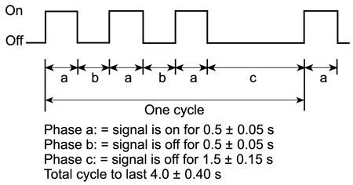

Figure 28: Evacuation Signal Pattern **C-14**

When considering the flash rate, you don’t want it to be too fast, but also you need to make sure that the flashes for each individual alarm are synchronized. The placement of the alarms is also important. Determining on the placement of each alarm within a building, it can make it seem that the flashes are not synchronized. What also needs to be taken into consideration is the color the visual signal will be, and the amount of brightness the light used for the visual signal will have. The placement, color, brightness, and the rate of the flash are important, because you also need to take in to consideration of some of the occupants in a building that may be photosensitive or that may have Epilepsy. Even though There isn’t a current law or standard that addresses this type of situation, it still needs to be taken into consideration so that you can ensure the safety of people. The NFPA 72 code does address the color the light for the signaling should be and the synchronization.

* *“Lights used for fire alarm signaling only or to signal the intent for complete evacuation shall be clear or nominal white and shall not exceed 1000 cd (effective intensity).” – NFPA 72, 18.5.3.4*
* *“Lights used to signal occupants to seek information or instructions shall be clear, nominal white, or other color as required by the emergency plan and the authority having jurisdiction for the area or building.” – NFPA 72, 18.5.3.5*
* *“The strobe synchronization requirements of this chapter shall not apply where the visible notification appliances located inside the building are viewed from outside of building.” – NFPA 72, 18.5.3.6*

Public occupancies and private occupancies share the same standards when it comes to the effectiveness and the intensity of the visible signal. However, sleeping areas are quite different because since a humans’ senses aren’t as alert. Depending on the height of the ceiling, and the distance the alarm is away from the pillow of the bed will determine the intensity of the noise of the alarm and the visible signaling as well. When it comes to the sound level of the alarm in in a sleeping area it is at the same level as it would be in a public occupancy, however the frequency of the signal is much lower. I study was done that more people who are asleep react and awaken to a lower frequency rather than at a higher frequency. That is why there is a requirement within the NFPA 72 code that the alarm system must work at a low frequency of 520 Hz when installed in a sleeping area. When it comes to the effective intensity of the visual signal in a sleeping area there are two different minimum values for the intensity of the visual. From the top of the pillow if the ceiling is less than or equal to 24 in (610 mm) than the minimum intensity level should be 110 cd. If the from the top of the pillow and the ceiling is greater than 24 in (610 mm) then the minimum intensity level of the visible signal must be 177 cd. Section 18.5.5.7.3 of the NFPA 72 code states:

*“For rooms with a linear dimension greater than 16 ft (4.87 m), the visible notifiction appliance shall be located within 16 ft (4.87 m) of the pillow.”*

What also comes into account when considering the visible signal of alarm systems is the corridor space. The dimensions of the space of the room determine the quantity of alarms that are needed to provide the correct amount of visible signals in a room to produce the alertness of an emergency. Table 3.1 will show the quantity of visible appliances required to be within a certain dimension per the NFPA 72 code. **C-14**

|  |  |
| --- | --- |
| **Room length (ft)** | **# of Visible Signals** |
| 0 – 30 | 1 |
| 31 – 130 | 2 |
| 131 – 230 | 3 |
| 231 – 330 | 4 |
| 313 – 430 | 5 |
| 431 - 530 | 6 |

Table : Visible Signals per Room Standard

This chapter within the National Fire Protection Association 72 code and standards is very crucial when designing a fire alarm system. If the specs and standards that are within this chapter aren’t done properly then you are risking the effectiveness of your system and diminishing it the systems efficiency. These standards are set to the minimum requirements for what a fire alarm system should meet to be able to perform. For a fire alarm system to perform efficiently and effectively it should be and exceed the standards set by the National Fire Protection Association. If this smart fire alarm system was produced on a much larger scale it will be very proficient. The specs of this smart fire alarm system meet every aspect within the codes; regarding the sound level component of the sounder and the visible signaling.

# 5.0 Project Design

This chapter covers several design choices and methods that are implemented for creating the S.M.A.R.T. Alarm System, based on the research performed in Chapter 4. The first thing covered is the hardware design used for the fire alarm circuits, including schematics and specifications. The software design section will describe the purpose of the Hub and its place in the network of fire alarms, as well as describing requirements for the software used in both the fire alarms and the central processing hub. Beyond the requirements, flow charts will also be included for both the programs used in the fire alarms and the central processing hub, as well as a class diagram for the central processing hub. There will also be a brief description of the wireless network’s design, and some of the choices made when designing and implementing it for the system.

## 5.1 Hardware Design

### 5.1.1 S.M.A.R.T. Alarm Fire Alarm Breadboarding

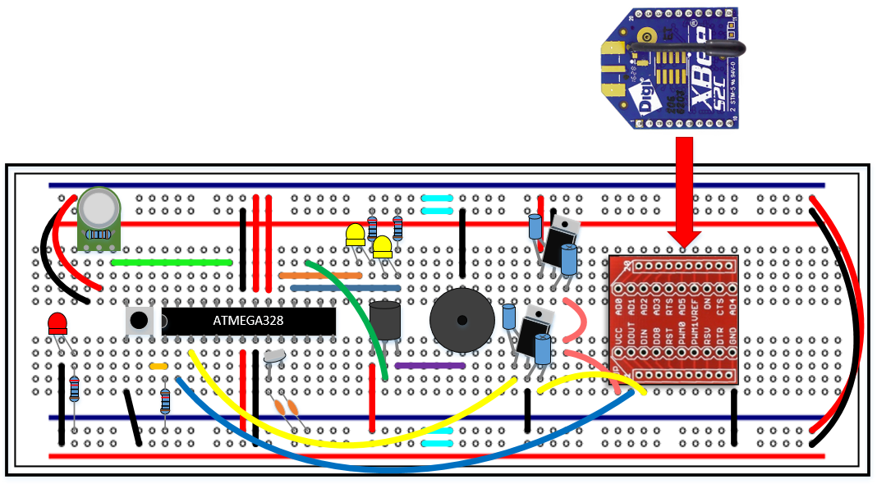

Figure : S.M.A.R.T. Alarm Fire Alarm Module Breadboard

The image above is our preliminary breadboard representation for the S.M.A.R.T. Alarm fire alarm modules. Key components of these modules are on Table x.

|  |  |  |  |
| --- | --- | --- | --- |
| Item # | Item | Quantity | Reference # |
| 1 | ATMEGA328 Microprocessor | 1 | ATMEGA 1 |
| 2 | XBEE S2C ZigBee Transceiver Module | 1 | XBEE 1 |
| 3 | 16 MHz Crystal Oscillator | 1 | X1 |
| 4 | Piezo Sounder | 1 | LS1 |
| 5 | MQ-2 Smoke and Gas Sensor | 1 | MQ2 1 |
| 6 | 3.3 – 5.0V Voltage Regulator | 2 | VR(1-2) |
| 7 | Auto Transformer | 1 | T1 |
| 8 | Light Emitting Diode | 3 | LED(1-3) |
| 9 | 22 pF Capacitor | 2 | C(1-2) |
| 10 | 10 µF Capacitor | 2 | C(3-4) |
| 11 | 100 µF Capacitor | 2 | C(5-6) |
| 12 | 220 Ω Resistor | 3 | R(1-3) |
| 13 | 5 kΩ Resistor | 1 | R4 |
| 14 | 10 kΩ Resistor | 1 | R5 |
| 15 | XBEE Breakout PCB | 1 | - |
| 16 | MQ-2 Breakout PCB | 1 | - |
| 17 | Push Button | 1 | PB1 |

Table : Fire Alarm Breadboard Components

### 5.1.2 S.M.A.R.T. Alarm Fire Alarm Schematic

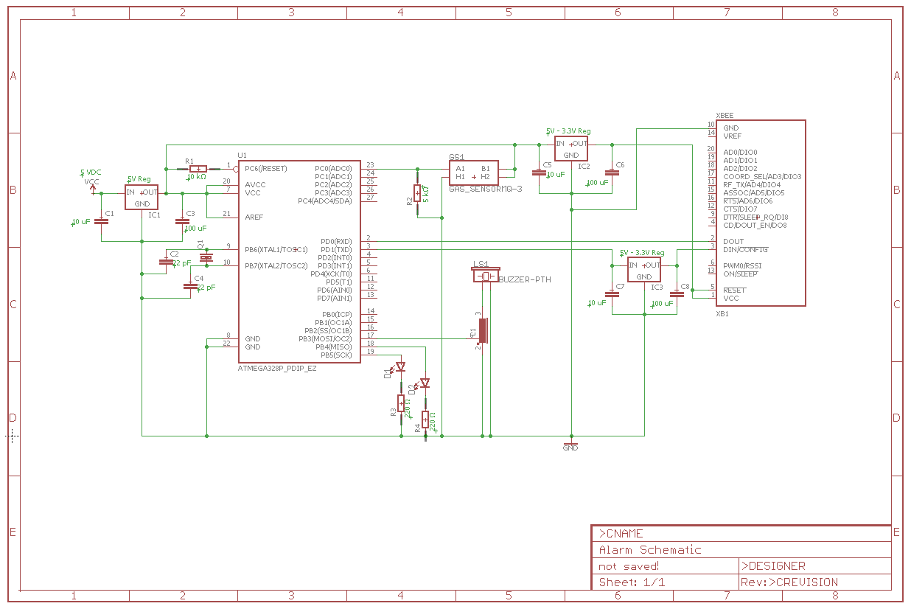

### 5.1.3 Battery Monitoring Circuit

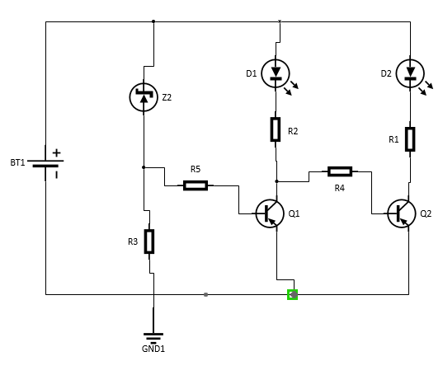

Figure : Battery Monitoring Circuit

This schematic shows the circuit we will be using to monitor the amount of power is left in the batter. This will help us determine when the battery power is low and needs to be changed within each alarm system. This circuit is very simple and it is easy to implement as well. The only things that are needed to make it work are resistors, an NPN transistor, two Zener diodes, and you can use two separate LEDs, with one being green and one being red, or you can dues a Dual LED. The Zener diodes that are used are 5.6V, and determining on the voltage that the LEDs require, regulates the amount of the threshold voltage that will control the switching between the two LEDs that will then establish when the battery is low. The design is very simple, you have one Zener diode connected to the positive lead, which is then followed by a resistor and then followed by a LED that is then connected to the ground. This first part of the circuit dictates when the green LED is on and when it turns off. If the voltage supplied is above the threshold, then the green LED is lit, and this is due to the reverse bias of the Zener diode. This flow of current also goes through the Zener diode and flows into the base of the NPN transistor, which turns it on and prevents the red LED form turning on. When the power supplied is lower than the threshold voltage, then the current flow to the LED is prevented by the Zener diode. When the power supplied is below the preferred voltage then the flow of the current that was going into the base of the NPN transistor is no longer supplied, which turns off the transistors; in return the red LED will then switch on due to the current flowing to it. This is a nice simple design when it comes to monitoring the status of the battery, because the Zener diode along with the transistor at as a switch between the two LEDs. This switching factor is due to the breakdown voltage of the Zener along with the forward voltage of the LED; which in return establishes the switching voltage and the flow of current supplied to the transistor which will turn it on and off. This design is also very cost efficient since the components within this design are very accessible and cheap.

#### 5.1.3.4 Power supply

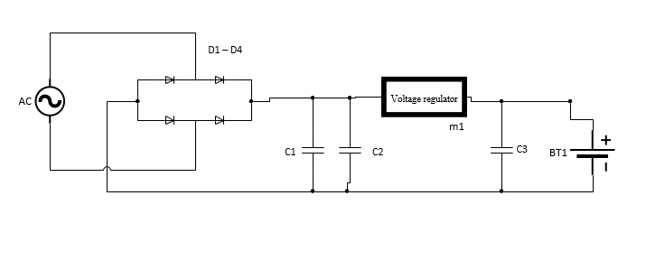

Figure : Power Supply Circuit

This schematic in the figure above shows the circuit of how our power supply will work. This schematic shows a Full Wave Bridge Rectifier Circuit, with smoothing capacitors and a voltage regulator. We chose to go with the full wave bridge rectifier circuit, because the full wave rectifier produces an output voltage that is purely DC. Also the full wave rectifier output has less ripple than the half wave rectifier, which produces a smoother output waveform. This design is more cost efficient, because it doesn’t require a centre tapped transformer. Also, the size of this rectifier design is much smaller without the transformer. The diodes are connected in bridge form and are in series pairs. This design allows for two diodes to be conducting during each half cycle. The bridge rectifier is then followed by a smoothing capacitance, this capacitance is what helps smooth out the full wave ripple output, and produces that purely smooth DC output voltage. When trying to find an acceptable smoothing capacitor you need to take into account the working voltage, and also the capacitance value. You want to make sure that the capacitance isn’t too low, otherwise it won’t a sufficient effect on the output waveform. However, if the capacitance is just large enough without the load current too big than it will have sufficient enough effect on the output waveform and create that smooth output voltage that would be pure like actually DC voltage. Figure x shows how the system will work.

From the Figure x you can see that the fire alarm system is being powered by a battery. The AC power supply is actually charging the battery; while the AC source is still connected. Which in turn is supplying the power to the alarm system. This is where the Full Wave Bridge Rectifier Circuit comes into play. The Full Wave Bridge Rectifier Circuit takes the AC voltage source as the input and then outputs a DC voltage. Which then charges the battery while it supplies power to the fire alarm system. The Full Wave Bridge Rectifier Circuit is a critical part to the powering of the fire alarm system. This is because rectifier circuit is what is converting the AC voltage that is coming in and converting it to DC voltage which charges the battery while it is supplying power to the fire alarm system. The AC source in this design is the primary power supply source for this fire alarm system, while the battery is the secondary power supply for this system.

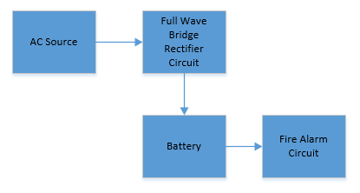

Figure : Power Supply Circuit Block Diagram

The battery being charged throughout this time is crucial, because when the AC is cut off it won’t be supplying power to the alarm. This is because the bridge rectifier circuit is constructed out of diodes, and diodes rely on a voltage source to work sense they act like switches. So since if the AC source stops supply voltage to the circuit, then the diodes are not on and there is no current flow. So therefor, since there is no current flowing through the circuit, the batter doesn’t get charged. So now the fire alarm system is solely running off of the battery during this lapse of time that the AC power supply is not working. During the time that the primary power supply is unavailable; according to the National Fire Protection Association 72 code and standards, the secondary power supply must be able to last 24 hours and 15 minutes until the primary source of power comes back on. However, this is only the maximum amount of time that is provided by the NFPA code and standards.

## 5.2 Software Design

### 5.2.1 Hub Software/Network Overview

For our Smart Fire Alarm system, the hub will be the most important processing unit. All of the fire alarms installed in the system will be using the same network sending data between Xbee modules to the hub system. Therefor the hub will be the coordinator for the network allowing all the fire alarms to connect to it. The most important aspect of the hub is that it will be doing all of the calculations needed to orchestrate the system.

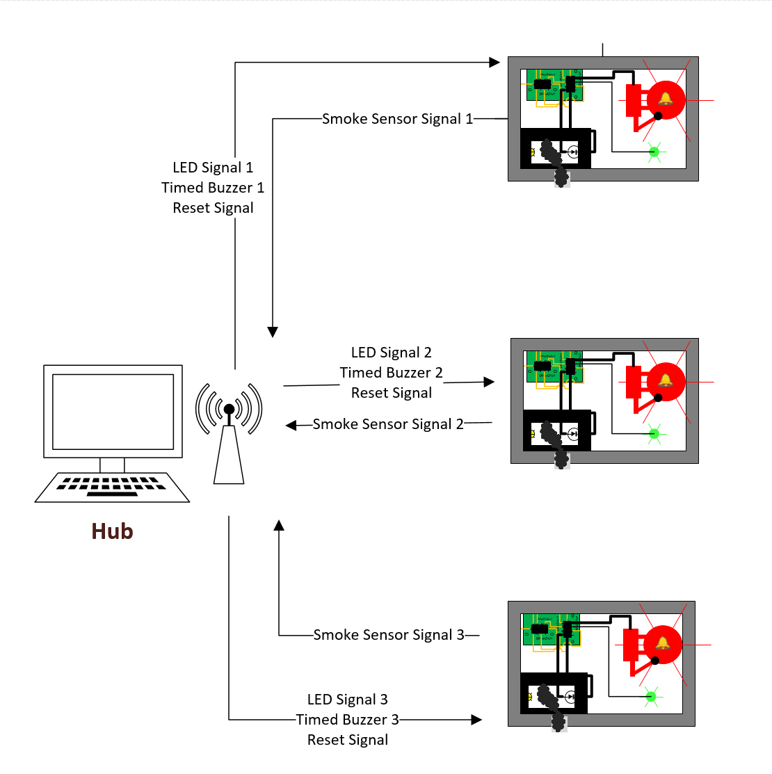

Figure : Hub Communication Diagram

The first important aspect of the software is that it will hold all important data regarding the number of alarms installed in the system as well as their locations. It will also hold the location of the suitable exits for the building that the system will be installed in. For each alarm installed in the system the hub will store information regarding the adjacent alarms or exits to each alarm. For example, the hub might store that alarm 2 has an exit directly to the north, alarm 3 directly to its right and alarm 1 directly to its left. It would then make sure that for alarm 1, alarm 2 is registered as being directly to its right. All of this information would have to be stored during installation of the system into a building. Once all of this information in stored, the hub will have a data blueprint of all alarms and exits inside the entire building and will have the knowledge necessary to direct people to the correct locations in the event of an emergency.

The next important aspect of the software is that it will be receiving signals from each of the fire alarms over the XBee wireless network. This means that when a sensor for an alarm reads that there is a hazard the fire alarm will send a signal to the hub that it needs to go off. The hub will save which XBee signal is correlated to which alarm so that it is aware of the specific alarm that goes off when it reads a signal. The hub will then use this information to know which specific alarm is going off and will join this with the above information to calculate the correct directions that people will need to travel through the building to reach the best exit.

A quick explanation of how the hub calculates the directions to send out to the alarms will now be provided. In the event that the hub receives a signal from an alarm that it is going off, the hub will start at that alarm and calculate the total distance to an exit in each of the possible directions that a person can go from this alarm that is going off. For example, if the alarm has two possible directions that you can go from this alarm, it will add the distance to the next adjacent alarm to the distance that it calculates it takes to get to the next closest exit from that adjacent alarm. The system will then continue to do this calculation all the way down until it reaches an exit. The returned value would be the total distance to an exit if you go that direction. It would then do this for the other direction and decide which direction has the smallest distance.

The beauty of this type of algorithm is that, as long as there is one continuous path from one alarm to all of the others, the system would have calculated the best direction to go from each alarm throughout the entire system. This type of algorithm is what is known as a recursive algorithm. The hub would then have all the information it needs to send the correct signals out to all the alarms in order to send everyone to the proper exits no matter where you are located throughout the building.

The last important aspect of the system is the sending of signals to each individual alarm. The system will send two important signals to each alarm in the event of an emergency. After the system decides the proper directions to send out to each alarm the hub will send out the signal to each alarm of which LED arrow to light up. This will be the visual que for users to know which direction to go. The LED signals sent out by the hub will follow the decisions that were made earlier of which is the best direction to travel to reach an exit. Secondly, the hub will calculate the order of buzzer sounds to send out in order to send audio ques to users of which direction to head in. The hub will do this by saving the “level” of each alarm from the fire. What this means is that while calculating the directions, the hub will also calculate the order of the alarms. It will keep track of the first alarm that is traveled to from the fire, then the second, then third and so on. It will use this information to send the buzzers off for each alarm in order with a delay in between. This delayed audio signal will be what a user can follow to expedite the process of figuring out the best way for them to exit a building. Lastly, the hub will also have a reset signal that can be sent out to all of the alarms in order to reset the alarms. This means turning off the LEDs for each alarm as well as turning off the buzzer sounds. This reset can either be set to go off after a certain amount of time or directly on the hub via a user sent signal.

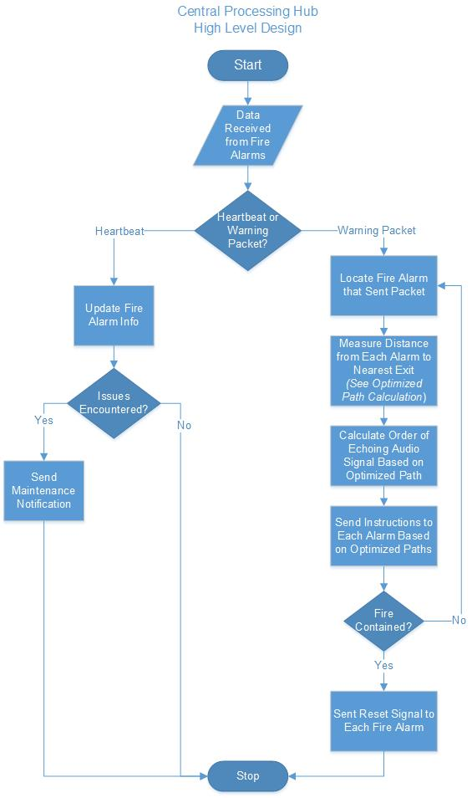The flowchart in Figure 27 serves to demonstrate the operations that occur in the Central Processing Hub’s software, in a high-level view. While it may not go into a lot of detail regarding the manner that each process is done, it goes a long way in explaining how the S.M.A.R.T. Alarm system. The cycle begins with the Hub receiving a data packet from a Fire Alarm device and discern whether it is simply a heartbeat packet or rather a (fire) warning packet. If it is simply a heartbeat packet, the pertinent information for that individual Fire Alarm will be updated in the software, and any issues reported will be noted. If there are any issues to address, a maintenance notification will be sent to the maintainer in hopes it will be taken care of promptly, depending on the issue. Otherwise, if there are no issues with the Fire Alarm, the cycle will begin again, as the Hub awaits the next heartbeat packet. Note: Heartbeat packets will be sent by each individual Fire Alarm approximately every 5 minutes, in a staggered manner as to avoid too many packets being received at once by the Hub.

Figure : Central Processing Hub Software High Level Design Flowchart

However, if the packet received by the Central Processing Hub is a warning packet, the steps taken by the Hub will be less passive. Firstly, based on the information from the data packet, the Fire Alarm and the potential fire’s location will be determined in the scope of the floor layout. Following this, the paths to the nearest exits from each Fire Alarm, including the origin of the fire, will be calculated by the Hub using the Optimized Path Calculation Algorithm in order to avoid the fire and evacuate the building as quickly as possible.

The order of the Echoing Audio Signals will be calculated in accordance with the results of the Optimized Path Calculation Algorithm. This will result in the coordination of fire alarms, as to create an echo effect for the S.M.A.R.T. Alarm system that will lead evacuees towards the nearest safe exit. At the same time, the directions for each Fire Alarm’s Visual Signals will be set in accordance with the results of the Optimized Path Calculation Algorithm. Once these are calculated, the appropriate instructions will be sent to each individual Fire Alarm, in order to guide the occupants of the building to safety. As long as the fire has not been contained and the Fire Alarms have not been reset, the system will continue to sense for fire and recalculate the exit paths if necessary, in order to ensure that if the fire spreads, evacuees will be sent to the nearest safe exit and will be able to avoid any perilous locations such as areas where there are fires or dead ends. Once the reset signals are sent by the Hub, the system will await to receive a monitor signal that will begin the fire detection cycle once again.

The flowchart in Figure 28 demonstrates how the Optimized Path Calculation Algorithm operates in greater detail. This is the most important part of the Central Processing Hub’s software, as well as being the heart of the entire S.M.A.R.T. Alarm system. The algorithm is designed to find the shortest path from any given fire alarm, including the origin of the fire, to a safe exit, using recursive calls. The algorithm begins with the location of the Fire Alarm that sent the original warning signal to the Central Processing Hub. At this point the program will check the adjacent Points of Interest to see whether they have been marked as visited.

If the Point of Interest has not been visited, the program will check if it is an exit or another Fire Alarm. If it is a Fire Alarm, it will be marked as visited and set as the Origin Fire Alarm, and the cycle will begin again for this Fire Alarm. Otherwise, if it is an exit a new path will be created for this exit, the Origin Fire Alarm will be added to the path and the distance from the exit to the current Origin Fire Alarm will be set added to the path’s distance. The program will return to the previous Origin Fire Alarm and start the cycle over for this Fire alarm.

If the Point of Interest has been visited and there are more Points of Interest in the adjacent Points of Interest list each will be “visited”. If there are no more unvisited adjacent Points of Interest, the program will check if the current Origin Fire Alarm is the Fire Alarm that initially detected the fire. If it is, the paths associated with the current Fire Alarms will be returned by the algorithm as the shortest paths to a safe exit. Otherwise, if the current Origin Fire Alarm is not marked as a source of the fire, the shortest path associated with the current Origin Fire Alarm will be selected. Following this, the current Origin Fire Alarm will be added to this path and the distance between the current Origin Fire Alarm and the previous Origin Fire Alarm will be added to the path’s distance value. The program will then return to the previous Origin Fire Alarm and continue the cycle for this Fire Alarm.

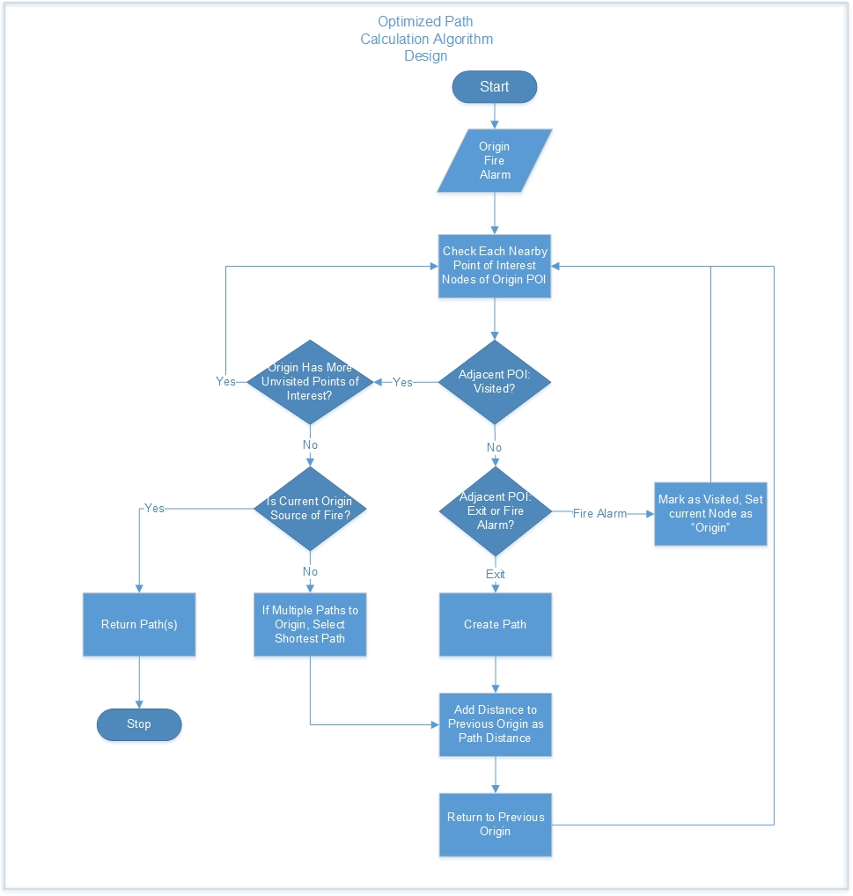

Figure : Optimized Path Calculation Algorithm Design Flowchart

The class diagram in Figure 29 gives a closer look at the classes and their methods that are to be used in the Optimized Path Calculation algorithm in the S.M.A.R.T. Alarm Hub software. The optimizePath class will be instantiating the other classes in the algorithm and will contain a currentSignal variable that serves as a status for the program (heartbeat, warning, test) as well as a HashMap that contains all of the Points of interest. The methods included are monitorMode that will simply signal the Fire Alarms to just monitor for fire, and a soundAlarm method that will signal the Fire Alarms to alert occupants of fire.

The signal class is comprised of a signalType variable, that designates the type of signal to be sent to the Fire Alarms, and a dataPackets variable, that contains an ArrayList of packet objects. The signal class has a constructor with a single int parameter, this value is meant to be the signalType of the signal object. The addPacket method will add a packet object to dataPackets and sendSignal will send out the packets in dataPackets. The packet class is comprised of a packetType variable, designating the type of packet (warning, test, etc.), an alarm variable that designates the packet a Fire Alarm destination, and a data variable that will contain the information to be parsed by the Fire Alarm. The packet constructor receives an int input parameter that sets the packetType variable and the createData method will read 3 int inputs: packetType, fireAlarm.getDirection, and fireAlarm.getSoundOrder, using this information the data will be created

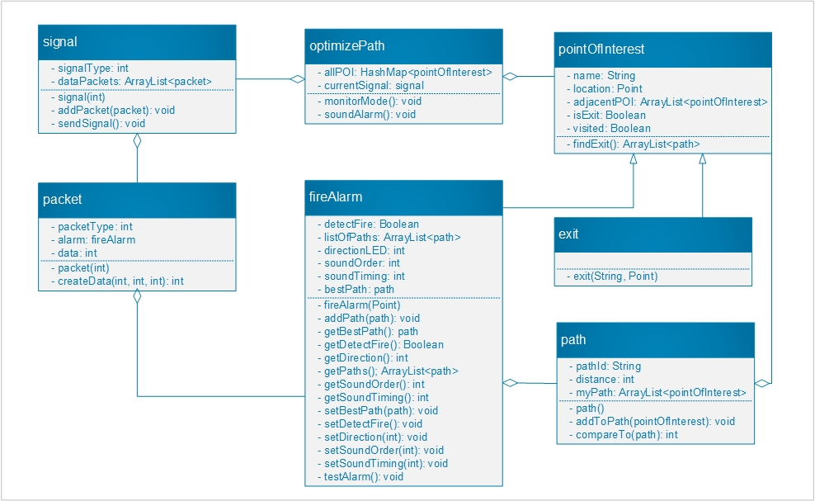

Figure : Optimized Path Calculation Algorithm Class Diagram.

The path class is comprised of a pathid variable, for identifying the path, a distance variable, measuring the distance of the path, and a myPath variable, an ArrayList of all of the pointOfInterest objects along the path. The addToPath method adds a pointOfInterest to the myPath ArrayList. The compareTo method overrides the method of the same name in the Java Comparable class, for finding the shortest path at a fireAlarm.

The pointOfInterest class is a super class for fireAlarm and exit, and is comprised of a name variable, a location variable, an adjacentPOI ArrayList of the adjacent pointOfInterest Objects, an isExit Boolean, and a visited Boolean. The findExit method will find the shortest path from every Fire Alarm to an exit, and return an ArrayList of Paths. The exit class is a subclass of pointOfInterest only comprised of a constructor based on a name String and a location Point, which will set the isExit Boolean to true.

The fireAlarm class is a subclass of pointOfInterest, and is comprised of a detectFire Boolean, to mark this fireAlarm as the one to detect the fire, a listOfPaths ArrayList comprised of all of the paths from the fireAlarm to an exit, a directionLED variable, that designates which arrow to light, a soundOrder variable, that designates the order in the Echoing Sound Signal for this fireAlarm, and a bestPath variable, that holds the shortest path from this fireAlarm to the nearest exit. The fireAlarm constructor takes a location Point as an input. The addPath method adds a path to the listOfPaths ArrayList. The getBestPath, getDetectFire, getDirection, getPaths, getSoundOrder, and getSoundTiming methods return the value for the bestPath, detectFire, directionLED, listOfPaths, soundOrder and soundTiming variables. The setBestPath, setDetectFire, setDirection, setSoundOrder, and setSoundTiming methods will set the corresponding variables. The testAlarm method will put the alarm in Test Mode, for the signal class to create test packets to send.

### 5.2.2 Fire Alarm Software Overview

The software for our fire alarm system will be written using the Arduino independent development environment. The Arduino IDE uses the built in Arduino programming language to access GPIO pins and perform other operations. The Arduino programming language is actually a set of C and C++ functions that can be called from your code. The Arduino IDE performs minor changes on the Arduino sketch that is written such as automatic generation of function prototypes and then passes the code directly into a general C and C++ compiler. The compiler that is used is the avr-g++ compiler.

The software for our fire alarm will start with checking if the fire alarm has received a wireless signal from the Raspberry Pi hub over the Xbee wireless module. The hub will be receiving signals from fire alarms and using this information to calculate the return signals for each alarm. Each alarm will be checking for its’ specific return signal telling it which led to turn on and if it should turn the buzzer on.

If a wireless signal has not been received, the program will then go on to checking the response from the MQ2 Smoke Sensor. The pin that the MQ2 sensor is connected to will need to be set to input using Arduino’s pinMode() function. Once the MQ2 sensors have been configured, we will choose a default input value and a threshold value. This threshold value will be the value that the smoke sensor will send when it senses a smoke emergency. Our program will then check if MQ2 sensor is sending our fire alarm a signal that is higher than our threshold value. The program will use Arduino’s analogRead() function to read the input from the sensor and save it into an integer variable. If the alarm reads that this sensor reading is below the threshold value, no action will be performed and the program will go back to the top of the loop. If the alarm reads that this smoke sensor reading is above the threshold value, however, the alarm will send out a wireless signal over the Xbee Module to alert the system that this fire alarm is going off. This wireless signal will be received by the hub for calculation and the hub will then send out separate responses to each of the fire alarms. After a wireless signal has been sent out by the fire alarm, the alarm will restart its programming loop.

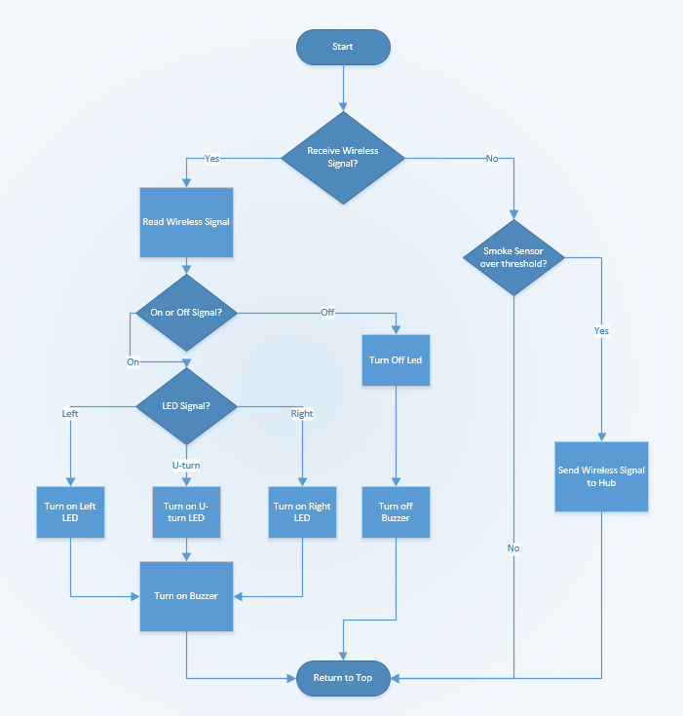

Figure : Fire Alarm Software Design Flowchart

If a wireless signal has been received by the fire alarm Xbee module, the first action that the fire alarm will take will be to decode the message. This means reading the wireless message and setting the proper variables accordingly. The first part of this process will be to check if the message received via the Xbee module will be a “On” signal or an “Off’ signal.

Once the fire alarm detects that an “On” signal has been received from the Hub, the fire alarm will go into checking which LED it has been commanded to turn on. There will be three options for this. The fire alarm will get the choice of turning on the left LED, the right LED, and a U-Turn LED. Each LED will be connected to different pins on the ATMega 328 microprocessor. The Arduino language comes with a function called digitalWrite which sends a signal out to a pin on the ATMega. This function takes in a pin number and either a HIGH or LOW signal as input arguments. The pins for each LED will be defined at the top of the Arduino program. If the left LED is connected to pin 13, for example, we will have the statement “int leftLED = 13” at the top of the program. These LED pines will also need to be set as output using Arduino’s pinMode() function. So if the fire alarm gets the signal to turn on the left LED, the program will run the line “digitalWrite(leftLED, HIGH).” If the fire alarm gets the signal to turn on the right LED, the program will run the line “digitalWrite(rightLED, HIGH).” Lastly, if the fire alarm receives a signal to turn on the U-Turn led, the line “digitalWrite(uTurnLED, HIGH)” will be run.

The last part of receiving an “On” signal via the Xbee module will be to turn on the buzzer connected to the ATMega 328. Thankfully, the Arduino programming language comes with a function for controlling the sound that it output via a buzzer. The tone() function generates a square wave for a specified frequency and duty cycle for a specified pin. For the ATMega328, the tone function will be able to set a minimum frequency of 31 Hz and a maximum frequency of 65 kHz. The tone function also takes in a optional duration parameter which is specified in milliseconds. The pin that the buzzer is on will be defined in the same way that the LEDs are defined. That pin will also need to be set to output using Arduino’s pinMode() function. If our fire alarm was going to set the buzzer to 4kHz and a duration of 1 tenth of a second, the line “tone(buzzer, 4000, 100)” would be run.

If the original signal received by the Xbee module was not an “On” signal and was instead an “Off” signal, a different section of code would be run. The “Off” signal will be sent out by the Hub to all alarms when a reset function is called. This function would turn off the LEDs of a fire alarm as well as turn off the buzzer that is connected to the ATmega 328. LEDs are turned off by the system in a very similar way to being turned on. The same digitalWrite() function is called, just with the LOW parameter instead of the HIGH parameter. In order to make the processing an easier process for the Hub, the fire alarm will not need to know which LED it needs to turn off. Instead, it will just run a turn off function on all the pins connected to LEDs. To turn off the left led, the program will run the line “digitalWrite(leftLED, LOW).” To turn off the right LED, the program will then run the line “digitalWrite(rightLED, LOW).” Lastly, to turn off the U-Turn LED, “digitalWrite(uTurnLED, LOW)” will be run.

The last part of the turn off signal will be turning off the buzzer. Thankfully, the Arduino programming language also comes with a designated function for this. The noTone() function provided by Arduino is specifically designed to stop the generation of a square wave that was triggered by the tone() function. It has only one input parameter. This parameter is the pin that you would like to turn off. In order for the fire alarm to turn off the signal to the buzzer, the line “noTone(buzzer)” will be run. After this is executed, this is the final step in handling an off signal so the program will go back to running its overarching loop that checks for a wireless message or MQ2 sensor reading.

## 5.3 Wireless Network Design

### 5.3.1 ZigBee Network Configuration

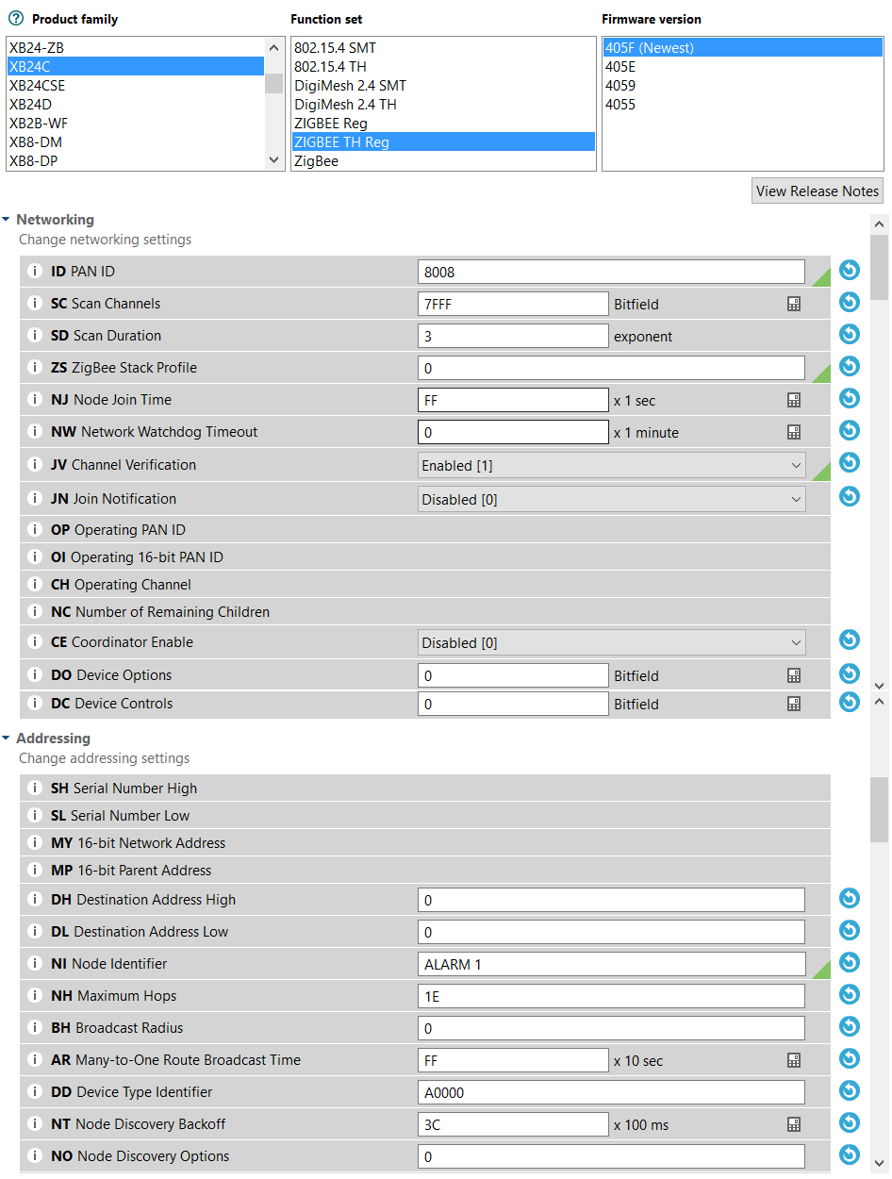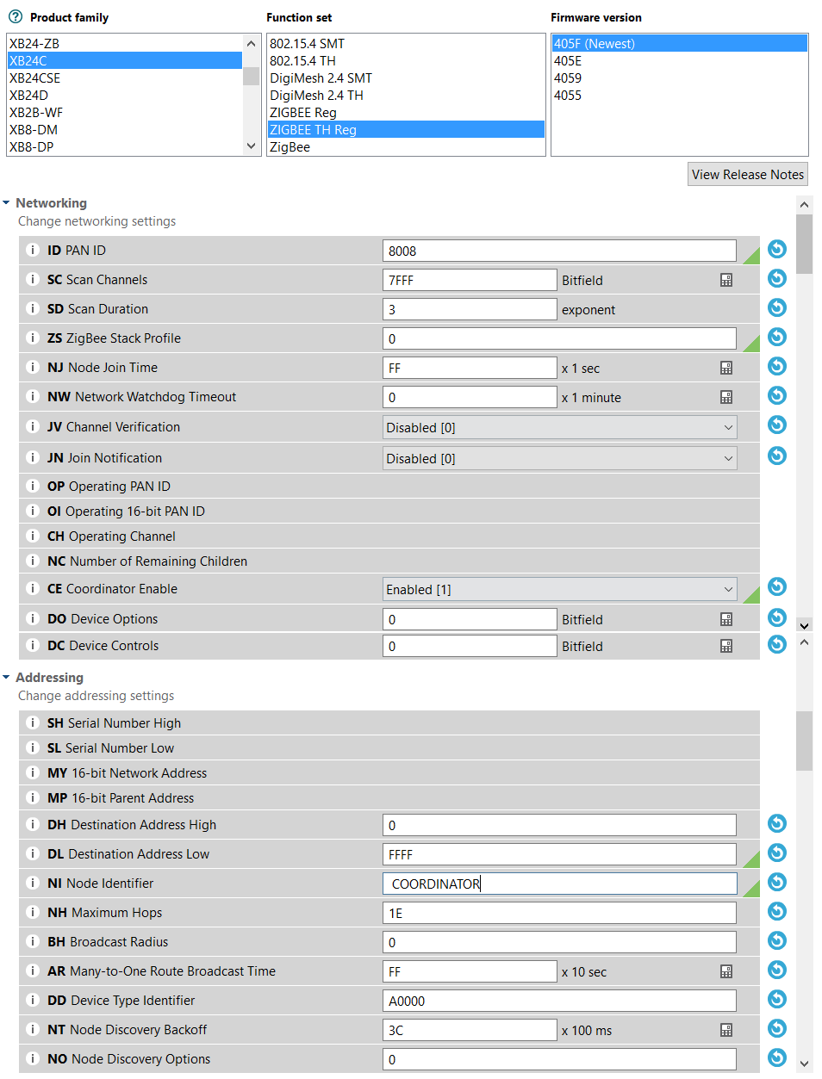The S.M.A.R.T. Alarm system will be utilizing a mesh ZigBee Network. A mesh network is composed of a single Coordinator and multiple Routers to create a wireless network. In order to configure the XBEE S2C ZigBee modules, the S.M.A.R.T. Alarm team will be utilizing the Digi International propriety software XCTU.

First, the Coordinator must be properly configured to control and maintain the ZigBee network for all XBEE S2C modules. We first select the XB24C product family and the ZigBee TH Reg (Through Hole Regular) setup using the newest firmware version. Next we choose a PAN ID for our wireless network. This ID will be used by all XBEE modules in the network, enabling them to join and send/receive data. Scan channels should be set to 7FFE, Scan Duration to 3, Node Join Time to FF (All of which are default) and Coordinator Enable to 1. Finally, we must set the Destination Address High to 0 and the Destination Address Low to FFFF (Broadcast Mode). Figure [5] shows all the necessary steps to properly set up the Coordinator.

Figure : XBEE Router Configuration

Figure : Xbee Coordinator Configuration

Next, we must set up the Router Modules. These Routers will be able to receive and transmit data to all nodes in the mesh network, enabling reliable and expansive wireless communication. We begin by choosing the XB2C Product Family and the ZigBee TH Reg as the Function set, using the newest firmware. We then match the Router PAN ID to the PAN ID we set when configuring the Coordinator. Again, we choose the default values for Scan Channels, Scan Duration and Node Join Time. We also set Channel Verification to 1 (Enable) and Coordinator Enable to 0. Finally, we set both Destination Address High and Low to 0 (the default Address Low for the Coordinator). Additionally, we can set a Node Identifier for each Router so it is possible to differentiate them.

### 5.3.2 Implementing the Network

Implementing a network can be split into three processes; Gathering Data, Sending Data and Receiving Data. There are established coding libraries that assist in these processes, as well as reading a plethora of different sensor data. Coding standard should be followed when implementing a network to support ease of use and to ensure a successful network.

### 5.3.3 Sending and Receiving Data over ZigBee Mesh Network

The ZigBee protocol is popular for many reasons, one of the biggest reasons is how a ZigBee network will automatically detect the most efficient path of data transmission from one node to another to ensure data transfer success. The S.M.A.R.T. Alarm system utilizes a mesh network to send and receive data. A mesh network is unique in the fact that it can self-adjust and connect to all other nodes, much different than a hierarchical system such as a tree network. Any device in a mesh topology may attempt to connect to any other device either directly or by using router devices to relay messages throughout a network in behalf of the original transmitting device. The route that data travels in a mesh systems is dynamic, meaning there is no set path for data to travel from one device to another. The route of the data is created on demand and can be modified if the network environment were ever to change. A mesh network has the ability to create/modify data paths dynamically, which increases both the range of the network and the reliability of the wireless connections.

The selection of a data path that the messages in a network will be relayed to their destinations is called routing [15]. The Coordinator and Routers in a ZigBee network are the devices responsible for finding and maintaining the routes in the network (an End Device cannot create routes). The distance of routes is described as the length of a path. A length is the number of devises in a particular data path. Additionally, two consecutive devices in a data path is called a link. Factors such a length, link quality, number of hops and energy conservation are all used to find the optimal data path for every routing scenario. In order to make this process as simple as possible, each link is assigned a link cost. There is a probability of success packet for each link to assign links their appropriate costs. The lower probability of success a link has, the higher the link cost. Routers are chosen based on the lowest link cost.

Data is send through a network when a data request is detected by a device. A data request can come I many different formats. These formats include broadcast, multicast or unicast with or without end to end acknowledgment. Broadcast transmission of data originates at a single node, and is then sent through all nodes in a network in a defined radius of the originator. A broadcast is used when a message is needed to be received by all devices in a network listening to a specific channel, no matter their address or PAN ID. To achieve this broadcasting effect, the destination address of the data packet must be set to 0xFFFF (Broadcast PAN ID) so that when a device receives this packet, it will send it on to the neighboring nodes as well as sending an acknowledgment back to the sender. In larger ZigBee networks, is would be hard and unnecessary for every device to send back an acknowledgment to the sender, therefore, only Coordinators and Router will send acknowledgments. In order to confirm that the data packet was broadcasted successfully, the ZigBee network makes use of “passive acknowledgment” [15]. In passive acknowledgment, after a device broadcasts a message, it will go into receive mode and wait until the same packet is rebroadcasted by any of its neighboring nodes. If the device detects a rebroadcast, it is confirmation that the message was send successfully.

Multicasting is the process in which a message is delivered to a group of devices within a single network instead of the whole network. Each of these multicast groups is identified by a 16-bit multicast group ID. Devices in a single multicast group are called group members. It is possible for a single device to be a group member of multiple multicast groups. Each device keeps track of what groups it is a part of in their individual multicast table (nwkGroupIDTable). It is possible for devices that are not members of a group to send messages to a multicast group, such as a light switch sending messages to multiple lights. It is a ZigBee standard that only data frame transmission is allowed using multicast. Therefore, no command frames are allowed to be transmitted using multicast.

Unicasting is the process of choosing a single destination to send a data packet. To do this, the destination address of the receiving device must be known. Unicasting is the most efficient way of transferring data through a network, and it can be very fast depending on routing and connection strength. The S.M.A.R.T. Alarm system will make use of all of these network communication mechanisms, using Unicast to send smoke sensor data the main hub and using broad cast to send the path planning and sound cascading data to the Alarm modules from the main hub.

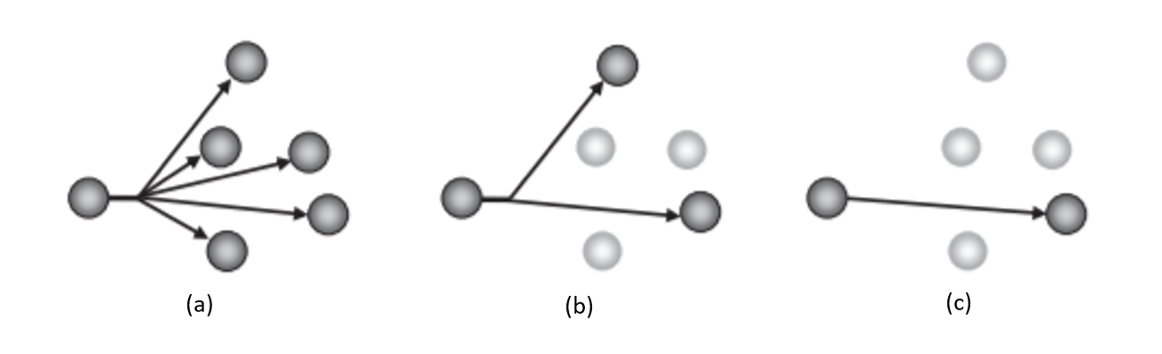

Figure : (a) Broadcast, (b) Multicast, (c) Unicast

# 6.0 Testing

This chapter will delineate all of the testing procedures and methods implemented in verifying that the S.M.A.R.T. Alarm System will meet the requirements set forth in previous chapters of this report, and the specifications hold true and work properly. This can be achieved by several phases of unit testing for both hardware and software components of the system, as well as testing the system as a whole in various scenarios. Most of the testing that will be performed this semester will consist of testing the fire alarm prototype in order to achieve a design that’s ready for PCB production, this includes both the hardware and the software of the fire alarm. However, this testing document will explain future testing to be performed on the final PCB as well as the final software implemented by the central processing hub, as well as some optional features that are desired in the final product but not essential in the scope of this project.

# 7.0 Administrative Content

This chapter will focus on the many administrative necessities in managing a project of this scope. This includes creating an estimated budget, tracking any expenses incurred in creating a working prototype for the system, estimates of creating the final project for each device and as a result the system as a whole, a plan for financing the project and a project timeline for the team to adhere to and demonstrate consistent progress. An important administrative item not included in this is the permissions granted for using certain images and diagrams included in this report. These can be found in the Appendix under section 9.2.

## 7.1 Estimated Budget

|  |  |  |  |
| --- | --- | --- | --- |
| **Component** | **Quantity** | **Part Cost** | **Total Cost** |
| Wireless Adapters | 5 | $10.00 | $50 |
| Battery Harness / Power Supply | 5 | $3.00 | $15 |
| Speaker/Alarm | 5 | $1.00 | $5 |
| Various Electrical Components | 5 | $10.00 | $50 |
| Microcontroller for Hub | 1 | $30.00 | $30 |
| PCB boards | 5 | $10.00 | $50 |
| Smoke Sensors | 5 | $7.00 | $35 |
| Boot flasher | 1 | $15.00 | $15 |
| **Estimated Total** |  |  | **$250** |

Table : Estimated Budget

The initial estimated cost for this smart smoke detector project is $250. We will add an additional $50 to this budget to account for broken parts, errors, and items that are unaccounted for. This brings the total cost of our project to $300.

## 7.2 Actual Expenditures: Prototype

The following tables list the costs associated with breadboarding and designing a prototype, and an updated estimated budget for the final system.

### 7.2.1 Central Processing Hub

|  |  |  |  |
| --- | --- | --- | --- |
| **Component** | **Quantity** | **Part Cost** | **Total Cost** |
| Raspberry Pi | 1 | $35.00 | $35.00 |
| MQ-2 Breakout PCB | 1 |  |  |
| Maxxwave MikroTik 2.4/5GHz Omni Swivel Antenna | 1 | $5.70 | $5.70 |
| **Estimated Total** |  |  |  |

Table : Fire Alarm Protoype Cost

### 7.2.2 Fire Alarm

|  |  |  |  |
| --- | --- | --- | --- |
| **Component** | **Quantity** | **Part Cost** | **Total Cost** |
| ATmega328 Microprocessor | 1 | $4.50 | $4.50 |
| XBee S2C Zigbee Transceiver Module | 1 |  |  |
| 16 MHz Crystal Oscillator | 1 | $0.29 | $0.29 |
| Piezo Sounder | 1 | $0.66 | $0.66 |
| MQ-2 Smoke and Gas Sensor | 1 | $3.95 | $3.95 |
| 3.3 – 5.0V Voltage Regulator | 2 | $1.99 | $3.98 |
| Auto Transformer | 1 | $1.00 | $1.00 |
| Light Emitting Diode | 3 | $0.15 | $0.45 |
| 22 pF Capacitor | 2 | $0.40 | $0.80 |
| 10 µF Capacitor | 2 | $0.40 | $0.80 |
| 100 µF Capacitor | 2 | $0.40 | $0.80 |
| 220 Ω Resistor | 3 | $0.40 | $1.20 |
| 5 kΩ Resistor | 1 | $0.01 | $0.01 |
| 10 kΩ Resistor | 1 | $0.01 | $0.01 |
| XBEE Breakout PCB | 1 | $2.98 | $2.98 |
| MQ-2 Breakout PCB | 1 | $0.95 | $0.95 |
| Push Button | 1 | $0.58 | $0.58 |
| **Estimated Total** |  |  |  |

Table : Fire Alarm Prototype Cost

## 7.3 Financing Plan

While everyone on the team has agreed to share any financial burden created by the project equally, we will seek sponsorships and other means to finance this project. After selecting a project, and receiving approval we have created a prototype of our system at the time financed by the group members. This allows a very accurate estimate of the costs the final implementation of the project for presenting at the Senior Design Showcase. Once this estimate is ready and we need to enter production of our final product we will submit proposals to companies interested in investing in a smart system for fire safety and those looking to showcase their semiconductor and component products. A tentative list includes: Texas Instruments, Taiwan Semiconductor Manufacturing, Honeywell Fire Systems, Siemens (Building Technology Division), and UCF. If no sponsorship or financial help is achieved, the team is willingly responsible for any costs incurred.

## 7.4 Project Timeline

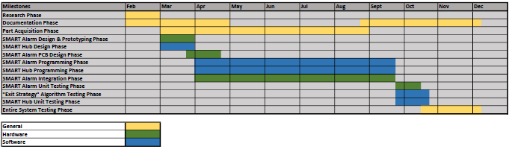

# 8.0 Conclusion

Many challenging problems were approached in the design of the S.M.A.R.T. Alarm system and were overcome and solved through diligent and consistent hard work by our team members during the research and design phases of this project. The requirements set during the initial proposal phase served as a blueprint that guided every component and design decision for both hardware and software implementation of the S.M.A.R.T. Alarm system as part of the prototype phase, and will continue until the final product is presented.

The S.M.A.R.T. Alarm system integrates several component and devices that when implemented properly can save countless lives in the face of danger, and provided a much-needed upgrade to the manner in which fire alarm systems communicate and coordinate evacuation in a building. Throughout this project, the number one objective in mind for our team was creating a product that will result in saving as many lives as possible by ensuring fast response times and an organized and intuitive manner for evacuating a building. The users that in charge of maintaining the system are also in mind, so that the task of system maintenance is one that will not take much time out of their day, and will prove to be easy to use and convenient depending on their needs.

Bringing together a team of students from different disciplines to create a well-rounded project is not an easy task, however the workload for designing the S.M.A.R.T. Alarm system was well distributed and the project properly reflects the well-rounded nature of our group from a technical standpoint. The manner in which the components, software and technologies have been integrated has allowed the S.M.A.R.T. Alarm team to come together and expand each other’s knowledge, while combining interests, ideas and technical skills. Throughout the duration of the S.M.A.R.T. Alarm design phase, it has been important to maintain that each technical detail is scrutinized and analyzed, to ensure that the impact of each decision is a positive one overall.

Going forward, important aspects of the project will rely heavily on the development of the software to be used in the Central Processing Hub. While the design of the algorithms for selecting the shortest evacuation routes in each building has been finished for the most part, the implementation of a Graphical User Interface and the software program to be used in the Central Processing Hub has much room for improvement, in order to optimize the user experience when it comes to the process of installation and maintenance. Beyond the scope of Senior Design, there are a few design changes that are specified in the research chapter of this report, that would result in a more complete product however, due to the constraints of the environment in which this will be tested and presented were not implemented in the design of the S.M.A.R.T. Alarm system. With this in mind, the design decisions made for the system, were made with the idea of proof of concept in mind so that beyond that the system may be scaled and prepared for a more commercial approach.

## 8.1

# 9.0 Appendix

## 9.1 References

|  |  |
| --- | --- |
| [1] | N. Artim, "3.2 An Introduction to Fire Detection, Alarm, and Automatic Fire Sprinklers," *Northeast Document Conservation Center,* 2017. |
| [2] | R. W. Bukowski, R. D. Peacock, J. D. Averill, T. G. Cleary, N. P. Bryner, W. D. Walton, P. A. Reneke and E. D. Kuligowski, "Performance of Home Smoke Alarms," National Institute of Standards and Techonology, 2008. |
| [3] | A. E. Cote and P. Bugbee, Principles of Fire Protection, Quincy, MA: National Fire Protection Association, 1995. |
| [4] | K. Alt, "Find the Best Smoke Detector Type for Your Family," A Secure Life, 2016. |
| [5] | V. Jain, "Learn the Workings of a Gas Sensor," EngineersGarage. |
| [6] | "Types of Smoke Detectors and Alarms," W. W. Grainger, Inc.. |
| [7] | "International Association of Fire Fighters (IAFF)," World Fire Safety Foundation, August 2008. [Online]. Available: http://www.thewfsf.org/iaff. [Accessed 25 February 2017]. |
| [8] | J. F. Cox, Fundamentals of Linear Electronics, Albany, NY: Delmar, 2002. |
| [9] | F. Tavernier and M. Stevaert, "Chapter 3: From Light to Electric Current- The Photodiode," in *High-speed Optical Receivers with Integerated Photodiode in Nanoscale CMOS*, New York, Springer, 2011. |
| [10] | C. Nave, "Photodiode Light Detector," HyperPhysics, [Online]. Available: http://hyperphysics.phy-astr.gsu.edu/hbase/Electronic/photdet.html. [Accessed 7 March 2017]. |
| [11] | D. Gislason, Zigbee Wireless Networking, Oxford: Elsevier, Newnes, 2008. |
| [12] | University of Hawaii. |
| [13] | R. Sheldon and X. Shirui, "ZB ZigBee Mesh Networking - Introduction to Building Your Own Mesh Network," National Control Devices, LLC, 12 October 2014. [Online]. Available: https://www.controlanything.com/Relay/Device/A3001-1. |
| [14] | L. Frenzel, "What's The Difference Between IEEE 802.15.4 And ZigBee Wireless?," Penton, 2013. |
| [15] | S. Farahani, Designing ZigBee Networks and Transceivers: The Complete Guide for RF/Wireless Engineers, Oxford: Newnes, 2008. |
| [16] | "Data Sheet: JN5168-001-Myy," NXP Laboratories UK Ltd, [Online]. Available: http://www.nxp.com/documents/other/JN-DS-JN5168MO-1v2.pdf. |
| [17] | "ETRX35x ZigBee Module Product Manual," Silicon Labs, [Online]. Available: http://www.mouser.com/ds/2/368/tg-pm-0516-etrx35x-957725.pdf. |
| [18] | "Xbee/Xbee-PRO RF Modules Product Manual," Digi International Inc., [Online]. Available: https://www.sparkfun.com/datasheets/Wireless/Zigbee/XBee-Datasheet.pdf. |
| [19] | "XBee S1 802.15.4 RF Modules," Digi International, Inc., [Online]. Available: http://www.mouser.com/ds/2/111/ds_xbeemultipointmodules-19140.pdf. |
| [20] | "Arduino - ArduinoBoardUno," [Online]. Available: https://www.arduino.cc/en/Main/ArduinoBoardUno. [Accessed 30 March 2017]. |
| [21] | "ATmega 328 Datasheet Complete," 2017. [Online]. Available: http://www.atmel.com/Images/Atmel-42735-8-bit-AVR-Microcontroller-ATmega328-328P_Datasheet.pdf. [Accessed 30 March 2017]. |
| [22] | "Raspberry Pi 3, ODROID-C2 and Pine A64+ Development Boards Comparison," 2016. [Online]. Available: http://www.cnx-software.com/2016/03/01/raspberry-pi-3-odroid-c2-and-pine-a64-development-boards-comparison. [Accessed 30 March 2017]. |
| [23] | "AM3358 Sitara Processor," 2017. [Online]. Available: http://www.ti.com/product/AM3358. [Accessed 30 March 2017]. |
| [24] | "BeagleBone Black Rev C - 4GB Flash - Pre-installed Debian ID: 1876," 2017. [Online]. Available: https://www.adafruite.com/product/1876. [Accessed 30 March 2017]. |
| [25] | "Arduino - MiniBootLoader," 2017. [Online]. Available: https://www.arduino.cc/en/Hacking/MiniBootloader. [Accessed 30 March 2017]. |
| [26] | *How To Load Bootloader onto Arduino.* [Film]. Zoo Rated Productions, 2013. |
| [27] | "AVR053: Internal RC Oscillator Calibration for tinyAVR and megaAVR Device: Application Note," 2017. [Online]. Available: http://www.atmel.com/Images/Atmel-2555-Internal-RC-Oscillator-Calibration-for-tinyAVR-and-megaAVR-Devices-ApplicationNote_AVR053.pdf. [Accessed 30 March 2017]. |
| [28] | "Arduino - Setting up an Arduino on a breadboard," [Online]. Available: https://www.arduino.cc/en/main/standalone. [Accessed 30 March 2017]. |
| [29] | "Auto Transformer," Circuit Globe. [Online]. [Accessed 12 April 2017]. |
| [30] | "IEEE 802.15 WPAN Task Group 4 (TG4)," IEEE, 2003. [Online]. Available: http://www.ieee802.org/15/pub/TG4.html. [Accessed 2 April 2017]. |

## 9.2 Copyright Permissions



Figure : ATMega Permission Request from Mouser for Use



Figure : BeagleBone Permission for Use



Figure : MQ-2 Permission Request from Polulu for Use



Figure : MQ-2 Permission from Polulu for Use



Figure : AC SWIM Antennna Permission from MikroTik for Use



Figure : Telegesis Permission Request for Use



Figure : Raspberry Pi Permission for Use



Figure : NXP Permission Request for Use

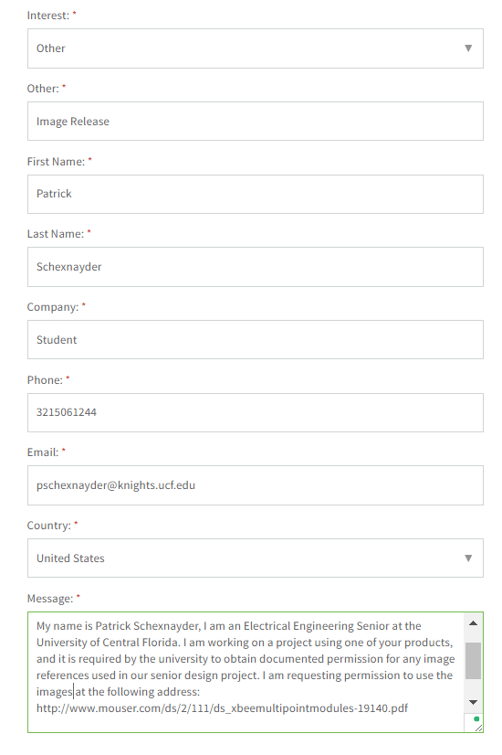

Figure : Xbee Module Permission Request



Figure : Zigbee Alliance Permission for Use



Figure : Image Permission Request from Chiara Buratti

## 9.3 Datasheets